iW-SA30 SIP Speaker
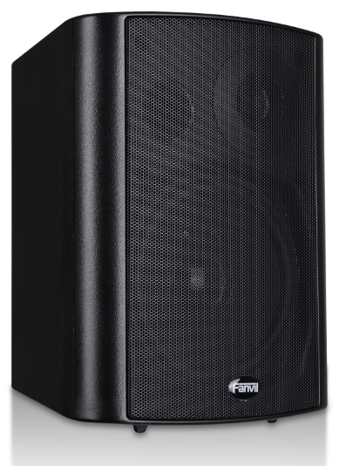

IW - SA30 is based on the VOIP phone Fanvil technology industry research and development of user requirements specifically for a SIP speakers products, voice transmission adopts the standard of IP/RTP protocol, it has inherited good bearing phone compatibility good advantages, can be perfectly compatible with the present all mainstream IPPBX/softswitch based on SIP/IMS platform, such as Asterisk, Broadsoft, 3 cx, Elastix, rapid deployment device provides a convenient for the user.  Function Highlights  - Compatible with standard SIP (RFC3261) protocol and main IPPBX/IMS platform  - All-in-one wall-mounted design, integrated with network audio codec, digital amplifier amplifier and speaker  - Built-in high fidelity speaker  - Online adjust volume output  - The built-in audio output interface to connect external active speakers  - Standard RJ45 port, the Ethernet front-end ports where you can access, support across different network segment and routing  - Adaptive output power according to the power supply voltage | Applications  - Business office, hotel, shopping center  - Education schools,the gym  - public places factory, museum  - Transportation airport, parking lot

Basic Performance
- 2 SIP lines
- POE enabled(Power Over Ethernet)
- Wall-mounted installation
- A built-in audio output to connect external speaker
- Support external power supply
- Industry certification: CE/FCC

Audio Features
- Narrowband speech coding: G.711a/u, G.723.1, G.726-32K, G.729AB
- Wideband speech coding: G.722
- voice activation detection/mute
- DTMF: With the audio (In-band), Out-of-band (RFC2833) / SIP INFO

Network/Security features
- Support PoE(802.3af)
- support the DNS and secondary DNS server
- Support VLAN
- Support SNTP client
- Support VPN L2TP / PPTP / IPSec
- Support SRTP
- Support web page HTTP / HTTPS
- Support Qos:802.1p/q, DSCP
- Support the MD5 authentication
- Support Web Filter
- DHCP / static / PPPoE
- STUN

Configuration and Management
- Via FTP/TFTP DHCP OPT66 / SIP/HTTP/HTTPS/PNP/TR069 automatically
- web management interface
- Web Packet capture (Web -based Packet - dump)
- Configuration export/import
- Software upgrade
- System logs (Syslog)

Physical Specifications
- WAN port：10/100BASE-Tx，Auto-MDIX，RJ-45
- LAN port：10/100BASE-Tx，Auto-MDIX，RJ-45
- PoE：802.3af(Class 3 - 6.49~12.95W)
- Main chip: Broadcom
- Output power: according to the power supply voltage automatic adaptation. A) PoE 8 w; B) the 12 v / 1.5 A, 10 w. C) 18 v / 3 a 20 w; D) 24 v / 3 a 30 w
- Horn frequency response: 75 hz - 20 KHZ
- Sound pressure (SPL 12/1 meters) : 100 db
- Power supply: 12 v / 1 a DC or PoE
- Working temperature: - 10 ~ 50 ℃
- Storage temperature: - 10 ~ 50 ℃
- Relative humidity: 20 ~ 80%
- Package weight: 3 kg
- Equipment size: 245 x162x182mm (W x H x L)

Above functions/features/specifications provide customer reference only, may change in the future, bearing without prior notification obligations, all functions/features/specifications must will be subject to the actual shipment of goods. If the customer about these functions/features/specifications have doubt, please contact distributors around the agent or bearing.
Check out more product information please visit bearing's official website: www.fanvil.com
Compatibility List

