
iW-SA30
SIP Speaker Quick Installation Guide

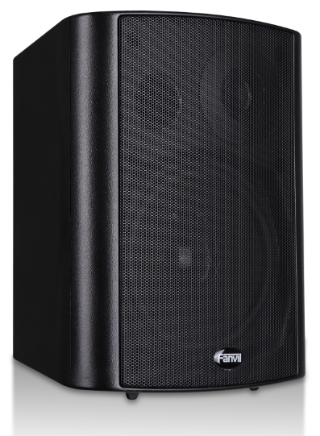


Interface Explanation
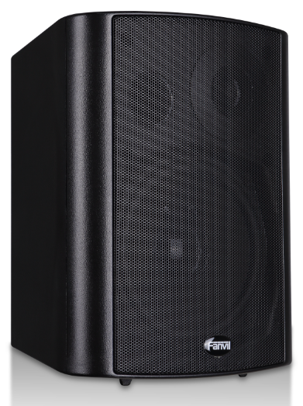
Interface Diagram

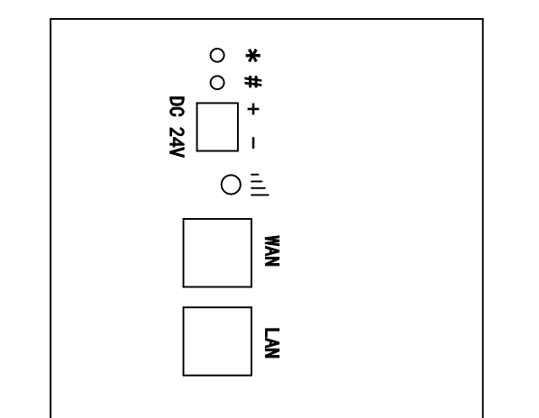
Speaker

Port | Description | Feature | Picture
DC 24V | DC Power Input port | Input Range:+12～+24V DC  (Notice: Plus-n-Minus connection of the Power) | 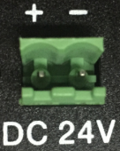
WAN | WAN port | 10M/100M Adaptive Ethernet port, connected to the network | 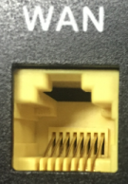
LAN | LAN Port | 10M/100M Adaptive Ethernet port, connected to the computer(which can be configured to routing mode, or to bridge mode) | 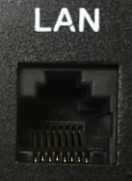
 | The Network Light | - The network get through , and the light put out  2, The network can not get through , and the light blink fast within 0.5s  3, The network get through but registration fail , and the light blink slowly with 1s | 
* # | Audio Output Interface | 1 , Long click "#" for more than 3s , and then IP Address will be announced by this device  2, Click "#****#*" , this device will automatically restart and reset to defaults | 
SIP Speaker Configuration

Step One: Connect to the network
Connect the end of network cable to the device WAN port, another end is connected to the LAN port of the router, then the hardware connection is completed. Normally, you should set your network to DHCP mode.
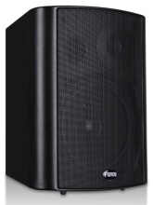

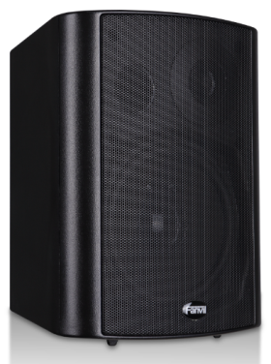
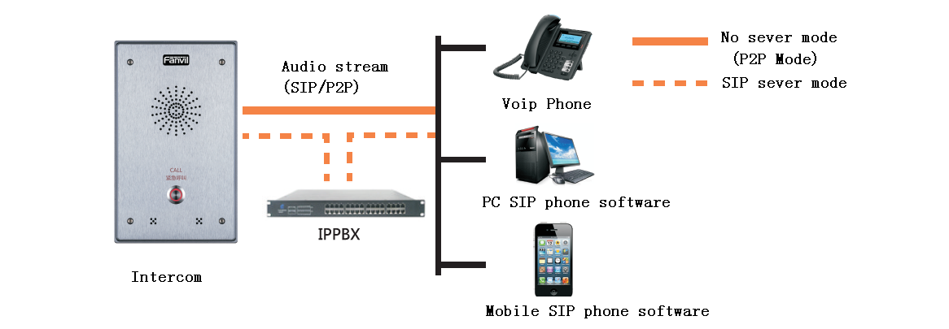
SIP Speaker
No server mode
(P2P mode)
Mobile SIP Phone Software
Audio stream（SIP/P2P）

PC SIP Phone Software
VOIP Phone
SIP Server mode
Step Two: Get the device IP Address:
Methods:
1. Use the default IP scanner tool to get it: Network Scanner
- Install the scanner tool: Network Scanner;
- Ensure the working computer (installing IP scanner tool, exe.) is in the same local network with the corresponding device;
- Run the tool (Network Scanner.exe), to search the IP address of corresponding device within the network.
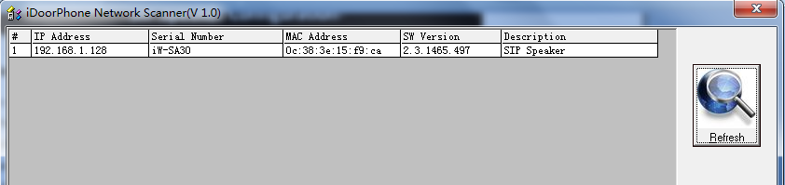
Method 2: Long Press “#”key for 3 seconds, the intercom will report the IP numbers by itself.
SIP Speaker Configuration

Step Three: Log in the WEB admin interface of the device
Input IP address (e.g.: http://192.168.1.128) the Web browser, the default user name: admin, password: admin.
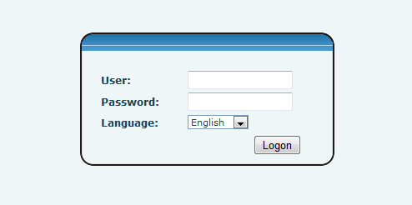

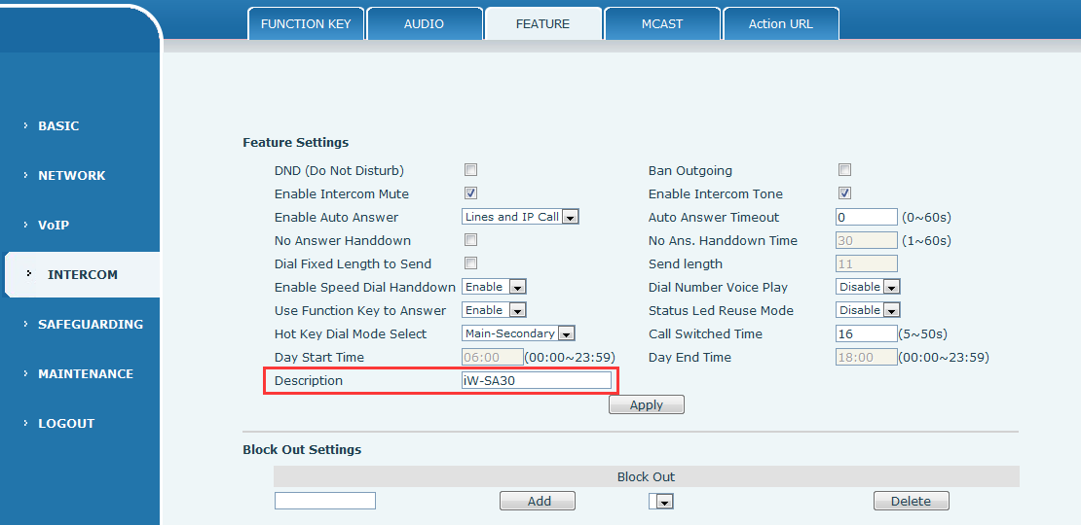
Step Four: Modify the device description

SIP Speaker Configuration

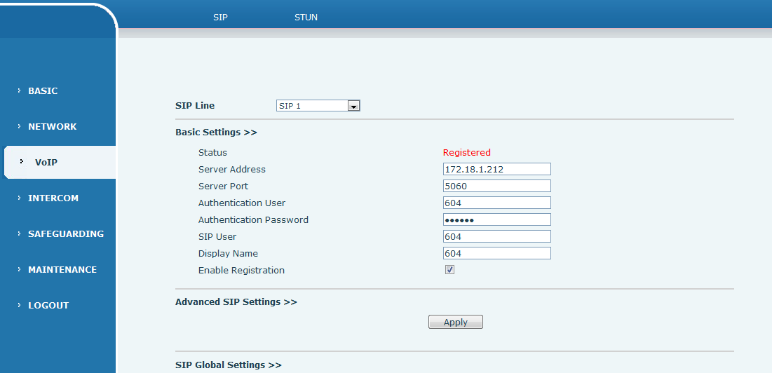
Step Five: Add SIP account
SIP Speaker Configuration

Step Six：The Volume adjustment
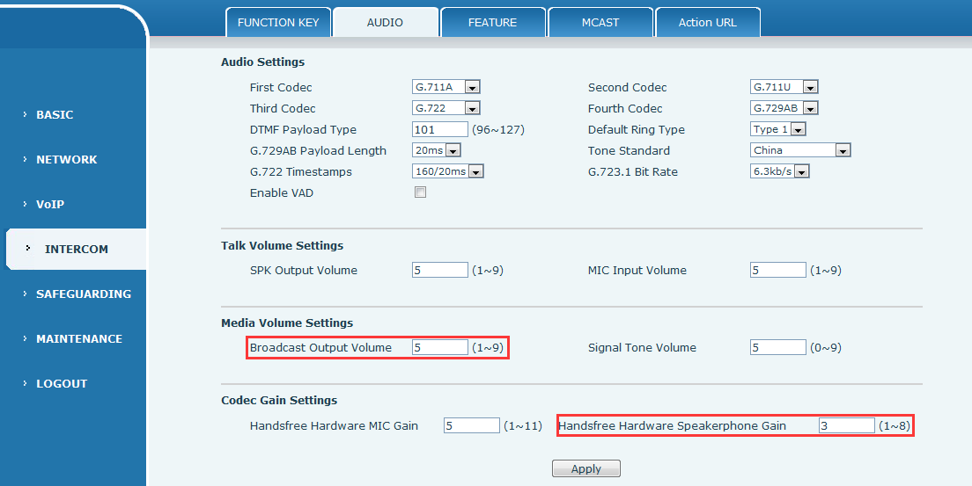
Method one: through the WEB can adjust the size of the volume, mainly is two, < Broadcast Output Volume > and < Handsfree Hardware Speakerphone Gain> below.
Hardware gain
The software gain, not greater than 5

