VoIP Protocols | SIP (RFC3261) over TCP/UDP/TLS, STUN, RTP/RTCP/SRTP,
Codecs | G.711a/u, G.722, G.729AB, G.726-32, G.723.1
DSP | Handset/Headset/Speaker-phone  (EHS support for Plantronics headsets)  VAD/CNG, Full-duplex AEC, HD voice, DTMF Inband/Relay (RFC2833)
Call Ops | Caller ID, Do-not-disturb, Auto-answering, Voice Message, 3-way Conference, Call Forward/Transfer
Model | X6
Power Supply | Input:100-240V  Output:12V/1A
Network Interface | 1Gbps, RJ-45 x2  (Network x1 + PC x1)
Audio Interface | RJ-9 x2  (Handset x1, Headset x1)


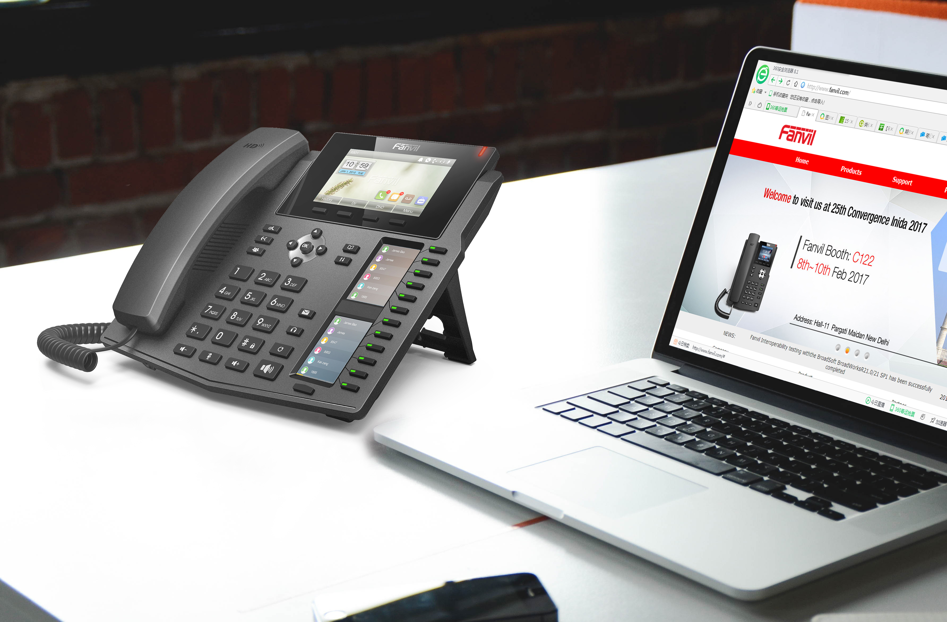
X6
Highlights
- Color Screen-4.3”main color screen+2x2.4”color DSS screen
- DSS Key-mapping LCD–12 DSS keys corresponded to the LCD display to provide dynamic DSS/BLF functions up to five pages at virtualized total 60 DSS keys.
- 6 Lines – Each line applied to one VoIP (SIP) service account.
- Fast/Gigabit Ethernet–Dual switched auto-sensing Gigabit network ports, PoE.
- Support Bluetooth with USB dongle
- Support EHS headsets(Plantronics)
- Higher security–Automated provisioning using TR-069 or AES encrypted XML configuration file, TLS/SRTP/HTTPS for advanced security and privacy protection
- Stronger compatibility–Interoperability with major platforms, such as, Asterisk, Broadsoft, 3CX, Elastix, Xorcom,etc.

Fanvil Technology Co., LTD. www.fanvil.com Tel: +86-755-2640-2199
3F, Block A, Gaoxinqi Building, Anhua Industrial Park, Qianjin 1 Road,, 35th District, Bao'An, Shenzhen, 518101 P.R. China.

