FANVIL X6 Enterprise IP Phone
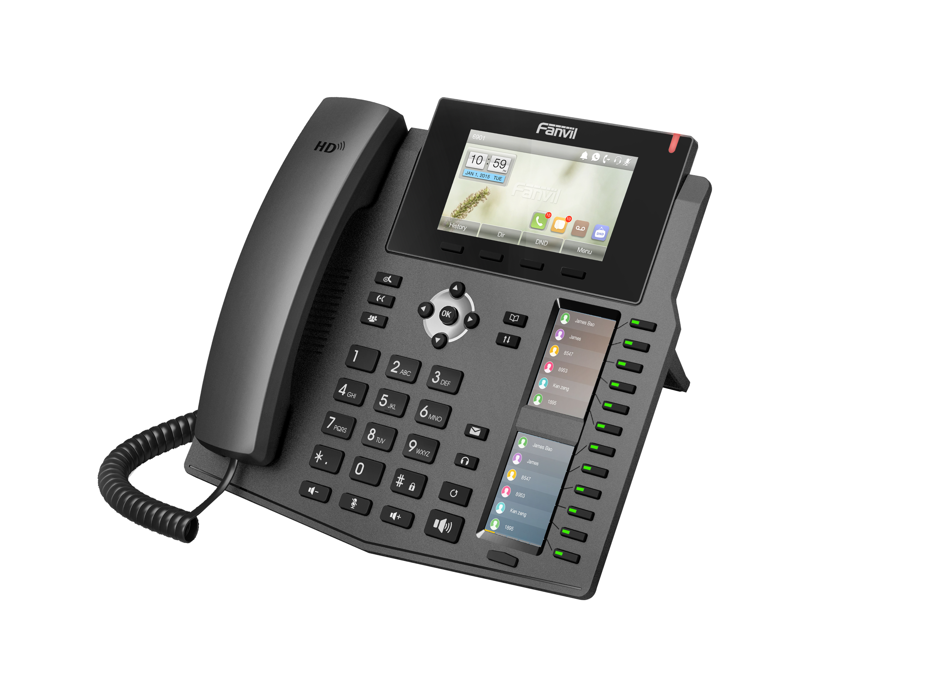
A New Enterprise Color-LCD Phone with Intelligent DSS Key-mapping LCD Display
The new Fanvil X6 IP Phone is a high-end enterprise desktop phone which comes with 2 intelligent DSS Key-mapping color LCDs to increase enterprise users’ productivity.

Highlights
√ 2 DSS Key-mapping LCD – 12 DSS keys corresponded to the
LCD display to provide dynamic DSS/BLF functions up to
five pages at virtualized total 60 DSS keys.
√ Gigabit Ethernet – 10/100/1000Mbps Ethernet with POE enabled.
√ Economic and Environmental Friendly design with Elegant
Housing, with high-resolution TFT color display, delivering a rich visual experience.
√ High Interoperability – Compatible with major platforms:
3CX, Asterisk, Broadsoft, Elastix, Zycoo, etc.

Generic
• 6 SIP Lines
• HD Voice
• POE Enabled
• 3 LCDs (Main + DSS)
• Handset(HS) / Hands-free(HF) / Headphone(HP) mode
• Intelligent DSS Keys
• Desktop / Wall-mount installation
• Optional External Power Supply
• Economical and Environmental friendly package
• Industrial Standard Certifications: CE/FCC

Call Features
• Call out / answer / reject
• Mute / Unmute (microphone)
• Call Hold / Resume
• Call Waiting
• Intercom
• Caller ID Display
• Speed Dial
• Anonymous Call (Hide Caller ID)
• Call Forwarding (Always/Busy/No Answer)
• Call Transfer (Attended/Unattended)
• Call Parking/Pick-up (depending on server)
• Redial
• Do-Not-Disturb (per line / per phone)
• Auto-Answering (per line)
• Voice Message (on server)

• Local 3-way Conference
• Hot Line
• Hot-Desking

Phone Features
• Phonebook (1000 entries)
• Remote Phonebook (XML/LDAP)
• Call log (300 entries, in/out/missed)
• Black/White List Call Filtering
• Voice Message Waiting Indication (VMWI)
• Programmable DSS/Soft keys
• Network Time Synchronization
• Action URL / Active URI

Audio
• HD Voice Microphone/Speaker (Handset/Hands-free, 0 ~ 7KHz
Frequency Response)
• Wideband ADC/DAC 16KHz Sampling
• Narrowband CODEC: G.711a/u, G.723.1, G.726-32K, G.729AB, AMR,iLBC
• Wideband CODEC: G.722, AMR-WB,
• Full-duplex Acoustic Echo Canceller (AEC) – Hands-free Mode,
96ms tail-length
• Voice Activity Detection (VAD) / Comfort Noise Generation (CNG) /
Background Noise Estimation (BNE) / Noise Reduction (NR)
• Packet Loss Concealment (PLC)
• Dynamic Adaptive Jitter Buffer up to 300ms
• DTMF: In-band, Out-of-Band – DTMF-Relay(RFC2833) / SIP INFO

Networking
• Physical: 10/100/1000 Mbps Ethernet, dual bridged port for PC bypass
• IP Configuration: Static / DHCP / PPPoE
• Network Access Control: 802.1x
• VPN: L2TP (Basic Unencrypted) / OpenVPN
• VLAN
• QoS

Protocols
• SIP2.0 over UDP/TCP/TLS
• RTP/RTCP/SRTP
• STUN
• DHCP
• PPPoE
• 802.1x
• L2TP (Basic Unencrypted)
• OpenVPN
• SNTP
• FTP/TFTP
• HTTP/HTTPS
• TR069

RFCs:
354/1321/1350/1769/1889/1890/2131/2132/2616/2617/2661/2833/2976/3261/3262/3263/3264/3265/3268/3311/3489/3711/4346/4566/5630/
5865

Deployment & Maintenance
• Auto-Provisioning via FTP/TFTP/HTTP/HTTPS/DHCP OPT66/SIP
PNP/TR069
• Web Management Portal
• Web-based Packet Dump
• Configuration Export / Import

• Phonebook Import/Export
• Firmware Upgrade
• Syslog

Physical Specifications
• Main LCD x1: 4.3 inch (480x272) color-screen LCD
• DSS Key-mapping LCD x2: 2.4 inch (240x320) color-screen LCD
• Keypad: 46 keys, including
4 Soft-keys
8 Function keys
4+1 Navigation keys + OK
12 Standard Phone Digits keys
3 Volume Control keys, Up/Down/Mute(Microphone)
1 Hands-free key
12 DSS Keys with tri-color LED
1 Page-Switch (PS) key
• HD Hands-free Speaker (0 ~ 7KHz) x1
• HD Hands-free Microphone (0 ~ 7KHz) x1
• HD Handset (RJ9) x1
• USB Port x1 (Connect with BT USB dongle)
• Support Bluetooth headset (Through USB Dongle)
• Support Plantronics Wireless headset (Through Plantronics APD-80 EHS Cable)
• Standard RJ9 Handset Wire x1
• 1.5M CAT5 Ethernet Cable x1
• RJ9 Phone Jacket x2: Handset x1, Headphone x1
• RJ45 Ethernet Jacket x2: Network x1 ,
PC x1 (Bridged to Network)
• Main Chipset: Broadcom
• DC Power Input: 12V/1A
• Power Consumption: Idle – ~ W, Peak – ~W
• Working Temperature: 0 ~ 40℃
• Working Humidity: 10 ~ 65%
• Dual-Functional Back Rack x1: Desktop Stand
• Color: Black
• Package Dimensions: 315x270x65mm (W x H x L)

The above specifications may be updated in the future without prior notice. All hardware/software/physical features should be based on the final shipped products. Customers should consult Fanvil’s retailers, distributors, or Fanvil directly, if customers have concerns on any feature.
For more information, please visit: www.fanvil.com

Company Profile:
Fanvil Technology Co., Ltd. is a professional developer and manufacturer of VoIP products. Fanvil provides VoIP communication devices solutions for small and medium sized businesses, as well as large mission-critical enterprise environments.

