Fanvil Introduces new X3S entry level color screen IP Phone with revolutionary design concepts and elegant appearance

Fanvil’s new X3S IP Phone is upgraded to color screen, which is an industrial masterpiece offers superior user experience and simplicity for office users.

Shenzhen, China, July 20, 2016
Fanvil Technology, a professional provider of IP communication solutions, today announced its new X3S IP telephone with elegant appearance and intelligent software suite enterprise market. The new X3S IP phone brings in brand new product concepts and strategies targeting broadening the deployment of IP phones. Fanvil upgrade entry level phone X3S to color screen, which will be the most economic choice for SMB office and enterprise supervisors.

Today’s consumers weight a product’s appearance as important as its functionalities. X3S is positioning to be not only a telephone siting on a user’s desktop for communication, but also a nice artwork in your office. It also supports wall-mounting installation to fit into various environments.

X3S combine the advantages of existing enterprise phone UI design experience and the advantages of color screen phone itself, not only the UI appearance but also operating experience will have qualitative leap.

Evolved from Fanvil’s C-series and existing X-series enterprise IP phones, X3S pushes its entry level cost-effective enterprise IP phone to another level. X3S inherits all enterprise features from Fanvil’s C-series and X-series enterprise phones, such as HD voice in handset, headset, and full-duplex speakerphone modes, PoE, Fast/Gigabit Ethernet, QoS, secure transmission, auto-provisioning, and so on. What's more, X3S add color screen, EHS headset, Web Portal. X3G is higher than X3S/P, which add Gigabit ethernet.

Availability
X3S/P will be generally available for purchasing on August 31, 2016 via Fanvil’s worldwide distribution channels.
X3G will be generally available for purchasing on September 30, 2016 via Fanvil’s worldwide distribution channels.

ABOUT FANVIL
Fanvil, an established VoIP Desktop Phone developer and manufacturer from china recognized by the global demand for VoIP based telecommunication solutions and devices for small and medium sized business, as well as large mission-critical enterprise environments, has grown into one of the Largest and most popularized used VoIP phone around the world. Fanvil is set to become a leading IP voice and video terminal manufacturer by providing the market with cost efficient and innovative IP voice and video products. Fanvil VoIP devices are always taking the advantage of clear timbre, rich function, excellent quality, perfect service and competitive price.
Contacts:
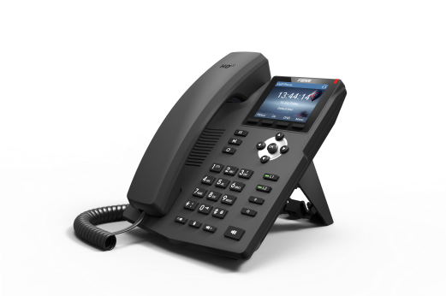

sales@fanvil.com (+86 755) 26647589
X3S/P
X3G

