


Highlights

- 2.4 inch (X3S/P)/2.8inch (X3G) color screen
- 2 Lines – Each line applied to one VoIP (SIP) service account.
- Fast / Gigabit Ethernet—10/100Mbps(X3S/P)/
10/100/1000Mbps(X3G) Ethernet with POE(X3SP/X3G) enabled
- 10/100 Mbps(X3S/P) 10/100/1000 Mbps(X3G)
- 500 contacts, 300 call logs – Each user can store separated phonebook locally up to total 500 contacts and 300 call logs.
- RJ9 headset
(EHS support for Plantronics headsets)
- HD Voice
- Compatible with major platforms: 3CX, Asterisk, Broadsoft, Elastix, Zycoo, etc.
Model | X3S
Lines | 2
Talking Mode | Handset  RJ9 headset  (EHS support for Plantronics headsets)  Hands-free (Speakerphone, Full-duplex)
Audio Quality | Toll-quality (G.711a/u)  Low-Bandwidth (G.723.1/G.726/G.729AB)  HD-Voice (G.722)
Phonebook | 500 entries
Call Logs | 300 entries  In / Out / Missed
Call Features | Caller ID  Auto-Answering  Do-not-disturb  Call Hold/Resume  Call Forward  Call Transfer  3-way Conference Call  Voice Message
Wall-mount | Yes
Color | Black
Network Interface | 10/100 Mbps(X3S/P)  10/100/1000 Mbps(X3G)  Network x1 / PC Pass-through x1
Power  Supply | Input: 5V 600mA  Output: 5V / 1A

By FANVIL®

The Entry level IP Phone designed for Business People
Fanvil Technology Co., LTD. www.fanvil.com Tel: +86-755-2640-2199
3F, Block A, Gaoxinqi Building, Anhua Industrial Park, Qianjin 1 Road,, 35th District, Bao'An, Shenzhen, 518101 P.R. China.
Fanvil X3 S/SP/G desktop IP telephone is the first IP telephone designed to provide superior user experience for office users and improve the efficiency.

设计最好的企业级入门IP电话

- The finest artwork in IP telephone industry
- Economical and intelligent product concepts
- Easy installation and configuration
- Smart and friendly user interface
- Secure and complete provisioning protocols
- Multi-language support

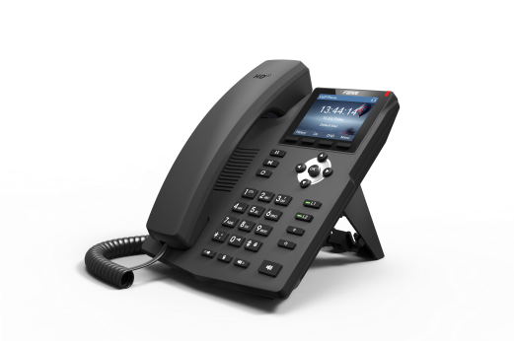
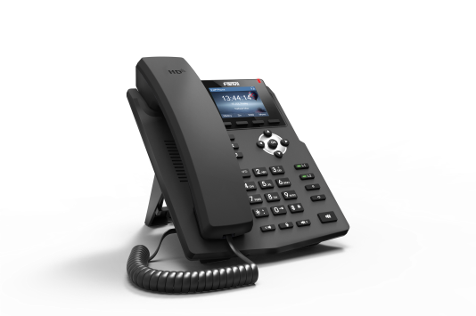

X3G
X3S/P

