
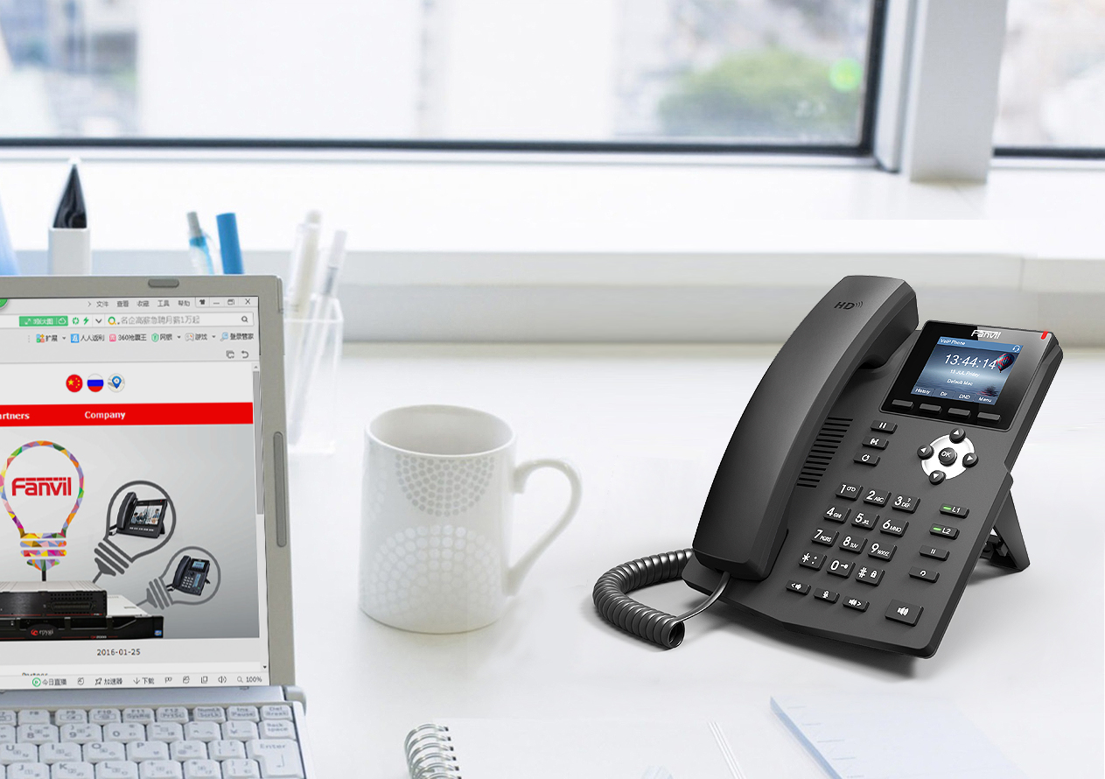

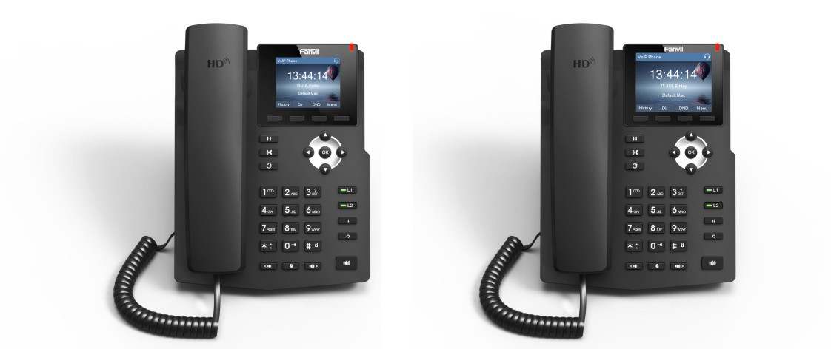

Generic
- The finest artwork in IP telephone industry
- 2.4/2.8 inch (320x240) color-screen LCD
- Easy installation and configuration
- Smart and friendly user interface
- Secure and complete provisioning protocols
- High Interoperability – Compatible with major platforms: 3CX, Broadsoft, Elastix, Asterisk, Xorcom, etc.
Fanvil’s new X3S IP Phone is an industrial masterpiece offers superior user experience and simplicity for home and office users with elegant appearance and intelligent software. X3S is positioning to be not only a telephone sitting on user’s desktop for communication, but also a nice artwork in your living room or office.
FANVIL X3S/G SOHO IP Phone
The phone designed for Internet life
Fanvil Technology Co., Ltd
HQ Add: Level 3, Block A, Gaoxinqi Building,Anhua Industrial Park, Qianjin 1 Road,
35th District, Bao’An, Shenzhen, 518101 P.R. China
Tel: 0755-2160-2199 Email: sales@fanvil.com Wed: www.fanvil.com

• 2 SIP Lines

• HD Voice
• POE Enabled(X3SP/X3G)
• Handset(HS) / Hands-free(HF) / Headphone(HP) mode (EHS support for Plantronics headsets)
• Desktop / Wall-mount installation
• Economical and Environmental friendly package
• Industrial Standard Certifications: CE/FCC

Call Features
• Call out / answer / reject
• Mute / unmute (microphone)
• Call Hold / Resume
• Call Waiting
• Intercom
• Caller ID Display
• Call Forwarding (Always/Busy/No Answer)
• Call Transfer (Attended/Unattended)
• Call Parking/Pick-up (depending on server)
• Redial
• Do-Not-Disturb (per line / per phone)
• Auto-Answering (per line)
• Voice Message (on server)
• Local 3-way Conference
• Hot Line

Phone Features
• Phone Accessibility Control by User PIN
• Intelligent Phonebook (up to 500 entries total)
• Remote Phonebook (XML/LDAP)
• Intelligent Contact Number Matching / Filtering
• Call log (300 entries total, in/out/missed)
• Voice Message Waiting Indication (VMWI)
• Network Time Synchronization
• Multi-language support in screen and web UI: English, Chinese(Traditional/Simplified), Japanese, Russian, Italian, Turkish, Germany, Dutch, Spanish, Hebrew, Polish, French etc.

Audio
• HD Voice Microphone/Speaker (Handset/Hands-free, 0~7KHz Frequency Response)
• Wideband ADC/DAC 16KHz Sampling
• Narrowband CODEC: G.711a/u, G.723.1, G.726-32K, G.729AB
• Wideband CODEC: G.722
• Full-duplex Acoustic Echo Canceller (AEC) – Hands-free Mode, 96ms tail-length
• Voice Activity Detection (VAD) / Comfort Noise Generation (CNG) / Background Noise Estimation (BNE) / Noise Reduction (NR)
• Packet Loss Concealment (PLC)
• Dynamic Adaptive Jitter Buffer up to 300ms
• DTMF: In-band, Out-of-Band – DTMF-Relay (RFC2833) / SIP INFO

Networking
• Physical: 10/100Mbps(X3S/X3SP), 10/100/1000Mbps(X3G) Ethernet, dual bridged port for PC bypass
• IP Configuration: Static / DHCP / PPPoE
The above specifications may be updated in the future without prior notice. All hardware/software/physical features should be based on the final shipped products. Customers should consult Fanvil’s retailers, distributors, or Fanvil directly, if customers have concerns on any feature.
For more information, please visit: www.fanvil.com



Fanvil Technology Co., Ltd
HQ Add: Level 3, Block A, Gaoxinqi Building,Anhua Industrial Park, Qianjin 1 Road,
35th District, Bao’An, Shenzhen, 518101 P.R. China
Tel: 0755-2160-2199 Email: sales@fanvil.com Wed: www.fanvil.com

• Network Access Control: 802.1x
• VPN: L2TP (Basic Unencrypted) / OpenVPN
• VLAN
• QoS

Protocols
• SIP2.0 over UDP/TCP/TLS
• RTP/RTCP/SRTP
• STUN
• DHCP
• PPPoE
• 802.1x
• L2TP (Basic Unencrypted)
• OpenVPN
• SNTP
• FTP/TFTP
• HTTP/HTTPS
• TR069

RFCs:
354/1321/1350/1769/1889/1890/2131/2132/2616/2617/2661/2833/2976/3261/3262/3263/3264/3265/3268/3311/
3489/3711/4346/4566/5630/5865

Deployment & Maintenance
• Auto-Provisioning via FTP/TFTP/HTTP/HTTPS/DHCP/OPT66/SIP PNP/TR069
• Web Management Portal
• Web-based Packet Dump
• Configuration Backup/Restore
• Auto/Manual Online Software Upgrade
• Syslog

Physical Specifications
• LCD x1: 2.4/2.8 inch (320x240) color-screen LCD
• Keypad: 32 keys, including
4 Soft-keys
12 Standard Phone Digits keys
5 Navigation keys
2 Line keys with tri-color LED
5 Function key
3 Volume Control keys, Up/Down/Mute(Microphone)
1 Hands-free
• HD Hands-free Speaker (0 ~ 7KHz) x1
• HD Hands-free Microphone (0 ~ 7KHz) x1
• HD Handset (RJ9) x1
• Standard RJ9 Handset Wire x1
• 1.5M CAT5 Ethernet Cable x1
• RJ9 Phone Jacket x2: Handset x1, Headphone x1
• RJ45 Ethernet Jacket x2: Network x1 (802.3AF POE Class 1 Enabled), PC x1 (Bridged to Network)
• Main Chipset: Broadcom
• DC Power Input: 5V/600mA
• Working Temperature: 0 ~ 40℃
• Working Humidity: 10 ~ 65%
• Dual-Functional Back Rack x1: Desktop Stand / Wall-mount
• Color: Black
• Package Dimensions: 275x215x62mm (W x H x L)

