Release Note

Version: R1.0.0
Model：X5S/X6
Date： 2017-10-18

1 New Features
- Add language selection for device’s 1st initialization.
- Add local recording function（Stored on USB）
- Add server recording function NOTE: Work with Fanvil server recording software
- Add the fanvil phone book search function NOTE: Work with Fanvil VoIP server software
- Add the Group Listening function
- Add the Group Ring function
- Add hiding function of password item in the configuration file NOTE: close by default
- Add the feature of DSS Key support for custom configuration
- Add the phone number hides the function to meet the call center number privacy requirements
- Change maximum number of call logs to 1000
- Add soft DSS Key function (you can configure Dss Key on soft Key)
- Add long-press OK key to reset phone NOTE: close by default
- Add conference selection in DSS key which can press once to come through the meeting
- Add custom SIP Info function
- Add RTP Keep alive function
- Add auto Headset function, improve Headset operation
- Add configuration file format of the point division method
- Support BLF list for VoipSwitch server
- Add IP Camera Auto Scan Preview function on the LAN

2 Optimization
- Optimiz the feature of standby event prompt function, add status bar system event icon display
- Optimiz the feature of LDAP query module to improve stability
- Optimiz the feature of Dss Call Park function supports subscription Call Park number status
- Optimiz the feature of SIP TLS security check function
- Optimize the feature of SIP SRV search processing function
- Optimize the feature of RTP receives the check and processing function
- Optimize the feature of sip hot spot automatic discovery function, support different group hotspots to discover connections automatically
- Remove the feature of Click to Talk UI prompt box to simplify the operationOptimized Optimize the feature of keyboard lock function, support timeout automatic upper lock
- Optimize the feature of the Default Line function is enabled by Default
- Optimize the feature of the standby clock is switched on, it is gray, only after synchronization time, it will be refreshed to normal color
- Optimize the feature of the volume value of DTMF 2833 by default to -10db
- Add the current WAN Vlan Id value to the LCD Menu network information page
- Add the Redia function configuration item to control the default behavior of RedialOptimized the feature of
- DSS increases the Memory Key subtype icon
- Optimize the feature of rule of code processing, which supports the matching of rules of the same prefix
- Optimize the feature of the * key processing behavior of the dial input state
- Optimize the feature of the handling of incoming calls in the Call Waiting state
- Optimize the feature of the Auto Provision module to add configuration items that are compatible with different server requirements
- SIP module to add the phone after the restart need to cancel the registration function, compatible with some SIP server
- Optimize the feature of UaCSTA module function to improve stability
- Optimize the feature of Video sdp direction negotiation mechanism
- Optimize the feature of SIP handles the mechanism of stun
- Optimize the feature of the principle of key handling under screen mode

3 Bug Fixes
- Fix the issue related to auto-provision failed by using HTTPS protocol on the condition that the time is not synchronized.
- Fix the issue that web page Codec items cannot save.
- Fix the issue that you preview the rtsp video, stuck in the interface after pressing "Cancel" button.
- Fix the issue related to browsers compatibility.
- Fix the issue that DND service code improper processing.
- Fix the issue that changing VLAN configuration cannot obtain an IP address with DHCP method.
- Fix the issue related to Yeastar compatibility
- Fix the option 100 parsing problem.
- Fix the issue that DeviceLog cannot be used after using https protocol to logon web.
- Fix the issue that dsskey configuration callPark function.
- Fix the issue that custom tone cannot be saved.
- Fix the data format of 3CX RTCP-XR JSON error problem.
- Fix the sip sdp Negotiation error issue if the codec format is lowercase
- Fix the issue that when it is registered with Stun method, the phone does not send a registration packet after rebooting.
- Fix the issue that importing contacts including the long-strings name
- Fix the incorrect port issue for Keep-alive message if it is registered with domain server.
- Fix the compatibility issue related to process the retry-after parameter.
- Fix the hold call issue when make a conference call with video phone
- Fix the issue that the call cannot be transferred after the pick-up with BLF/Presence method.
- Fix the compatibility issue for vpn server
- Fix the issue that SIP INFO DTMF parameter value is incorrect.
- Fix the issue that the SIP Group function does not take effect in some specific cases.
- Fix the issue related to Broadsoft.
- Fix the issue related to 3CX.
- Fix the issue that network connection drop by using L2TP method.
- Fix the issue that the system will automatically delete the "# " when the number beginning with "# ".
- Fix the issue that the phone is set to 12 hours format, it is still 24 hours format.
- Fix the issue related to DTMF RFC2833 that only sending End Event one time.
- Fix the un-registered issue on 3CX server sometimes.
- Fix the CTI issue related to 3CX phone

4 New Features Descriptions
- Add the feature of local record function（Stored on USB）
Description：Plug in the USB device on the phone, open the recording on the page application page, set the type for the local recording, set the function-keyevent-record. Set up a call, press the set recording key, start recording, press the recording button again, the end of the recording. You can view / play the recording file under the phone application-USB
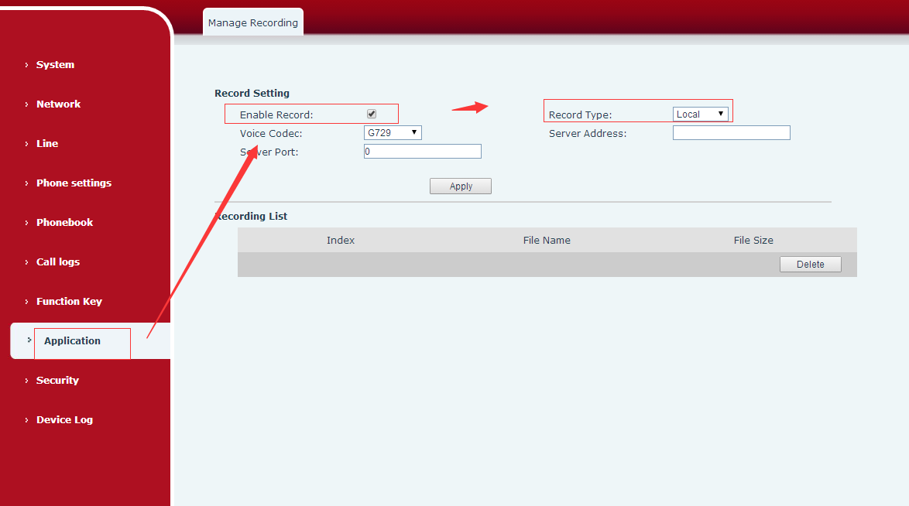
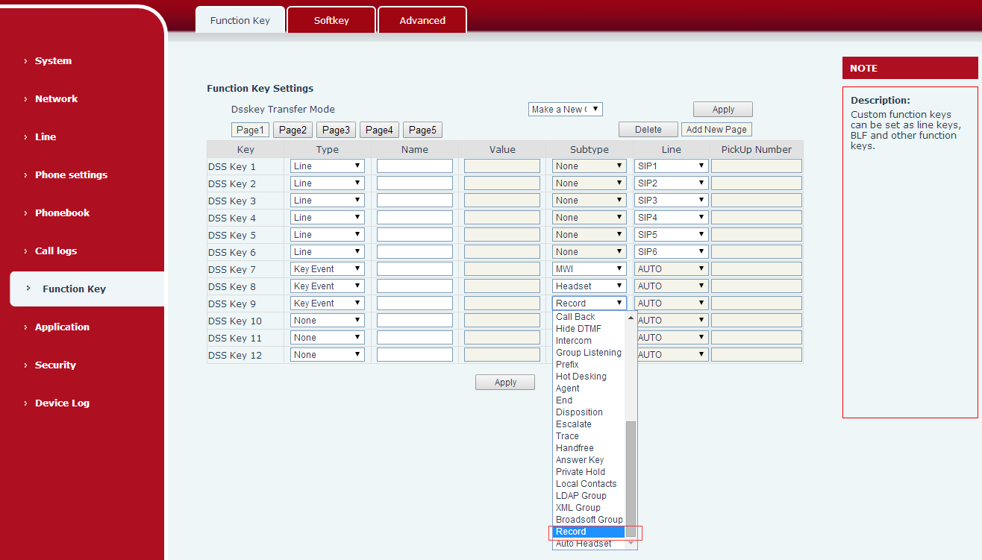
- Add the feature of server recording function（with fanvil server recording software）
Description：In the web page application page to open the recording, set the type of server recording and set the server address and port. Set the function-keyevent-record. The recording server is on (using fanvil recording software), set up a call, press the set recording key, start recording, press the recording key again to end the recording. You can see the recording file on the server side, you can download to the local playback recording files
Note: The current recording software only supports PCMA, PCMU, G722 encoding
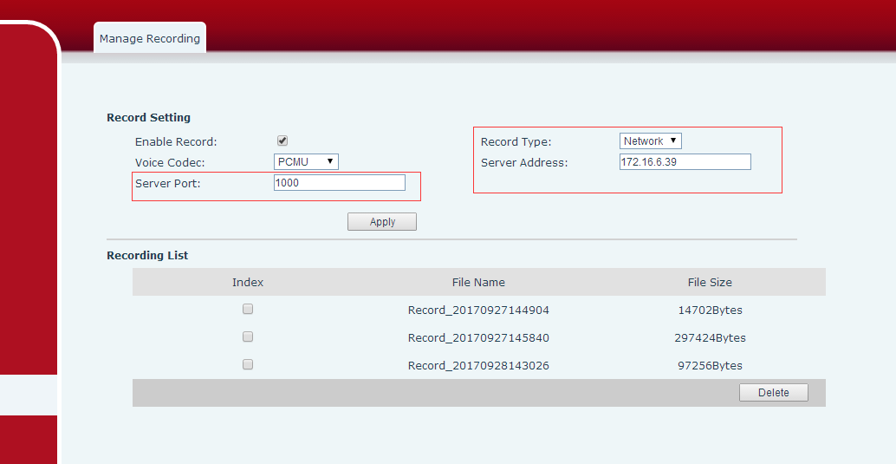
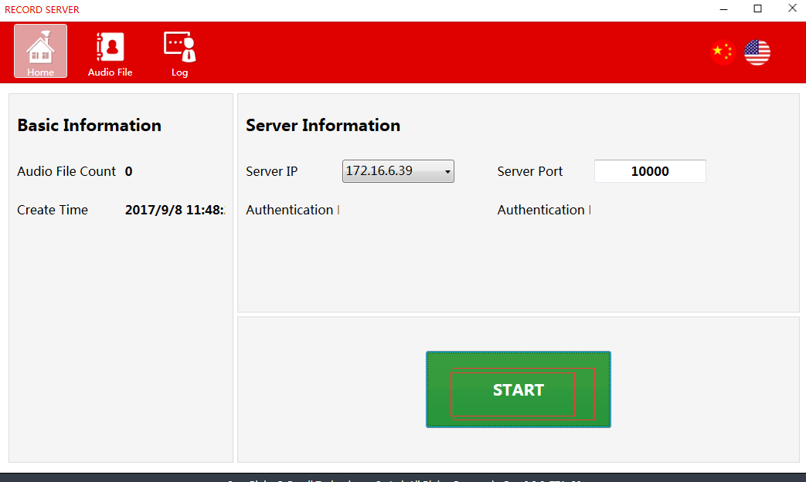
- Add the fanvil phone book search function (with fanvil voip server software)
Description：Fanvil xml cloud phone book, browse is the current level of GET xml file, the query is the current level of the xml contact; incoming call, the xml Internet phone book all the files are downloaded to the local query
- Add the Group Listening function
Description: Enter the web page function key-sofekey page, screen select talking, listen to move to the right. When the phone has a call, press the group listen key, the phone handsfree and handle / handsfree and headset can hear the other end speak at the same time.
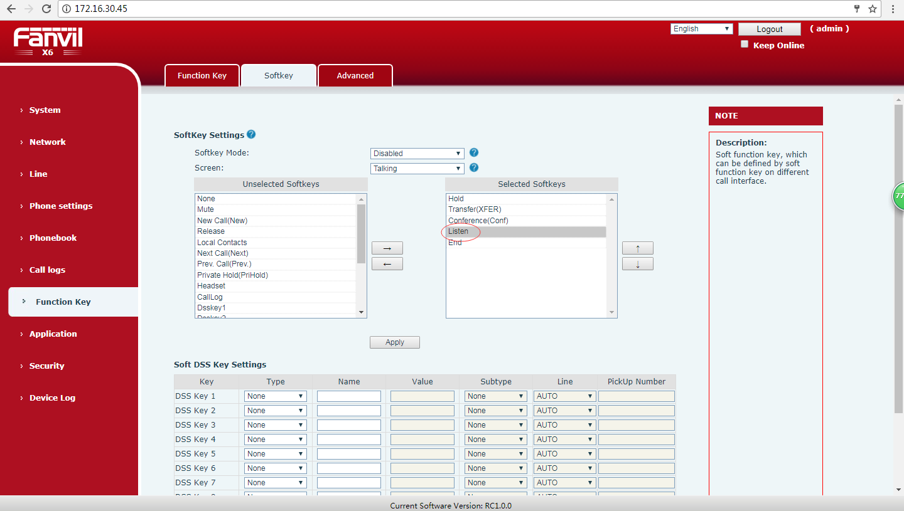
- Add the Group Ring function
Description: In the web page phone setting-features page set the ring from headset for the group ring. When the phone has a call, the handsfree and handle / handsfree and headphones can hear the ring at the same time
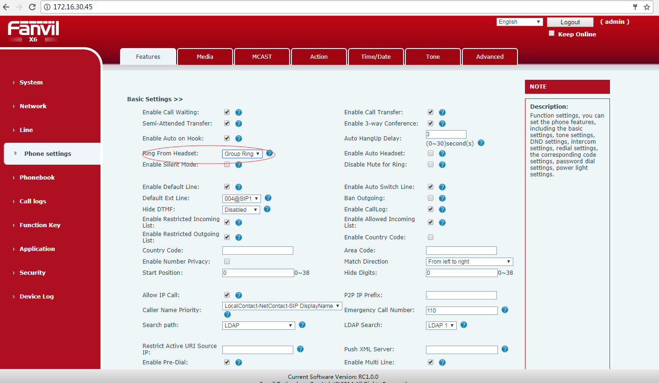
- Add the feature of configure the password item in the configuration file to increase the password hiding function. The default is closed
Description: "<PHONE FEATURE MODULE>" module to increase the configuration "Hide Password:" to control whether the password is displayed when the configuration file is exported. When 0 is displayed, the password is 1, the password is hidden.
- Add the feature of DSS Key support for custom configuration
Description:Enter the web page function key-advanced page can set the navigation key for the corresponding function
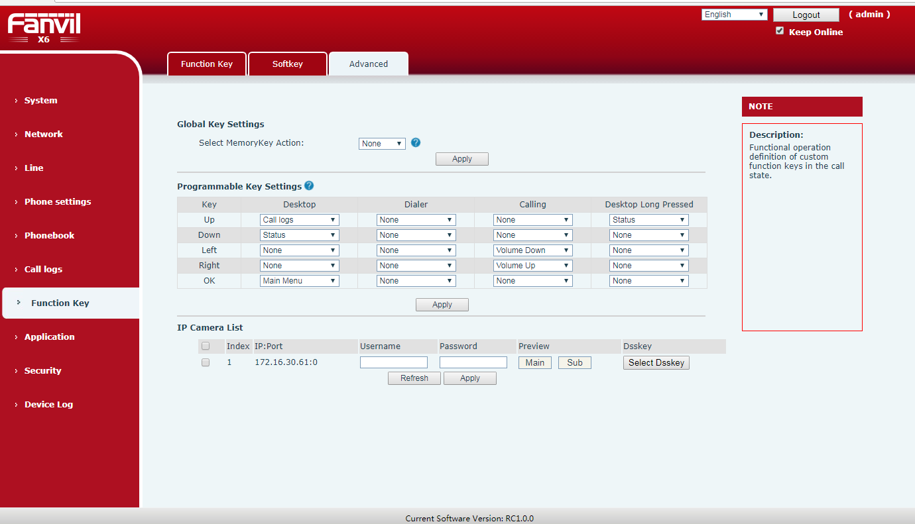
- Add the feature of the phone number hides the function to meet the call center number privacy requirements
Description: Enter the page phone settings-features page, open the number of privacy, fill in the starting position, select the starting direction, fill in the hidden number of bits. When the phone has an incoming call, the corresponding number is hidden
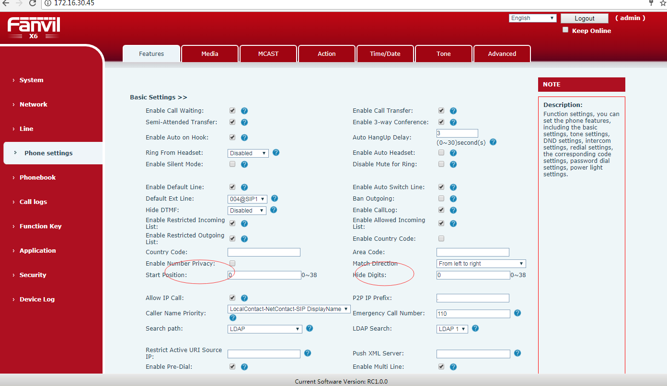
- Add the feature of soft Dss Key function (you can configure Dss Key on soft Key)
Description:Into the web page, function key-sofekey page, you can set the Soft Dss Key, set up, the corresponding Dss key moved to the right. The phone will have a corresponding sofe key display, you can do the appropriate operation
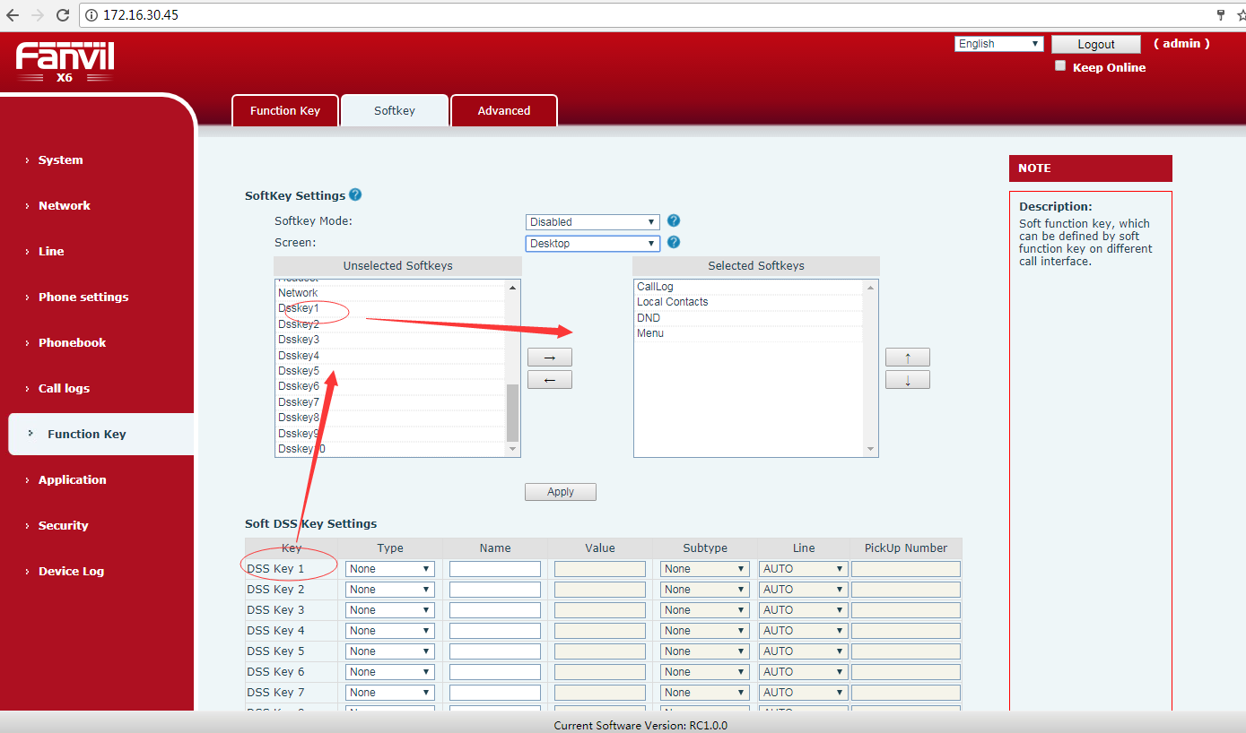
- Add the feature of the captain presses the OK key to Reset the system. Off by default
Description: Into the web page function key-Advanced page, set the desktop long pressed the key value for the reset. Standby press the corresponding key key for 6 seconds, there will be clear configuration tips page, you can choose whether to clear the configuration
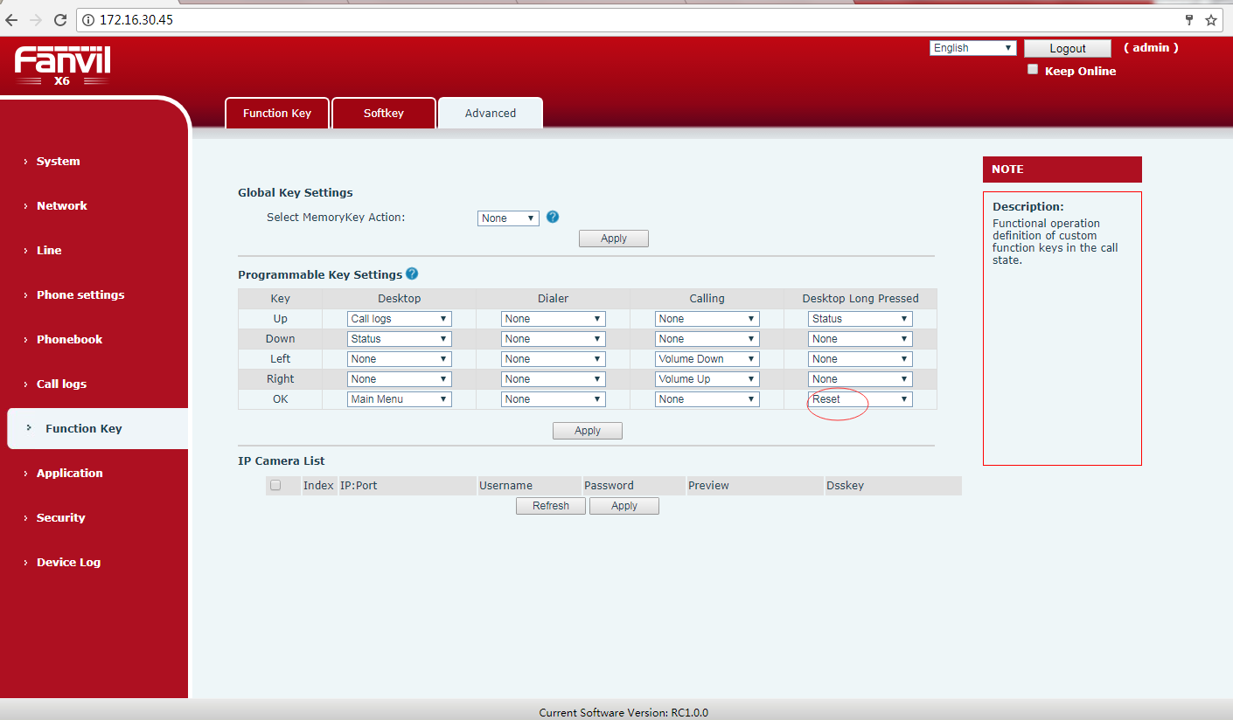
- Add the feature of Dss BLF/Conference key, one key into the meeting
Description:Phone into the web page or lcd the function key interface, set the dss key type for the memory key, subtype for the blf / conf, value is to join the number A. If the A phone and B phone has a call, then press the set dss key, will join the A, B call to, and A, B phone to establish a three-way call.
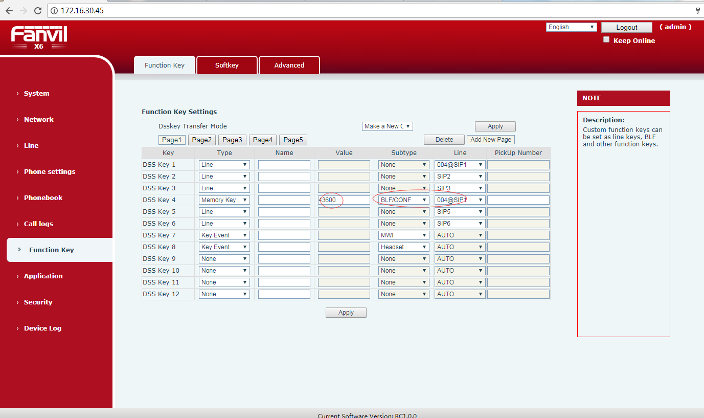
- Add the feature of custom SIP Info function
Description: Enter the web page line-sip page and set the flash mode. You can enable the local flash function, or send sip info
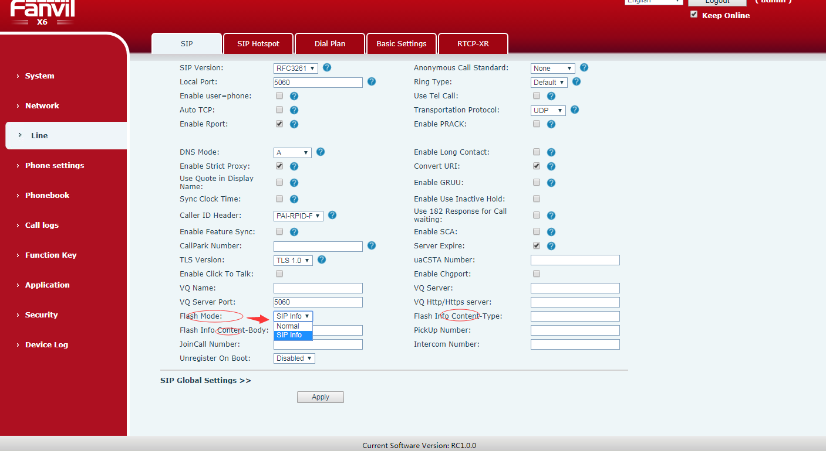
- Add the feature of RTP Keep alive function
Description: Call hold when the opportunity to send RTP from time to time to stay connected
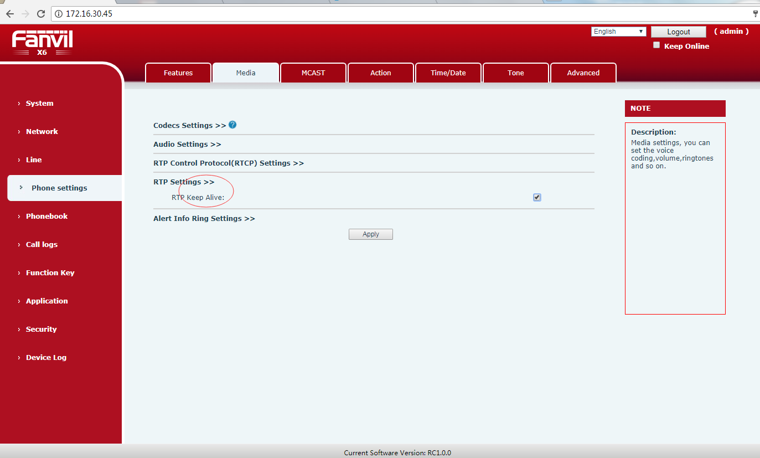
- Add the feature of auto Headset function, improve Headset operation
Description: Enter the web page function key page, set the dss key type for the key event, subtype for the auto headset. Standby can press the corresponding dss key, click to open Auto Headset, and then click to close. After opening, the LED lights
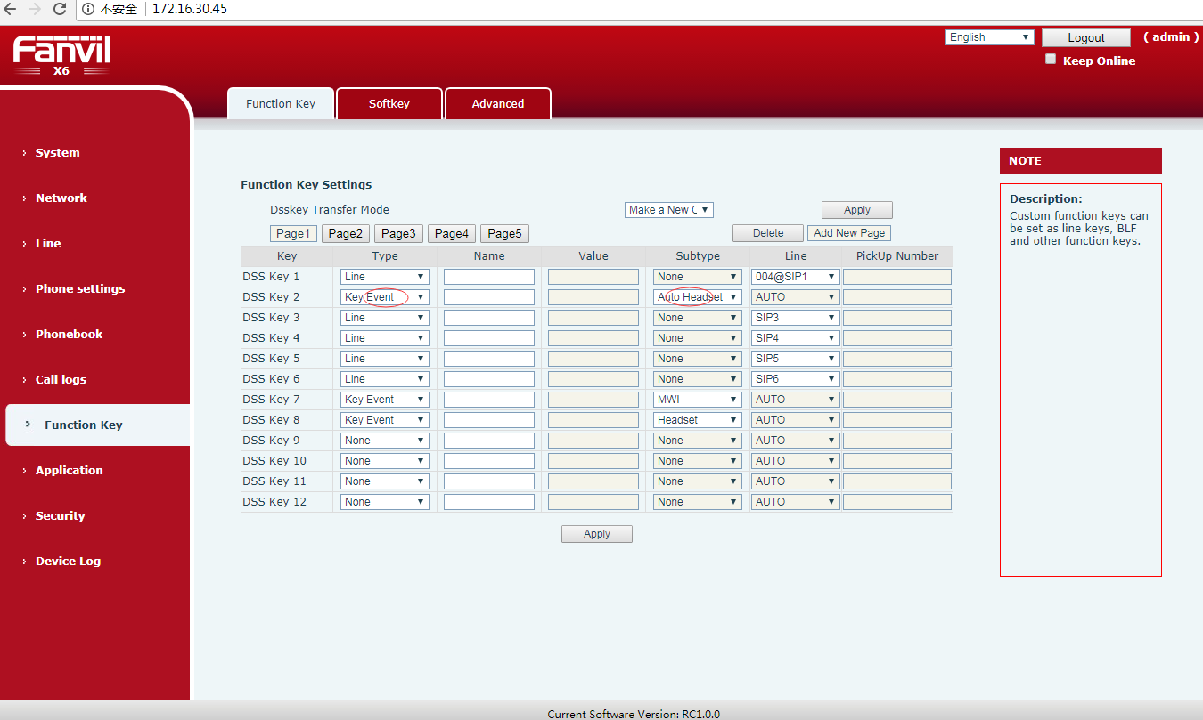
- Add the feature of the configuration file format of the point division method
Description: Enter the web page system-configurations page, You can view the nc configuration file
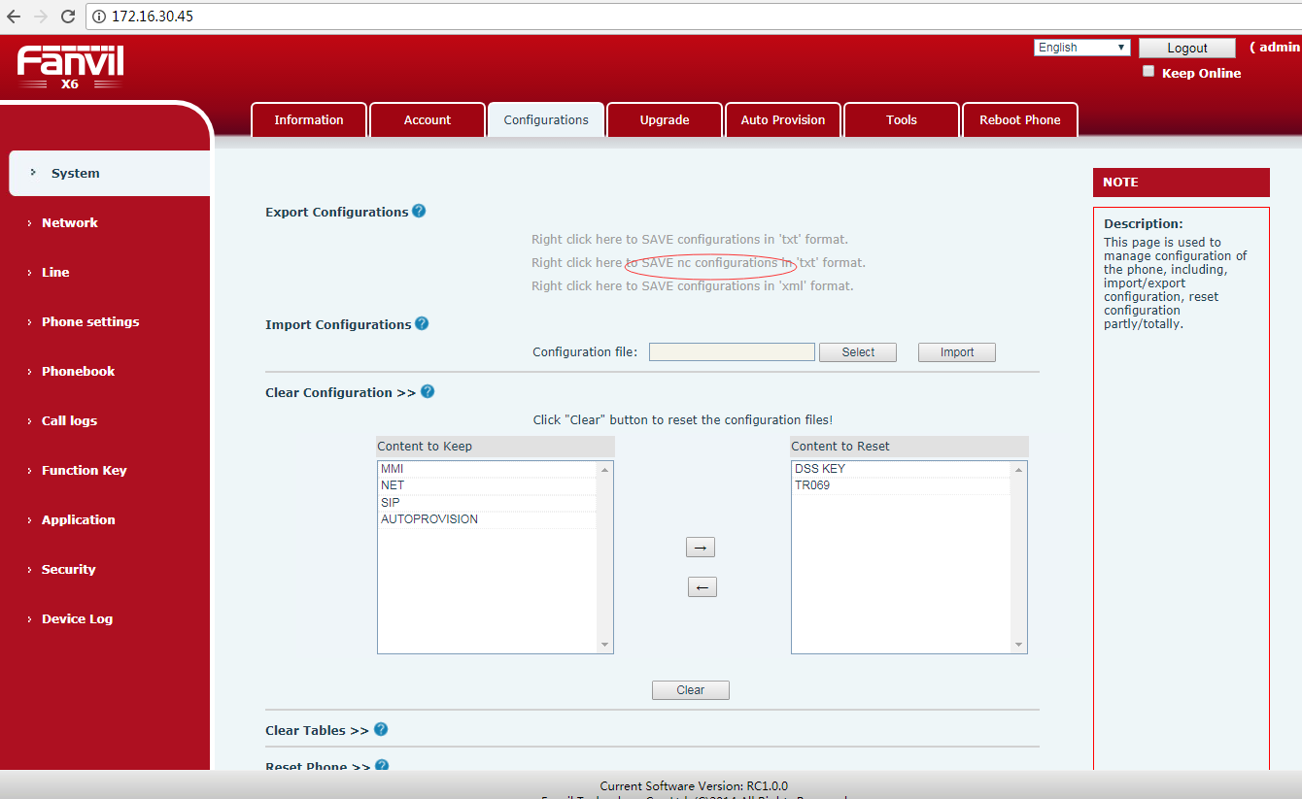
- Add the feature of BLF list function support for voipswitch server
Description: Enter the web page line-sip page register voipswitch account, open enable blfList, fill in the blf list number. When the configuration is complete, the system automatically assigns each extension to the phone key
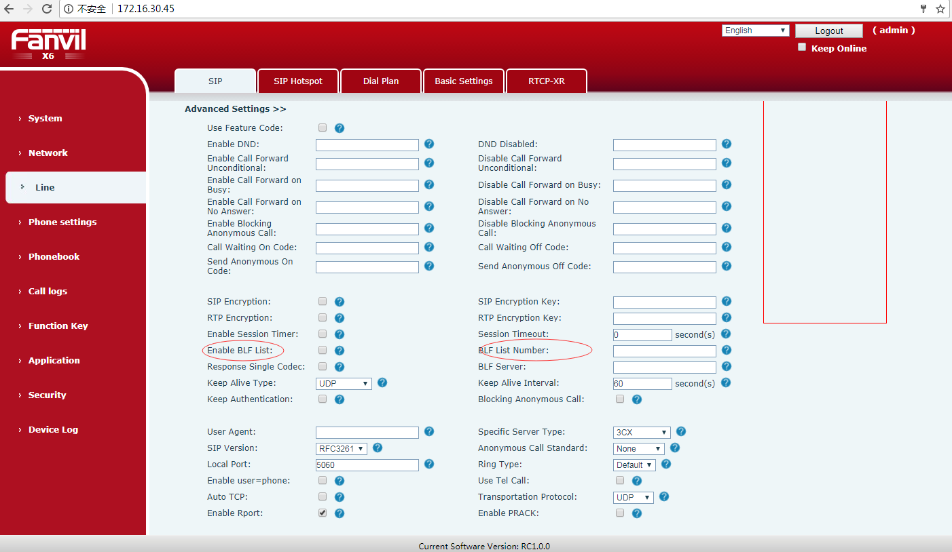
- Add the feature of IP Camera Auto Scan Preview function on the LAN
Description: Into the web page function key-advanced page, click refresh, if the same LAN has a ip camera, will be displayed in the following. You can click on the preview, view the camera screen on the page, or set the dss key, press the dss key on the phone, will display the camera
