Release Note

Software Version：1.2.4
Models：X5S/X6
Date： 2017-12-12

1 New Features
1.Add firmware online upgrade function
2.Add voice quality icon in the call
3.Add 3cx server recording function
4.Support for 3cx hotdesking function
5.Support to achieve transfer\hold\conference function through DTMF
6.Support SIP account via DHCP Option 120
7.Support DHCP Option 132 for vlan ID function
8.Add a MAC field to the sip package and close by default
9.Add Spanish
10.Support USB WiFi function（RTL8818EU chip）
11.Support expand board （EXP200）

2 Optimization
- Optimized the feature of sip timer processing
- Optimized the feature of sip displayname processing
- Optimized the feature of DSS page turning function
- Optimized the feature of date display format
- Optimized the feature of increase progress prompts when version upgrade
- Optimized the feature of improved SIP support TCP/TLS STUN functionality
7. Optimized the feature of Support to add ring road to the tripartite meeting
8. Optimized the feature of SIP circuit display
9. Optimized the feature of TR069 related information can be customized
10. Optimized the feature of the random number generation mechanism in SIP

3 Bug Fixes
- Fixed the issue that repair softkey related issues
- Fixed the issue that LDAP contact related issues
- Fixed the issue that The address of SDP was not updated after the TCP/TLS protocol was restored and stun was started
- Fixed the issue that After receiving the Invite, we receive Update again, and in some cases, we cannot cancel the call
- Fixed the issue that length of the SSL negotiation key length at 2048
- Fixed the issue that problems that cannot be saved when certain configuration parameters are upgraded
- Fixed the issue that dss key will not normally be accessible when the network phone is configured with username and password
- Fixed the issue that display name not configured for the end phone, and the length of the phone number was long enough to display the problem
- Fixed the issue that after the repair system time has been modified, there is no update Timer problem

4 New Features Descriptions

1.Add the firmware online upgrade function
Description： The automatic upgrade of firmware can be achieved through the configuration of the web page.
1.Web - system - upgrade page, fill in the available upgrade server address, and if there is a new version on the server, the page will display version information and upgrade button will become available; Click upgrade to see whether the updated version is updated.
On the website, the Lcd- advanced Settings - software version will also have the upgrade button, and the version will be updated.
2.Enable automatic escalation, fill in the update cycle, and the chance to periodically update the update.
Web page configuration:
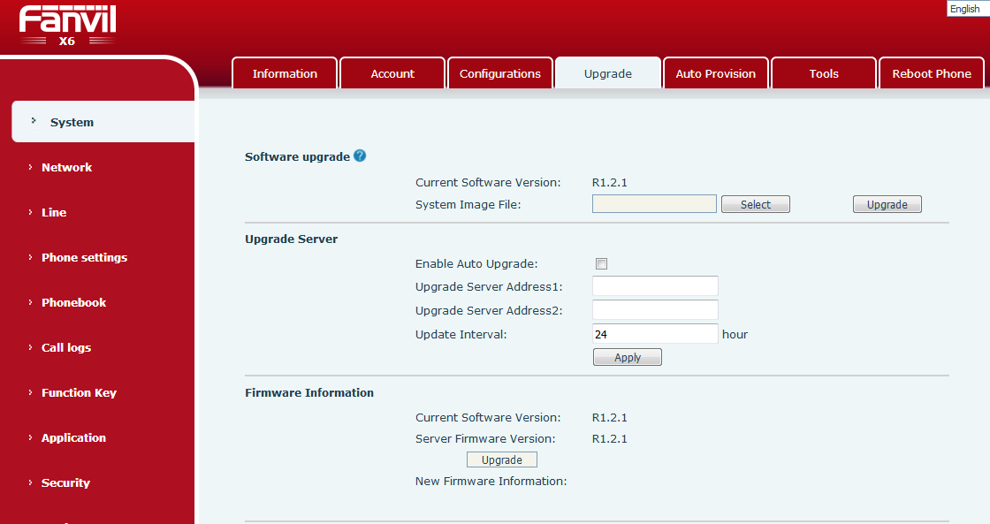
2. Add the voice quality icon in the call
Description： The voice signal quality of the two sides of the phone, the interface LCD has the corresponding icon prompt, which will be displayed according to the strength of the signal, as shown in the figure:
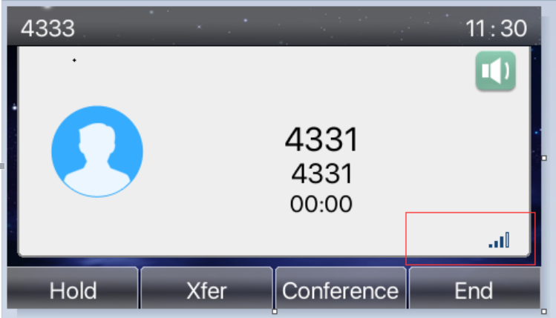
3. Add 3cx server recording function
Description： Support 3cx server recording function on call
Add new configuration items under the <RECORD CONFIG MODULE> MODULE
Type： 0:sip info
The webpage is as follows:
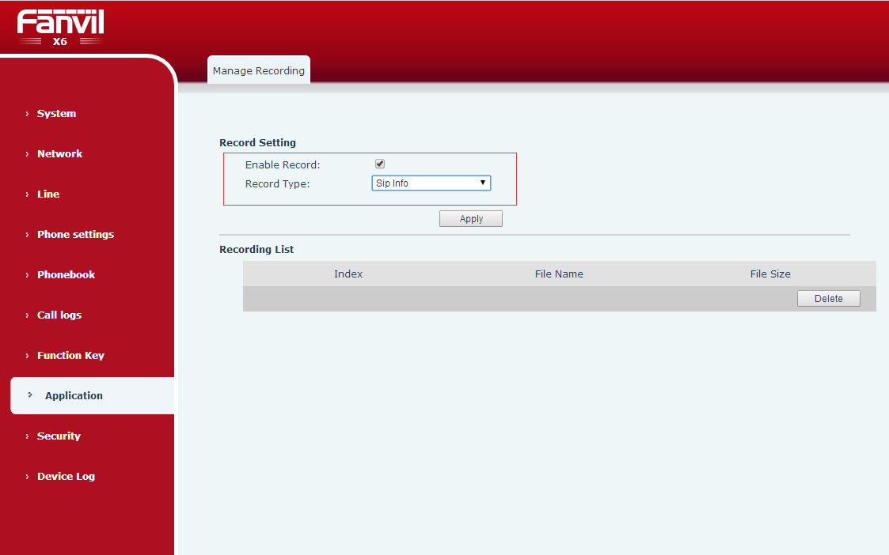
Usage:
The phone is registered with the 3CX server account, while the phone page is checked for Enable Record, and the type selects sip info
Then, the function key is set to the record key, the test phone call, press the recording key, the phone starts recording, press the recording button again, and the machine stops recording.
The recording module of the 3CX server will see the corresponding recording file
4. Support to achieve transfer\hold\conference function through DTMF
Description：By web export phone configuration file, the xfer, hold, the conf specified configurable DTMF content, call according to hold/transfer/conf, corresponding model of DTMF content directly to send a call interface remains the same, the DTMF content of hidden function keys.
Page shortcuts page, add BLF subtypes: BLF/DTMF, press this function button, and change to send DTMF on the call. When standby, SIP call BLF corresponding number.
The website configuration is as follows:
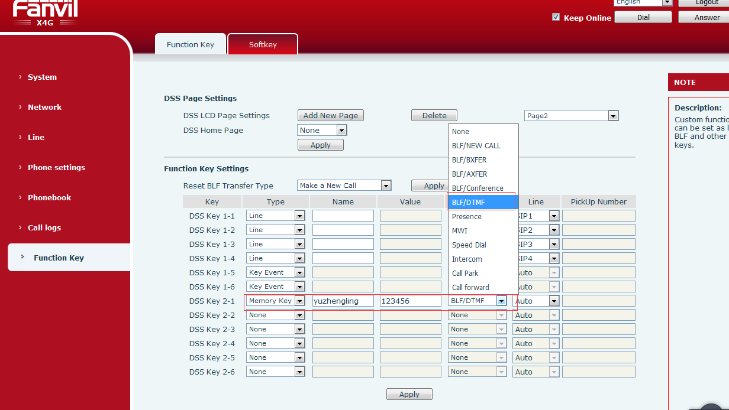
5. Support the SIP account via DHCP Option 120
Description：The registered server address of the SIP account via DHCP Option 120
The web page adds configuration items as shown in the figure below:
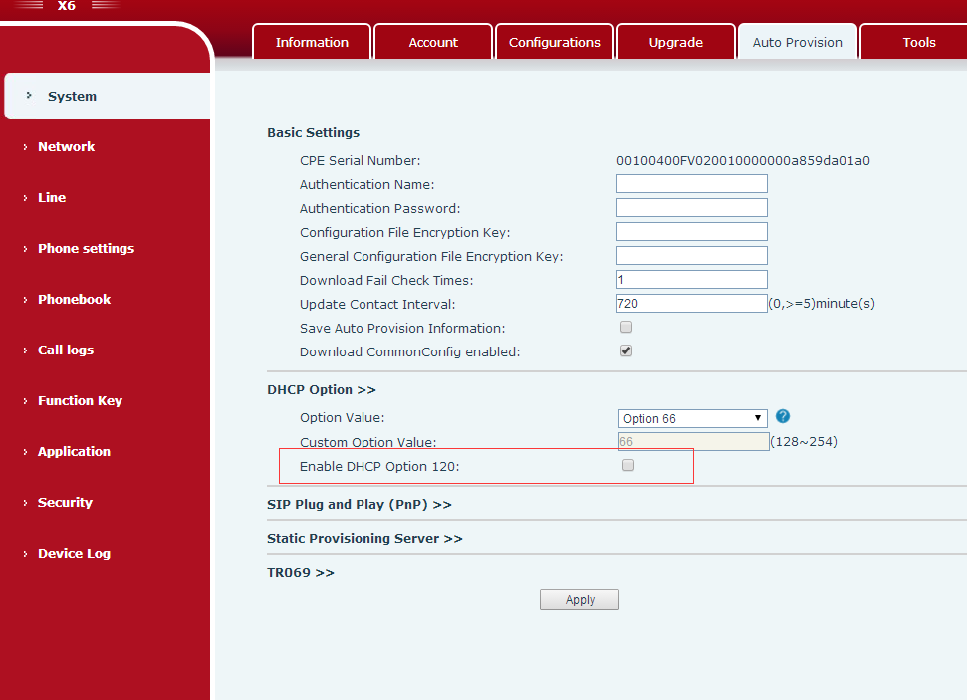
The Dhcp server configuration is shown in the figure:
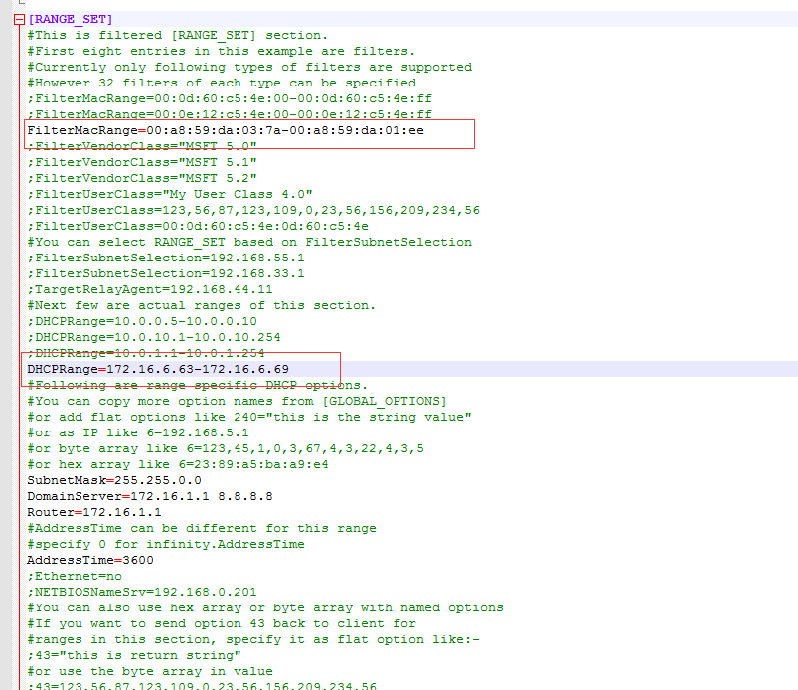
So in the MAC segment above, we're going to make sure that we're in the MAC
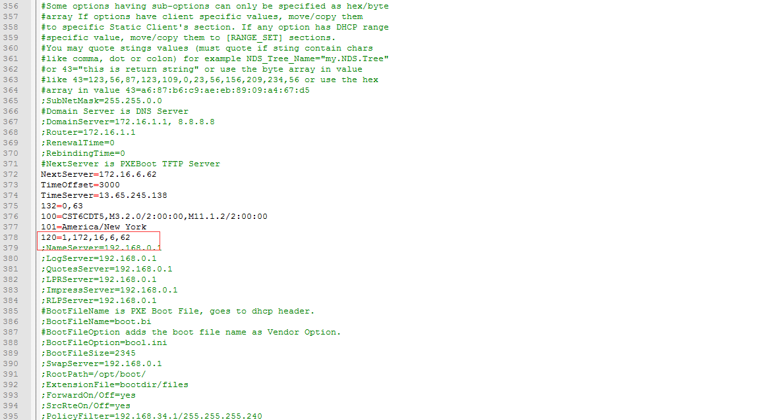
Option 120 configuration is shown in figure, where 172.16.6.62 is the server address of our server to sip server.
After the configuration is done, the server can restart the machine to restart the phone. After the restart, the server address is the address of the next address.
6. Support DHCP Option 132 for vlan ID function
Description：By means of DHCP Option 132, a vlan ID function is obtained by the phone. After the phone is switched on, the vlan ID is not taken to obtain the DHCP, and the DHCP is retrieved after obtaining the vlan ID.
DHCP option supports custom (128-254), which is vlanID, 2 bytes, and cannot be duplicated with autoprovision.
Add option 132 at the DHCP server, as shown in the figure:
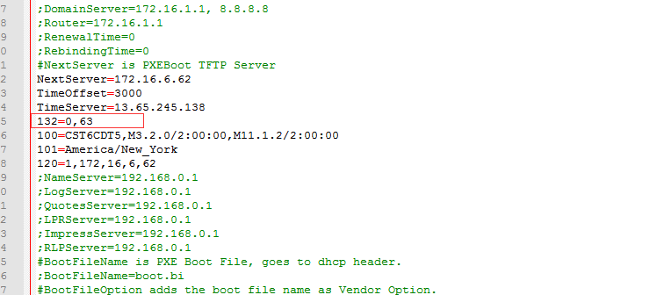
And 63 of them is vlan ID.
Web page setup:
