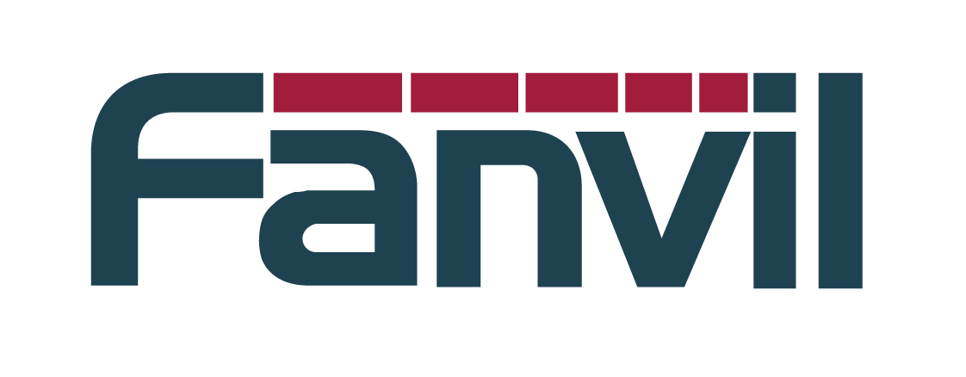
Release Note

Version：R2.2.0.3765
Model：X2、X2C、E02
Date： 2017-8-8

New Features
- Added the Ukrainian language.
- Added the feature that you can select the language after the first power on.

2 Optimization
- Optimized the feature of DHCP option 100/101 processing.
- Optimized the feature of SIP TLS Security checking.

3 Bug Fixes
- Fixed the problem of SIP Head too big caused the buff overflow.
- Fixed the problem that when the system resolved a domian to an IP end with 255 caused the network error.
- Fixed the problem that the system did not save the IP address in the Call history after an IP direct call.
- Fixed the problem that SIP found UA failed when the incoming request with short number in the To header.
- Fixed the problem that the phone can't execute auto provision correctly after received the second "check-sync;reboot=false".
- Fixed the problem of display error after the web call log sorted by date time.
- Fixed the problem that the phone did not changed the proxy settings after changed the Agent settings that cased register failed.
- Fixed the problem that action URL module can not send unmute event.
- Fixed the problem that Chinese contact name can not display correctly in call hold state.
- Fixed the problem that the phone did not update the caller name after the call had been transfered.

