Release Note

Version：14.0.0.1.r2
Models：C600/F600/C400/F400/D600/D900
Hardware：1.0/2.0
Date： 2017-12-12

1 New Features
1.Add TLS version 1.1/1.2
2.Add DHCP Option 2，DHCP Option4，DHCP Option42，DHCP Option100 and DHCP Option101
3.Add updating remote phone book regular and automatic
4.Add Korean in LCD
5.Add AutoHeadset function
6 Add video call send i frame request
7.Add video calls to parse SEI type frames

2 Optimization
1.Optimize delivery of SIP subscriptions
2.Optimize SIP TCP analytic processing
3.Optimize SIP NOTIFY Message processing
4. After upgrade, the phone goes into effect and no need to restart.
5.Optimize DSP voice and video call
6.Optimize bluetooth function
7.Optimize HTTPS authentication
8. Optimize the function of auto update dynamic encryption configuration file bring about constant reboot

3 Bug Fixes
1.Fix phone sound amplifiers not closed in some cases.
2.Fix phone not registered after reboot.
3.Fix logic error of UA lookup
4.Fix SIP TLS memory leak
5. Fix some server reply 400 and can't resend subscription package
6.Fix the problem that SIP message contains some special fields which can not be processed normally.
7.Fix the problem that when the phone registered to the public network server,
A field in the registration message is not updated after the middle of the router is restarted.
8.Fix the problem that not answer the call normally use some special server tests.
9 Fix the problem that receive the update message , Update the status is invite status, not to update cseq.
10.Fix the problem that bye message and info message has the same field values in sometimes
11.Fix the problem that registration period send registration packet, if there have any subscription, it can be send subscription package
12.Fix the problem that register some server use tls,it can not registration after reboot.
13.Fix the problem that not display the right status when establish a three-way conversation.
14.Fix the problem that main server and backup server.
15.Fix the problem that push l2 no effect under the talking.
16.Fix the problem that action plan can add same and redundant rules.
17.Fix the problem that the phone use active url to dial,the phone number is XXX, it only dial *.
18. Fix the problem that Specific domain names are unable to perform automatic deployment.
19. Fix the problem that Certain call logs delay to save in some cases.
20. Fix the problem that Call record number and the long name cannot display.
21. Fix the problem that the dial number is not encrypted when we open password prefix and extract the number to the call dialer.
22. Fix the problem that String length in ACS Server URL input box leads to incomplete address.
23. Fix the problem that we play music can hear some voice when mute.
24. Fix the problem that MWI does not have unread number hint idle screen when we starting up, Inconsistent with the status bar.
25. Fix the problem that GoogleM53 later versions of the browser cannot save capture package and log.
26.Fix the problem that Configure no answer forward on web page.
27. Fix the problem that Obtain DNS server automatically configuration item on web page cannot shown in DHCP mode.
28. Fix the problem that Logoning web page can change LCD language when the phone use special languages.
29. Fix the problem that the FTP failed occasionally to download the network phonebook in some cases.
30. Fix the problem that the first number of backup DNS is 0, which leads to mode switching invalid when switching network mode.
31.Fix the problem that we modify the VLAN tag value not take effect

4 New Features Descriptions
1. DHCP Option 2，4，42，100 and101
Description: Option 4 and Option 42 use to configure the SNTP server address,
Option 2 and Option 101 use to configure time zone; Option 100 use to configure daylight saving time.
2. Update remote phone book regular and automatic
Description: In the web page auto provision page, after auto provision,the phone book can update regular and automatic, the default is 60 minutes.
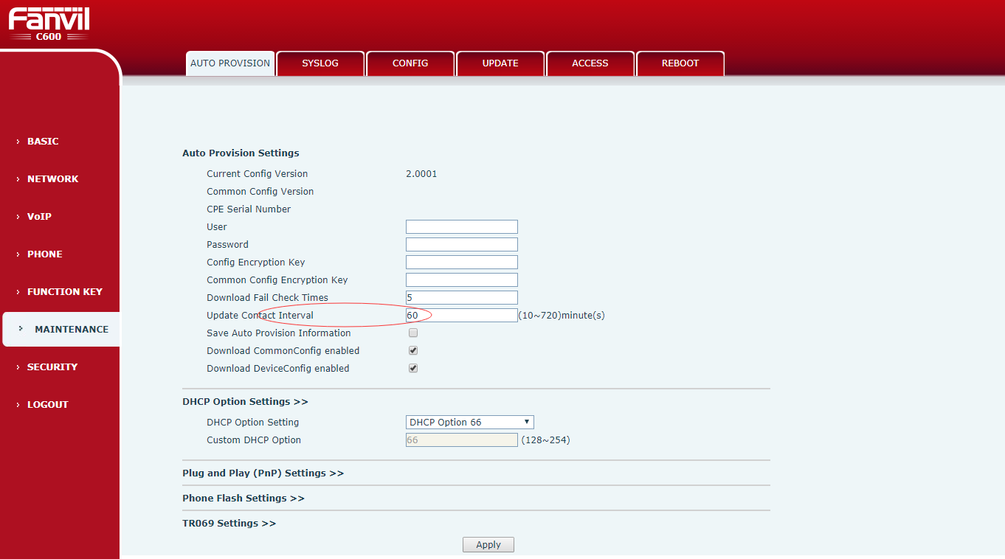
3. AutoHeadset function
Description: Enter the web page function key page, set the dss key type for the key event, subtype for the Description :auto headset. Standby can press the corresponding dss key, click to open Auto Headset, and then click to close. After opening, the LED lights.
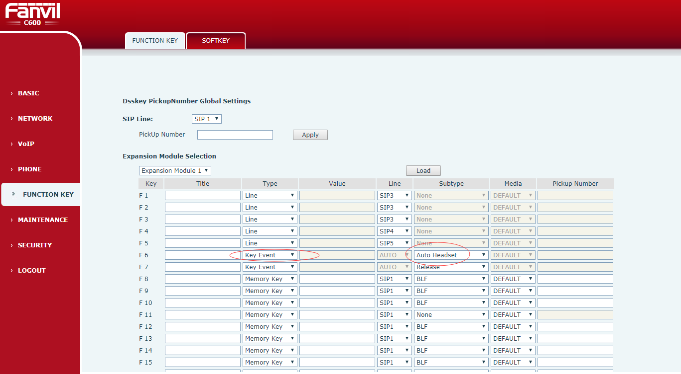
4. video call send i frame request
Description: compatible with Huawei cloud video platform, we can establish a video call with Huawei equipment.

