Fanvil Release Newly H-Series Hotel Phone

Fanvil Technology, a professional provider of IP communication solutions,today announced its new H-Series hotel telephone with anelegant appearance and friendlysoftwaresuite for the hotel market.

Shenzhen, China, November 3, 2016
The H-Series is Fanvil’s newest series of phonesdesigned for hotels. Its stylish, contemporary appearance, excellent voice quality and powerful functionality, along with matching integrated communications platforms can replace traditional phones and can become a new generation of intelligent terminal equipment.The H-Series hotel IP phone will look great in most hotel rooms andwill support most application requirements.In addition, it has excellent call quality.

Fanvil has three H-Series models: The H2, H3 and H5.The H2 is specially designed for hotelbathrooms, business halls or other service-related locations.It is easy to operate and is wall-mountable. The H3 & H5 are designed for the hotel room. The H5 is the high-end versionof the H3 and has a 3.5’ color display screen, which could provide a great customized experience for the hotel user.

The H3 & H5 accomplished powerful telephony features by combining the communications platform and features such as call transfer, hotline,voice mail, call hold and more. The H3 & H5 IP phones support 6 programmable keys.They can be defined according to the hotel's needs.For example, they could be programmed with an equipment service hotline (housekeeping, ticketing, switchboard, food and beverage, etc.) or hotel special features (alarm clock, voice mail, etc.).In addition, it has a USB port to charge your mobile phone.

Availability
H2/H3/H5 now is in batch production and can make a reservation via Fanvil’s worldwide distribution channels.

ABOUT FANVIL
Fanvil is an established VoIP Desktop Phone developer and manufacturer from China that has grown into one of the Largest and most popularized used VoIP phone around the world.Recognizing the global demand for VoIP based telecommunication solutions and devices for small and medium sized business, as well as large mission-critical enterprise environments. Fanvil is set to become a leading IP voice and video terminal manufacturer by providing the market with cost efficient and innovative IP voice and video products. Fanvil VoIP devices are always taking the advantage of clear sound quality, rich functionality, excellent quality, perfect service and competitive prices.
Contacts:
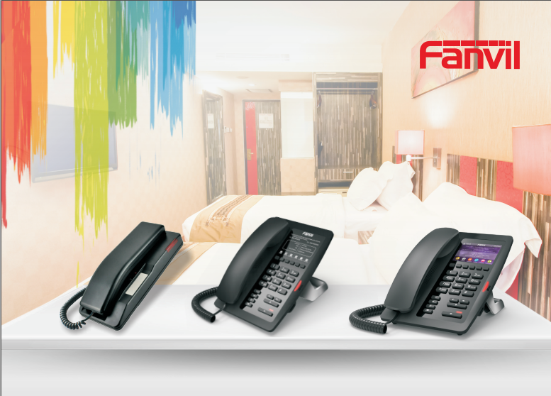
sales@fanvil.com(+86 755) 26647589

