

Fanvil vDroidPhone User Manual

Table of Contents
Welcome 4
summarize 4
Phone features 4
Basic operation 5
Download and install 5
instructions 6
1. Phone functions 6
1.1. Call 6
1.1.1. Dial call 6
1.1.2. Redial 6
1.1.3. Release from the contacts 7
1.1.4. Release from the phone records 8
1.2. Call incoming 8
1.2.1. Answering and reject 9
1.2.2. Forward 9
1.3.Talking 10
1.3.1. Talking 10
1.3.2. Blind transfer 11
1.3.3. Attend to transfer 12
1.3.4. Calls to keep 13
2. Contacts 14
2.1. Local contact 15
2.1.1. The contact list 15
2.1.2. Look at the contact 15
2.1.3. Contacts search 16
2.1.4. Add contact 17
2.1.5. Delete Contact 18
2.2. Group 19
2.2.1. Add group 19
2.2.2. Delete and edit group 20
2.3. Network Phonebook 20
2.3.1. Add the XML remote phonebook 21
2.3.2. Add the LDAP phonebook 21
2.4. Access control device 22
2.4.1. Access control device editor 23
2.4.2. A key to open the door 23
3. Call Log 24
3.1. Call Log 25
3.2. Call log details 25
3.3. Delete call log 26
4. Favorite 26
4.1. Favorite 27
4.1.1. Add and edit favorites 27
4.1.2. Delete favorites 27
4.2. MWI 28
4.2.1. Listen to the MWI 29
5. Settings 29
5.1. Introduction of hotspot 29
5.1.1. Scanning Qr code, connect to the hotspots 30
5.1.2. Manually add, connected to the hotspots 30
5.1.3. Filter connected to the hotspots 31
5.1.4. Disconnect 32
5.2. Account Settings 33
5.3. Feature Settings 36
5.4. Media Settings 36
5.5. Blocklist Settings 37
5.6. Advanced 38
5.6.1. Network 38
5.6.2. System Debug 39
5.6.3. Back-up 40
5.6.4. Configuration Guide 40
5.6.5. Restore Config 41
6. About 41
6.1. Company profile 41
6.2. Help 42
6.3. Check for update 42
7. Exit 42

Welcome

Summarize
Fanvil vDroidPhone is a free SIP soft phone and is suitable for the android version 4.2 and above. Fanvil features SIP hotspots can synchronize information with a desktop phone. Support both voice and video calls, LDAP enterprise-level contacts, BLF subscription feature, that make vDroidPhone have Ordinary telephone business at the same time, more professional SIP features, more suitable for business use.
Phone features
- support SIP 2.0 (RFC3261) and the related protocol
- support 2 SIP account, can set up multiple calls (unlimited), support forward, blind transfer, Attend to transfer
- support SIP hot spots, as the client side, and fanvil phone server side implementation information synchronization
- support caller id, voice mail and state of BLF subscription
- LDAP enterprise update the phone book to make the enterprise address book management more convenient
- suitable for the android 4.2 and above system, and the most perfect compatible android devices

Basic operation

Download and install
Download the way
- Scan qr code to download, you can use the browser, such as QQ scan
- Fanvil website to download
- The Chinese users can be downloaded in the android market, application treasure to search
Installation steps：
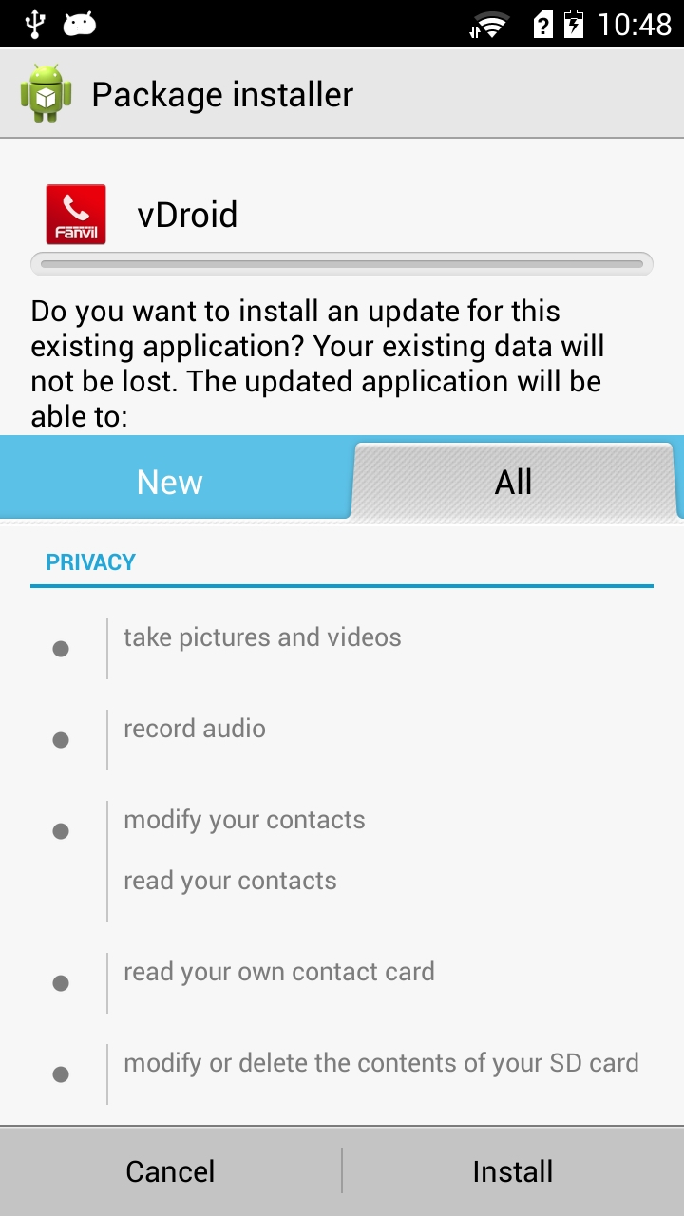
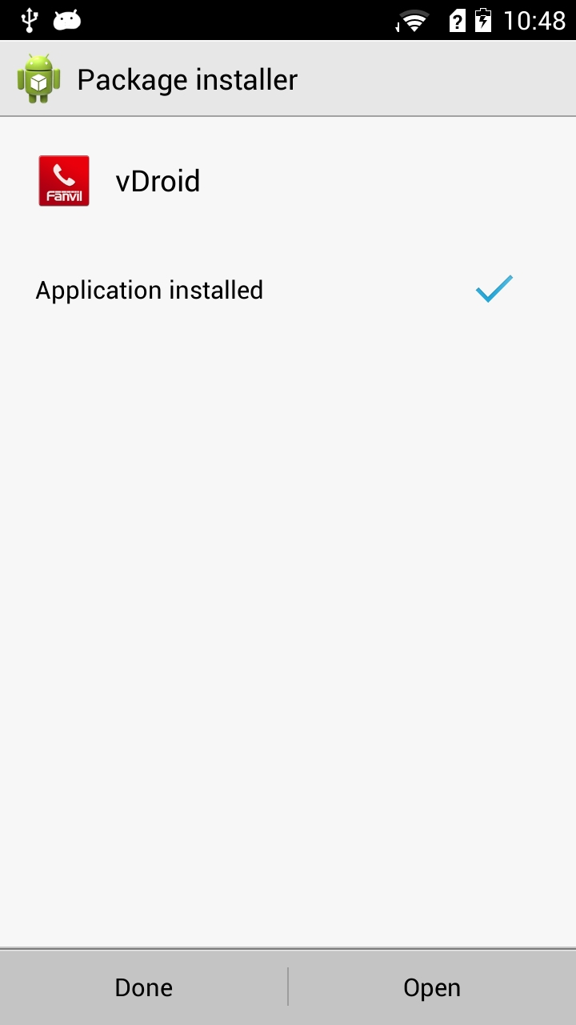
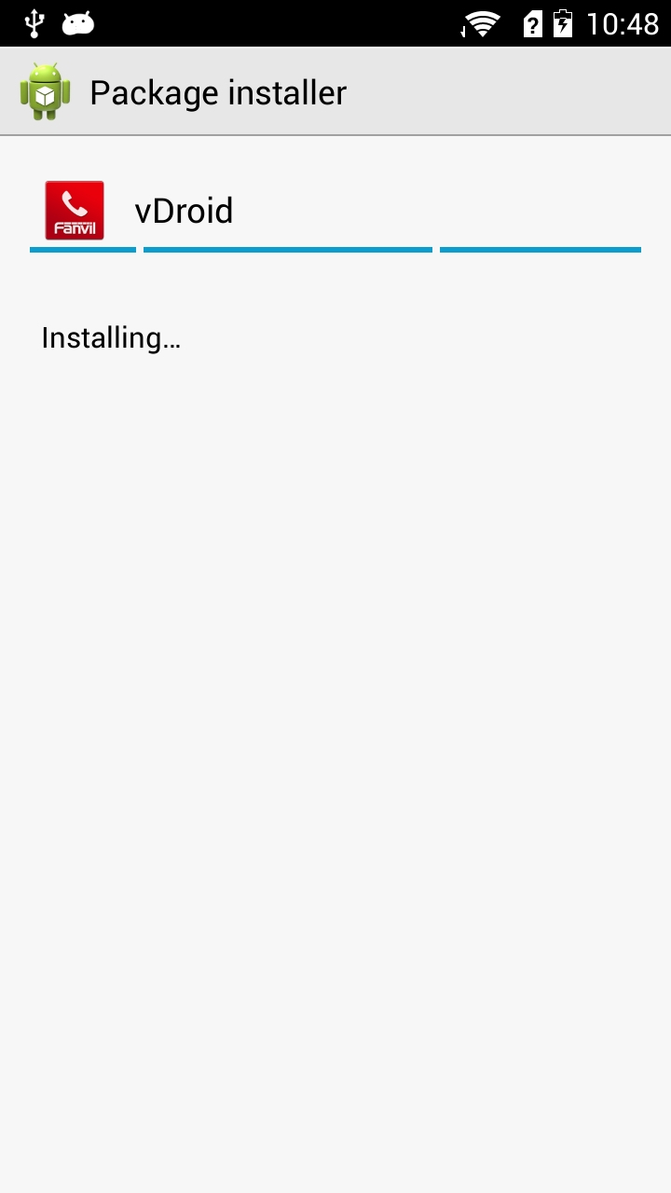
Step 1:check the privacy related permissions, click install after confirmation.
Step 2:installation

Step 3:the installation is complete. Click open to enable the software, enter the main interface.

Instructions for use

1.The phone features

1.1 Call
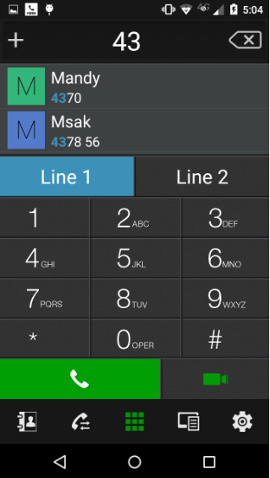
    - Call dial pad
Number index area, click to extract the full number dial pad

Step 1: Go to the dial pad.
Step 2: Enter the number to be dialed.
Step 3: Select the line.
Step 4: Select the outgoing voice or video.

Choose the call line, line unregistered cannot be selected

Choose a video or voice call, click the outgoing

    - Redial
Click on the dial pad voice or video button, one can extract the number to recall to the dial pad, and then select the outgoing mode to make a call.

    - Release from the contacts
Step 1: enter the contact page
Step 2: choose android contacts or VDROID contacts.
Note: android contact was read original android device contacts, can also be used for network call. VDROID Contact: contacts added from vDroidphone.
Step 3: select contacts, click details into the interface
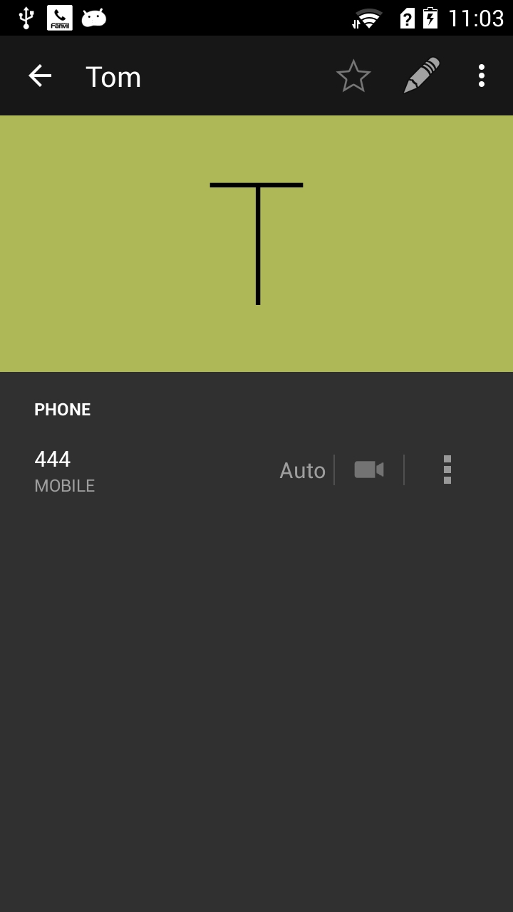
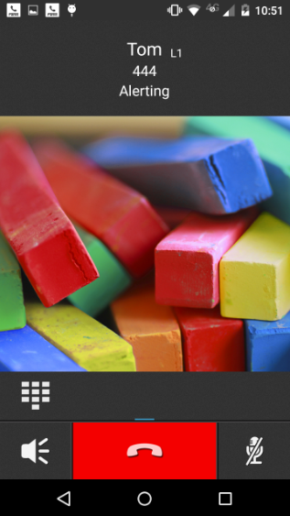
Step 4: click on the entry for voice calls, or click the video button for video calls.
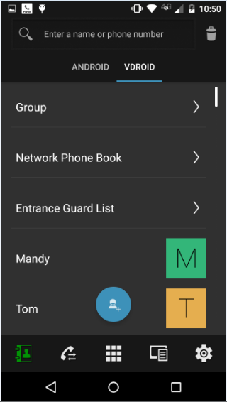
Step 1: enter the contact list, click on the contact Tom, into the detailed list
Step 2: Click the contact using the default outgoing voice line, click on the video icon, the video mode exhaled

Step 3：alerting

步骤1：查看隐私等相关权限，确认后点击安装。
步骤1：查看隐私等相关权限，确认后点击安装。
步骤1：查看隐私等相关权限，确认后点击安装。
    - Outgoing from call log
Outgoing call from the call log will use the last line calls and patterns (voice or video)
Step 1: Go to the call log page
Step 2: Click an outgoing call records
Step 3: Click on the right side of the clock marks recorded into the details page, click the outgoing call 444
Step 4: In the detail screen, click on the icon in the upper right corner for more, choose Edit
exhaled before the number to retrieve the dial pad to exhale.
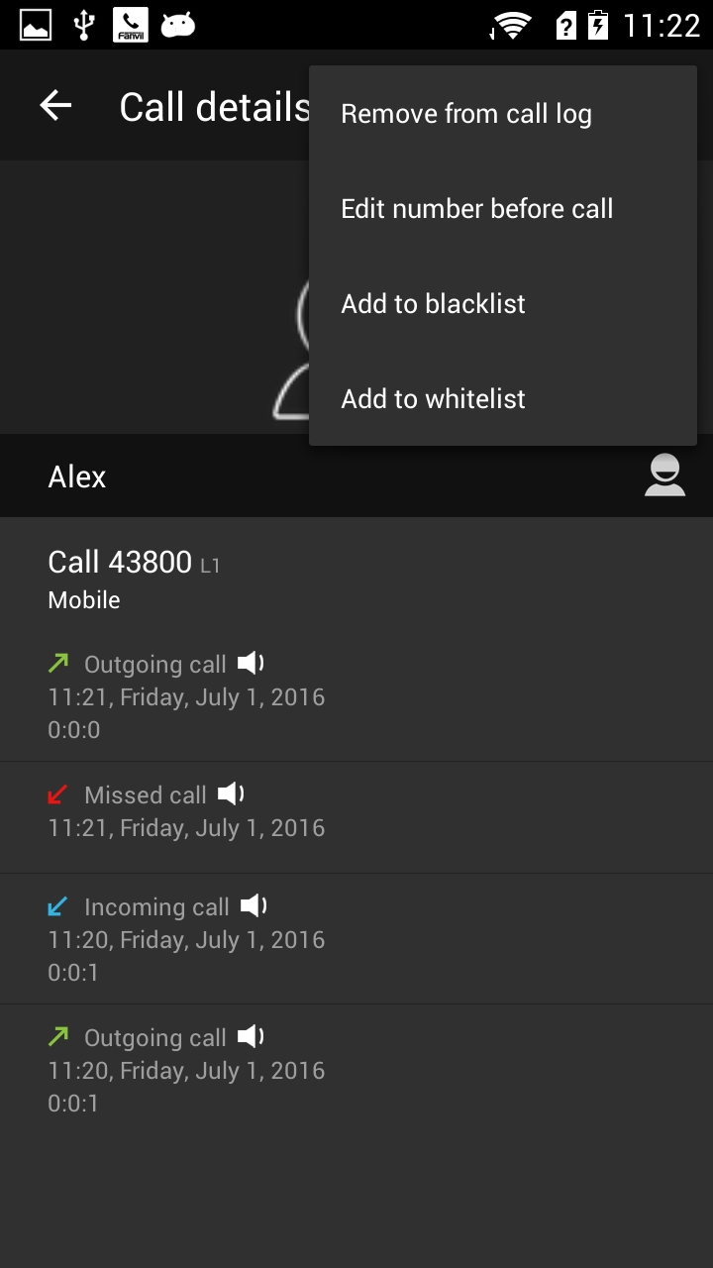
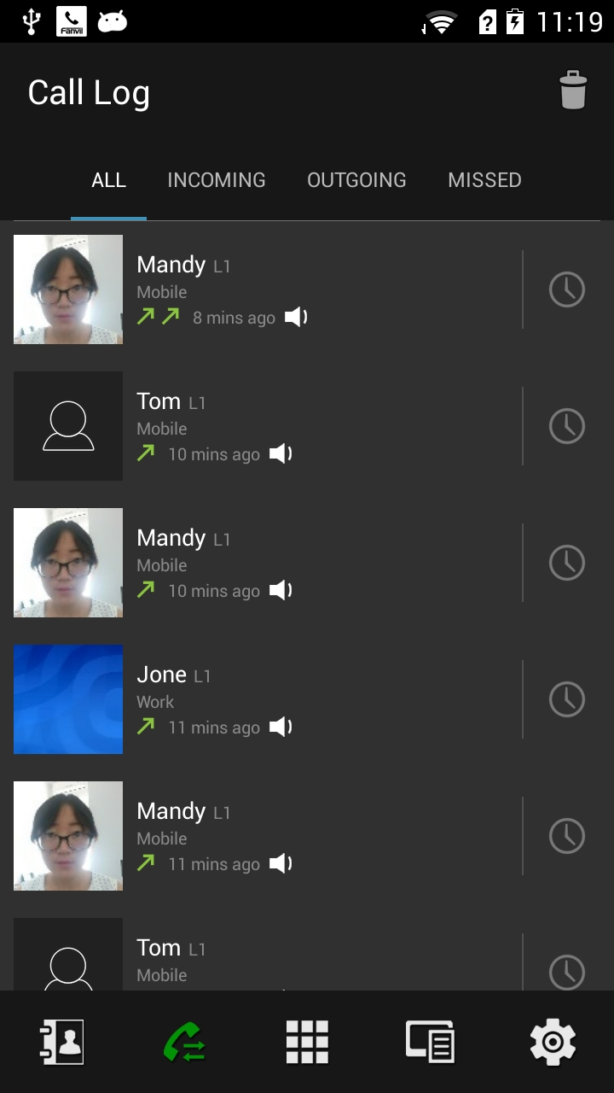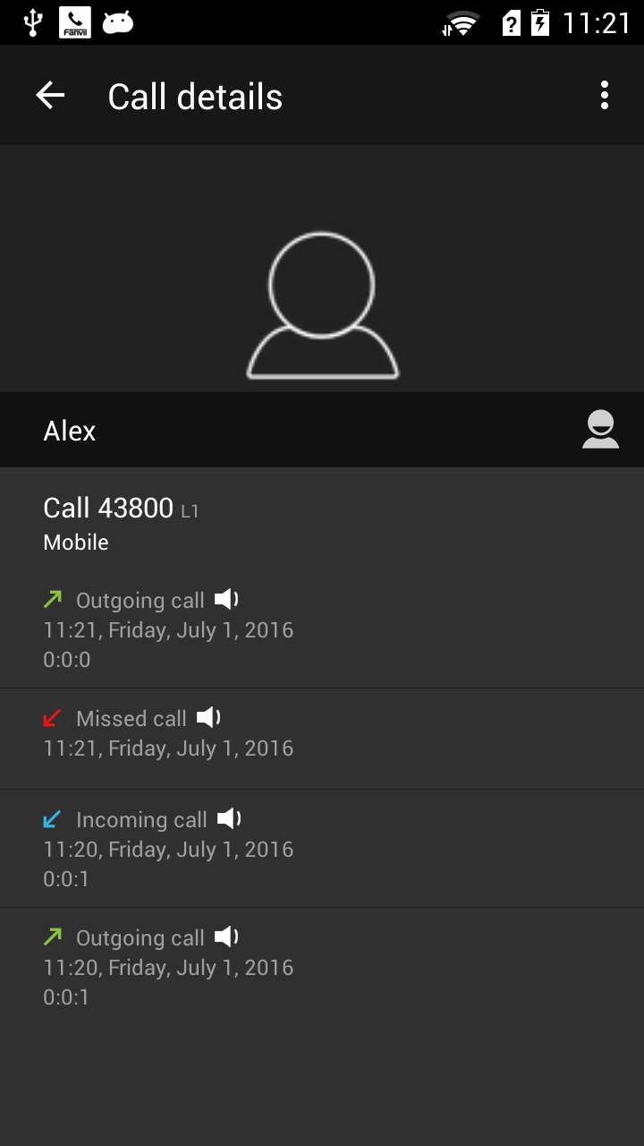
Call directly
detail
more
Call directly
The number dial pad to extract, edit, or call

Step 1:Enter the call log page, click on a record and call out. You can enter the detail page when you click the clock symbol.
Step 2: Click on Call number and call out. Click more options.
Step 3: choose edit number before call, you can put the number in the dial plate,then you can edit and call out.

Incoming
    - Answer and reject
Video call can choose video or voice answer; a voice call can only receive video.0
Step 1: Swipe to the right to select a voice answered, slide up to select a video to answer.
Step 2: Select the slide reject.
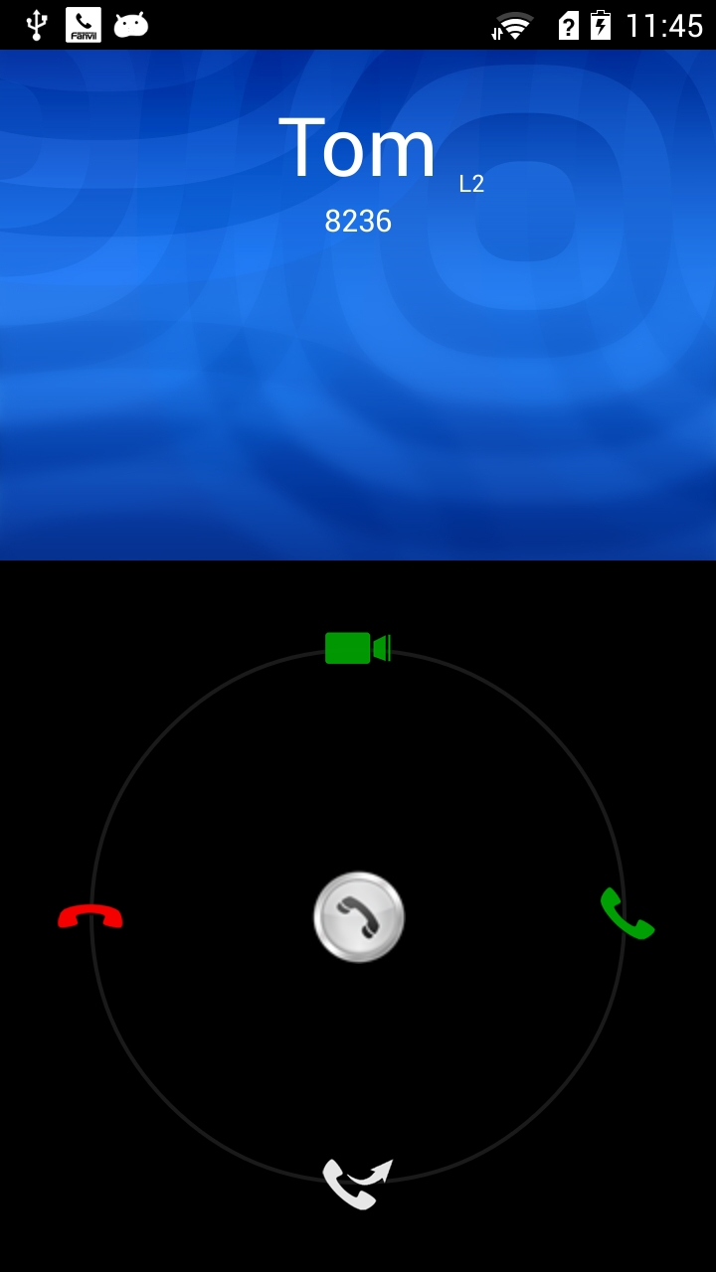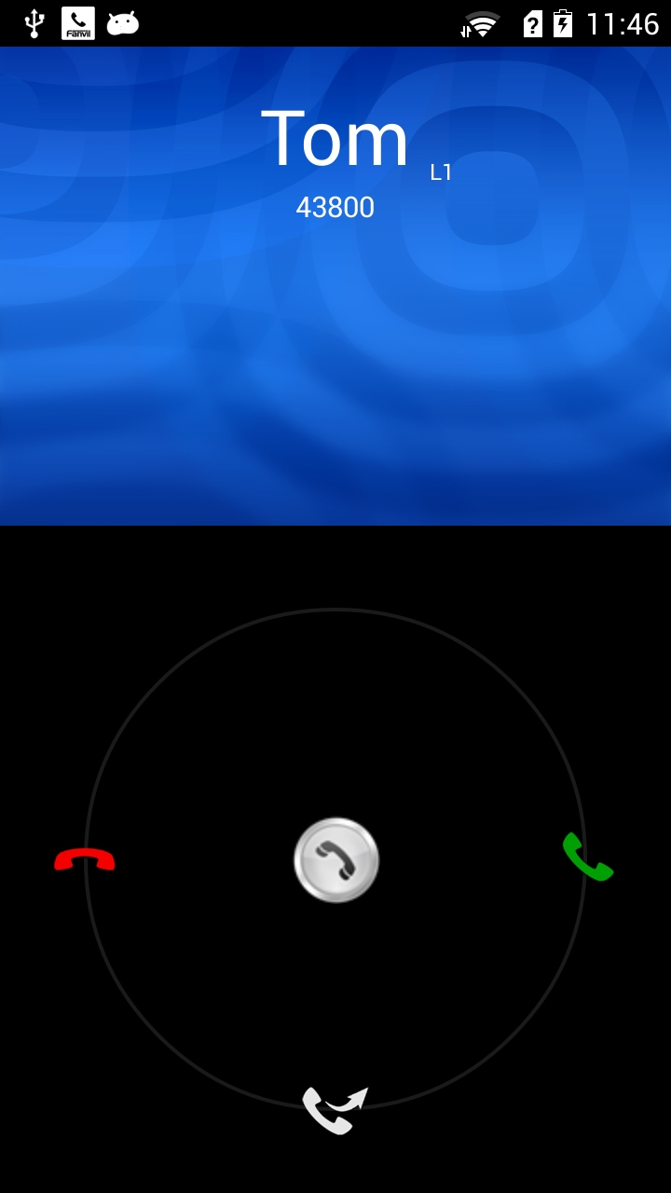
Video answer
Reject
line
Number and Name
Voice answer
Voice answer
Reject
Video call: can video answer and voice answer.
Voice call:only voice answer

1.2.2 Forward
Transfer the contact list of dial, it will only display binding line and transfer to line the same, or binding auto line contacts.
For example, the current line to be transferred is line 1, the contact list only shows the binding line 1 and auto line, binding line 2 contacts will not be displayed, in order to find the number more convenient.

Step 1: slide down into the shift dial.

Step 2: Manually enter the extension number to be transferred to the index area will display the results of the index.

Step 3: Click the contact button or enter the contact list. Click on one, the number back to dial.

Step 4: Press the Forward button to transfer, the call log will display missed calls after the completion of the transfer. Or press Cancel to return a call interface.

Input the number you want to transfer

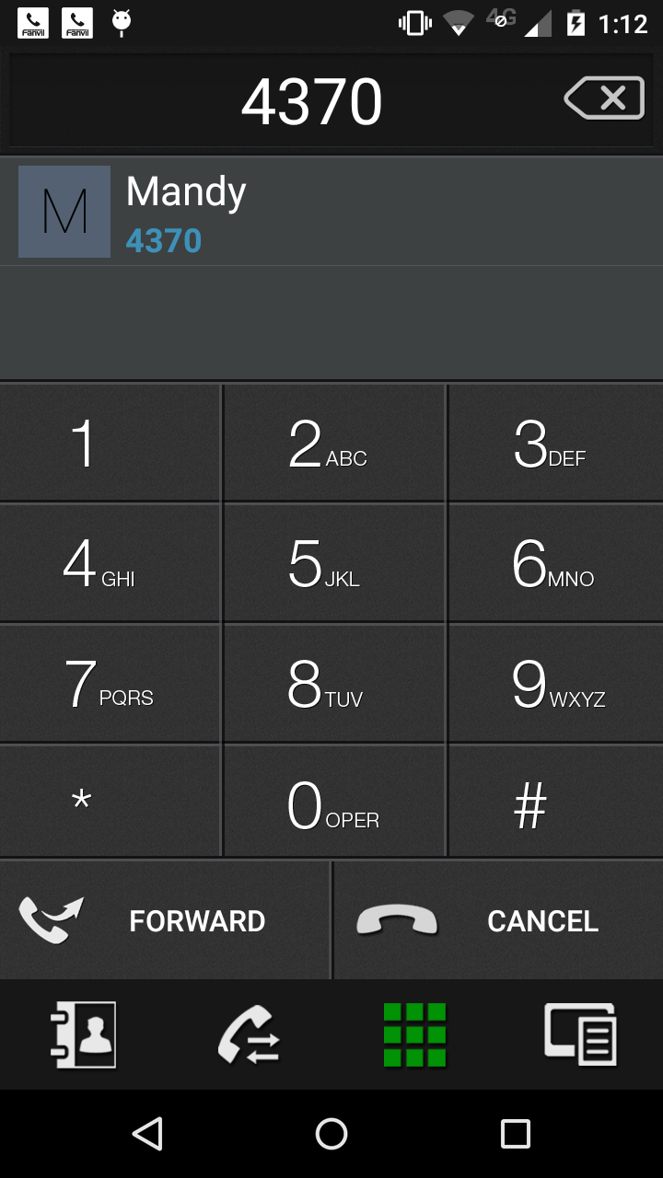
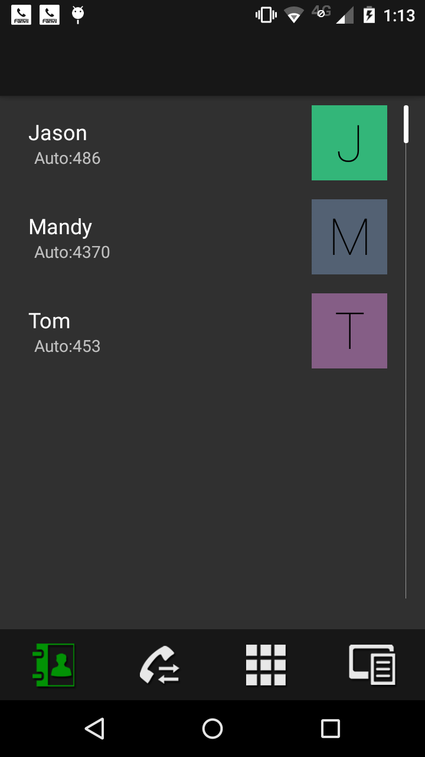
forward

Step 1:slide down into the shift dial.

Step 2:Manually enter the extension number to be transferred to the index area will display the results of the index.

index area

Choose tel number from contacts

Click on one of contacts and the number will appear in keyboard.

Switch back to the transfer interface

forward
return to the call

Step 3:Click the contact button or enter the contact list. Click on one, the number back to dial.

Step 4:Press the Forward button to transfer, the call log will display missed calls after the completion of the transfer. Or press Cancel to return a call interface.

  - call
    - call
Function of each button on the call interface is in the following figure.
Multi-channel call, you can slide the screen left and right to switch a call.

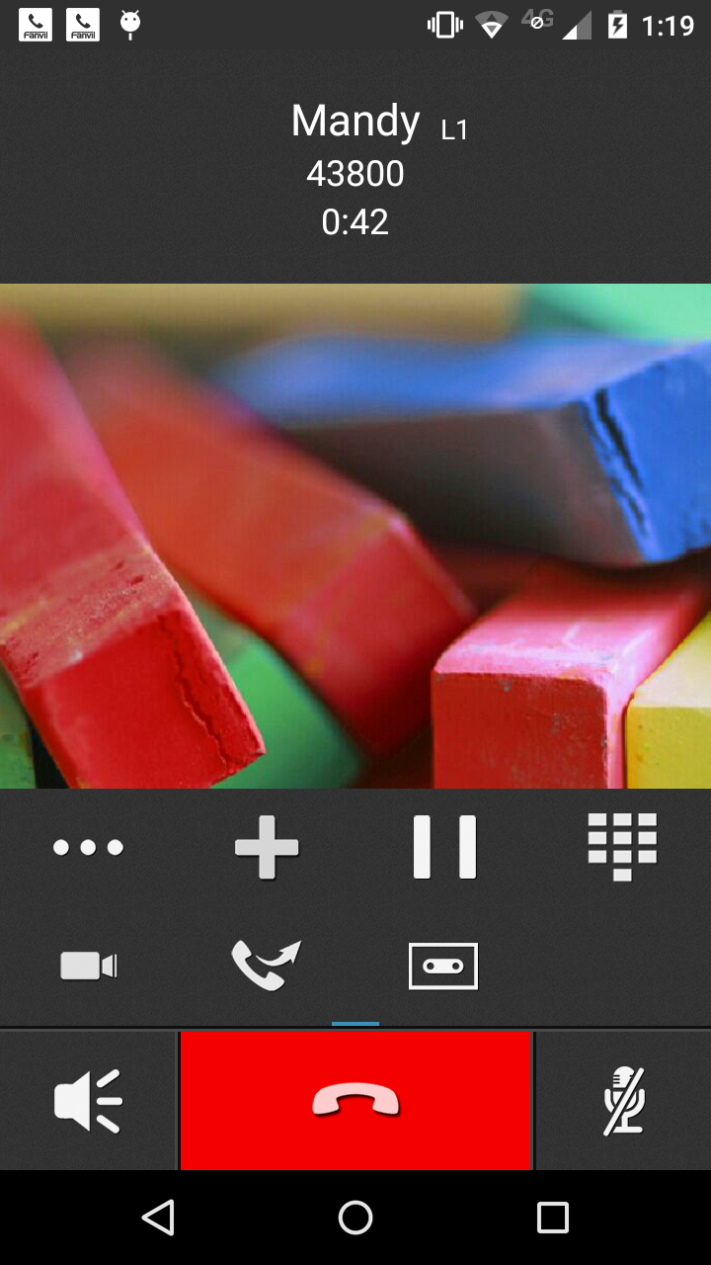
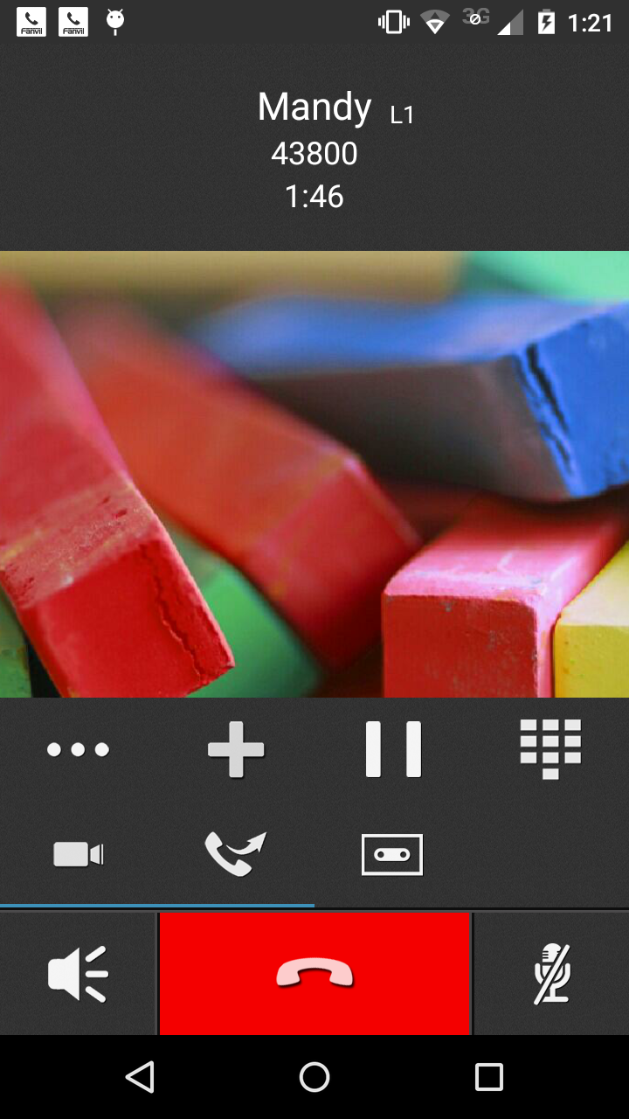
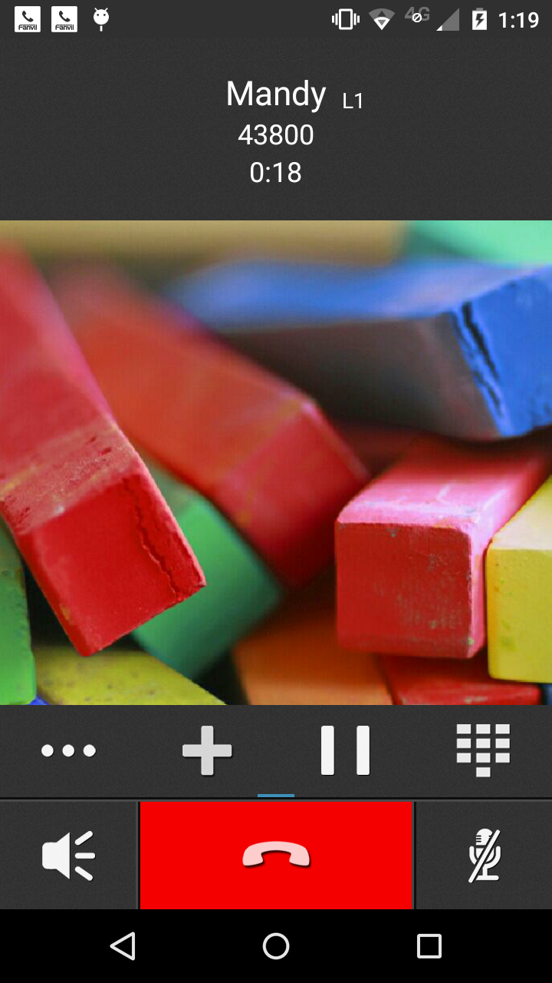
Hold key , communication keep into recovery key, click it can get back to the phone.

The name, line,tel number and talk time of other side

more options

Video call
conversation transfer facility

Call recorder.
when Multiple calls，you can slide around the screen to switch between calls.

DTMF keyboard,after press open and press cancel button back.
Mute:We can hear the voice when turn on ,but other sides can not.
Open the speaker

    - Blind Transfer
Step 1：on the call interface, click the Transfer button.
Step 2：enter the number you want to transfer on the transfer dial pad, or enter a contact / Call Log / Favorite choose to transfer contacts, the number clicked on will be extracted to transfer dial.
Step 3：Click the transfer button to transfer, or press the Cancel button to cancel the transfer.
Step 4：after the success of the transfer, vDroidphone will hang up, transfer failed will return to the first call path interface.
Step 1: Click the transfer button in call interface.
Step 2:According to the above, except to manually enter number, you also can click on the address book, call records, the collection to search contacts,then click it.
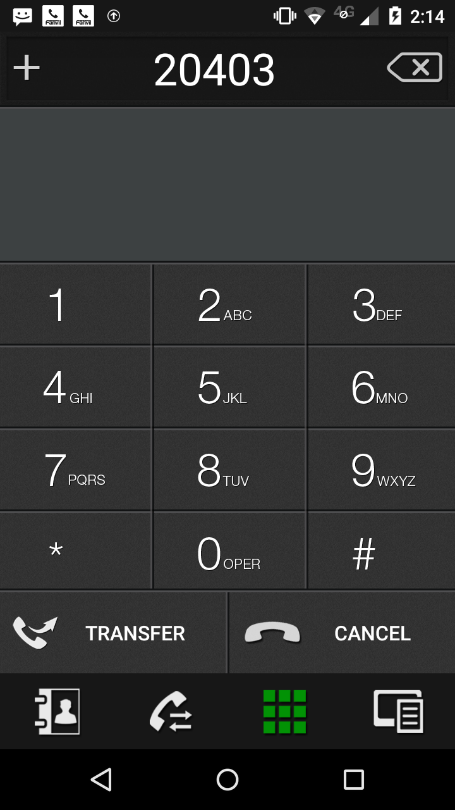

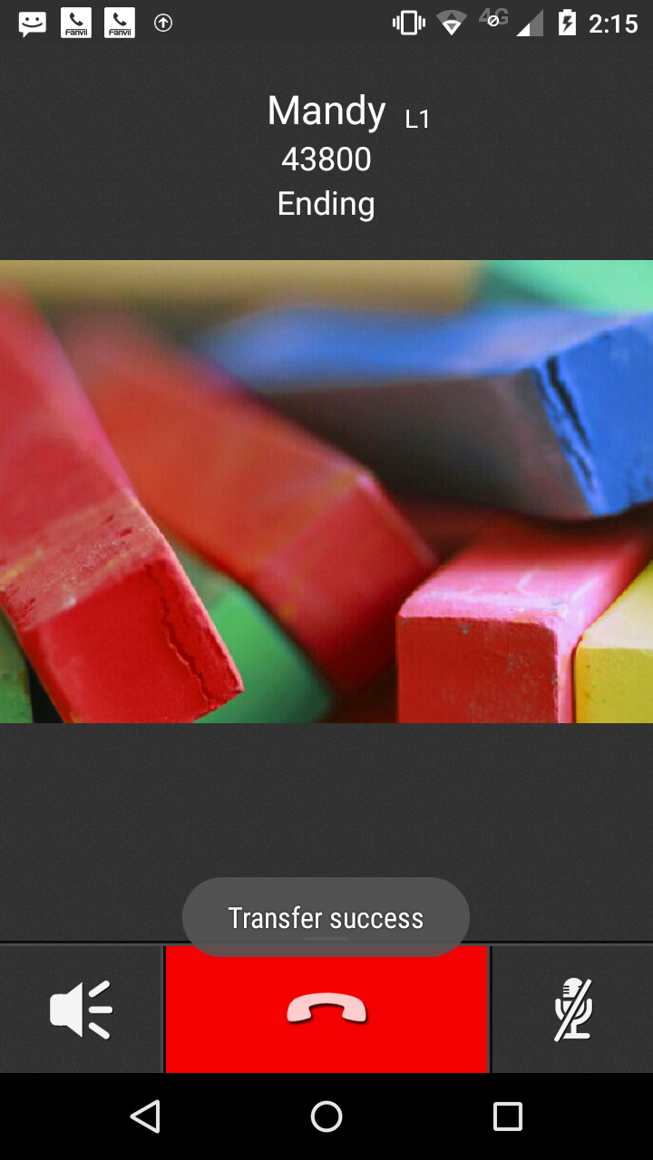
Step3:For example,the address book have multiple contacts and you can choose one.
Step 4: No matter transfer success or transfer fail there will be clues appear, vDroidphone will hang up when success, transfer failed will return to the first call path interface.
Click the Transfer button to enter the dial pad transfer

Manually enter the number or enter another three Find

Contacts
call log
telephone dial
favorite
In Case Contacts,choose a click, will bring back the number dial pad, then transfer key to transfer

Prompt transfer is successful, they will hang up.

Prompt transfer is successful, they will hang up.

    - Attendance Transfer
Compared with Blind Transfer, Attendance Transfer needs to manually establish a new way to call, and on this basis two-way calls will be transferred.
Step 1: in the conversation all the way, click on the plus sign to establish a new way to call.
Step 2: After the call is answered, click the transfer button to enter the transfer interface.
Step 3: Choose the first call to achieve attendance transfer.
Step 4: After the successful transfer, the transfer will have successful prompt, and will automatically hang up. Transfer failed return of the road holding call interface. Transfer failure will return the holding call interface of the road.

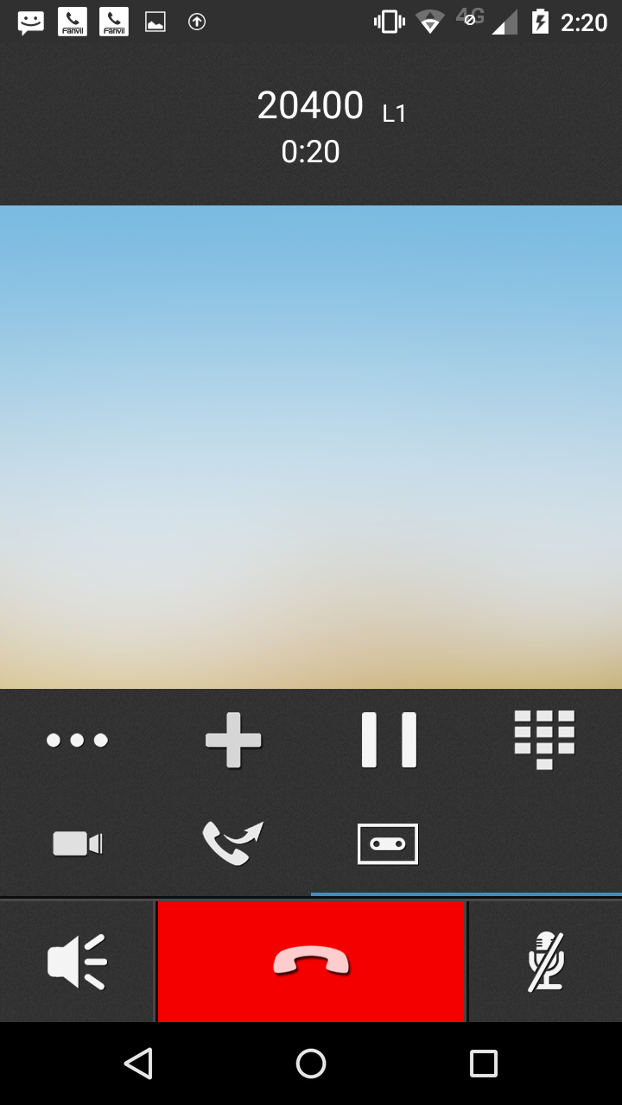
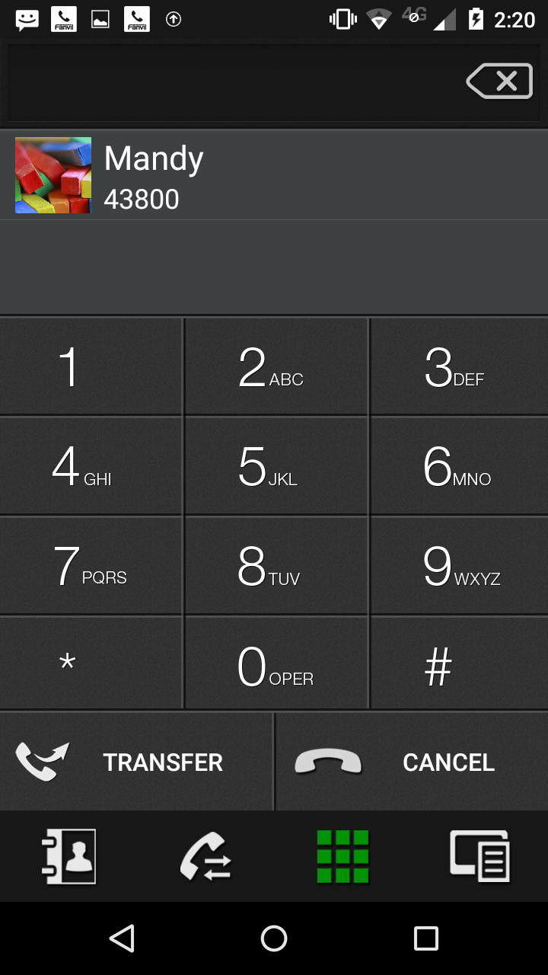
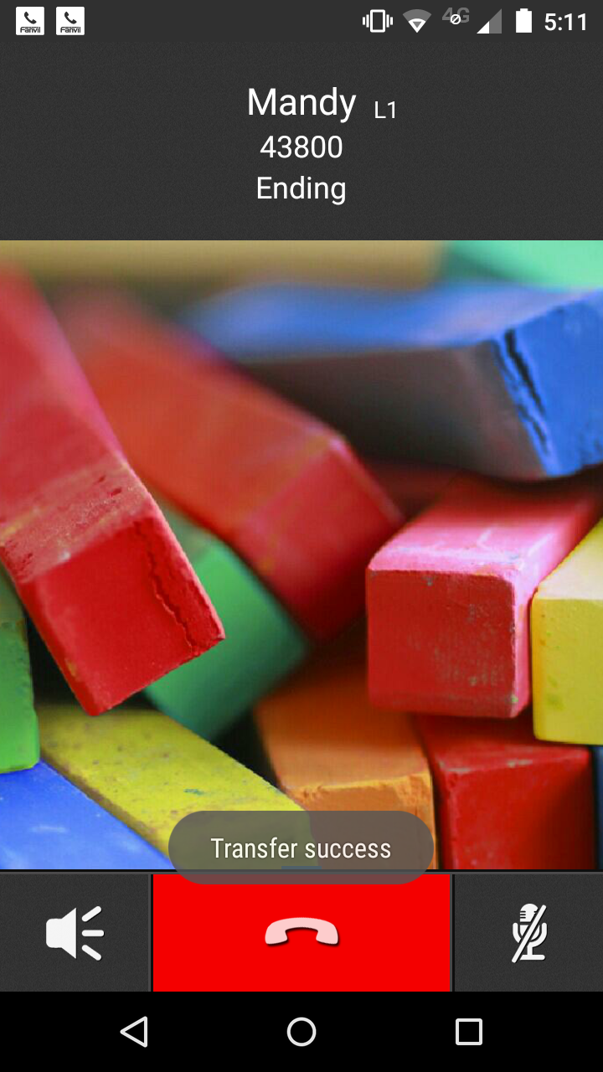
In the first call interface, click on the plus button and make a new call.
click the transfer button to transfer in second interface, then go to the transfer interface.
The first call display here and you can click it to transfer

phonebook
calllog
favorite

when transfer success,it will hang up automaticlly.
Step 1. In the first call interface, click on the plus button and make a new call.
Step 2.click the transfer button to transfer in second interface, then go to the transfer interface.
Step 3：the first call will appear below input box, click to transfer. Also can do a blind transfer operation.
Step 4. No matter transfer success or transfer failure, there will be clues appear, vDroidphone will hang up when success, transfer failure will return to the first call path interface.

    - Call on hold
After pressing the hold key, the call will be temporarily held; you need to press the recovery key to release the hold.
If there are multiple calls, only the current default route is active, the other way will be held, the call can be switched to manually release the hold.

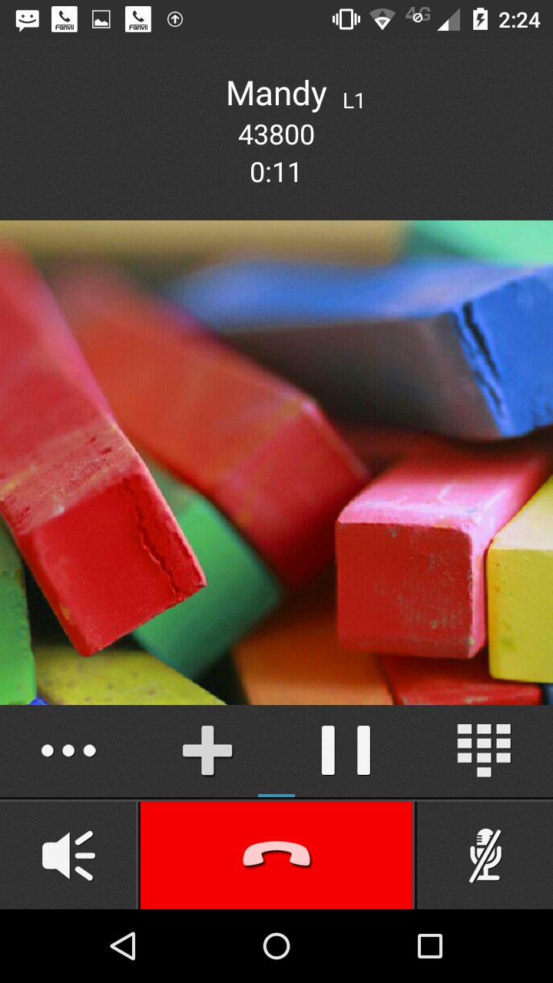
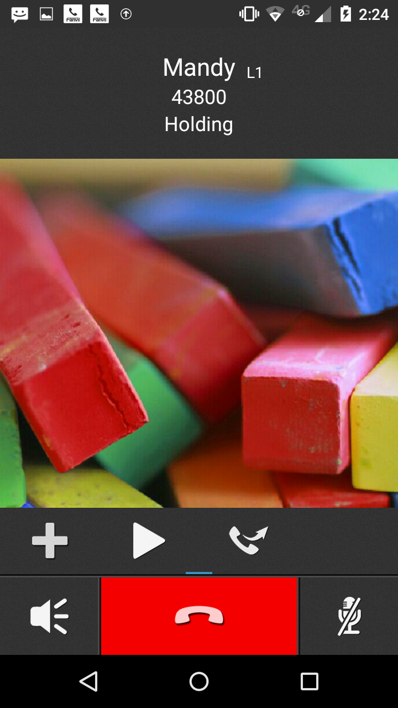

Call status，show call duration is not hold,lod display holding.

hold

Release hold
Holding key, press the call on hold

Releasing hold button， pressed to release hold, call normal

2.phonebook
  - local phonebook

2.1.1 contact list
Apear the phone and vDroid contact ,to be the safe side phone contacts :Set to only read permission.you can read and edit vDroid contact
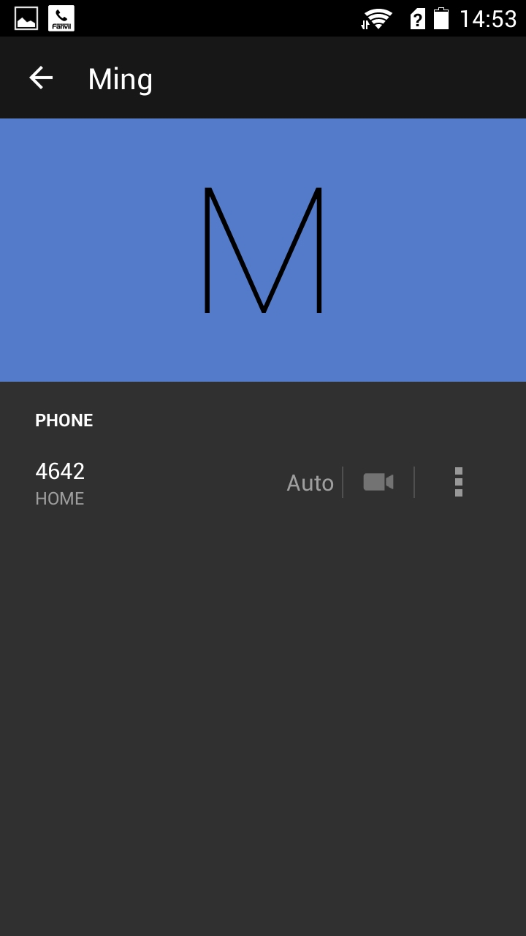
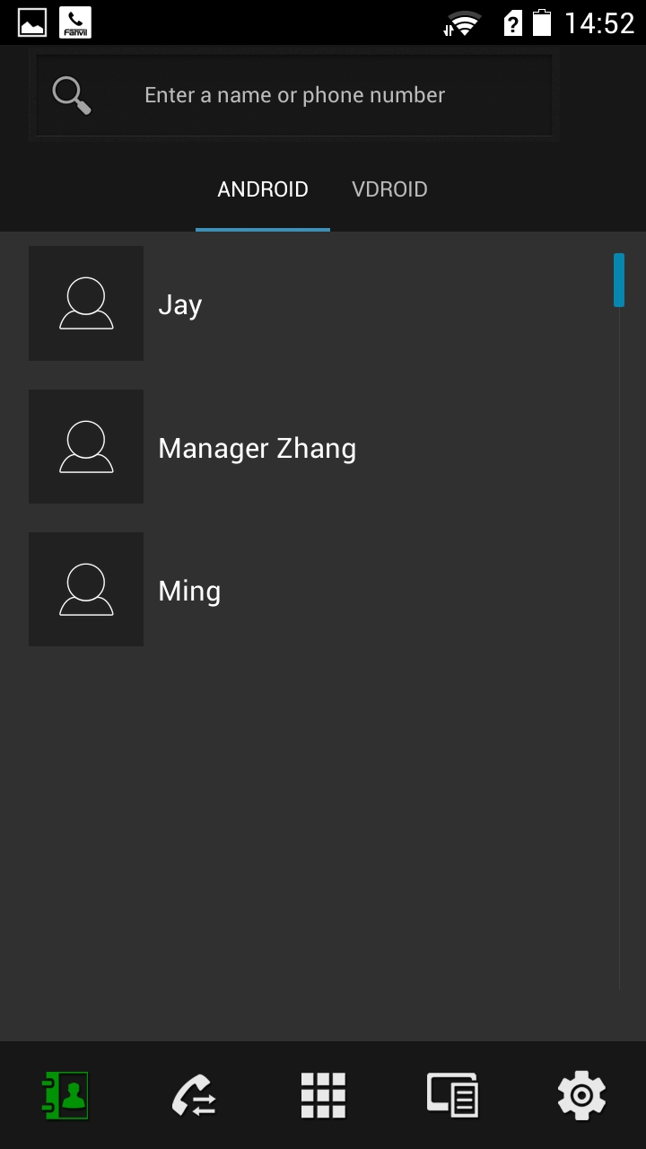

The phone contacts can’t edit

More options,including join to blacklist and join to white list.

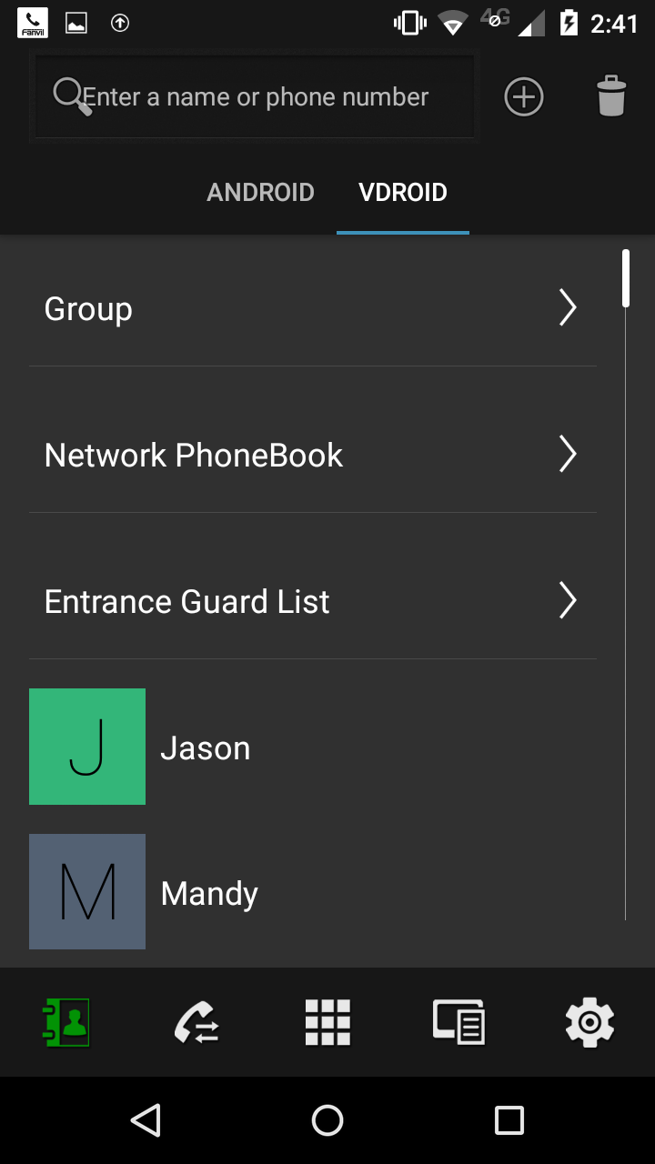
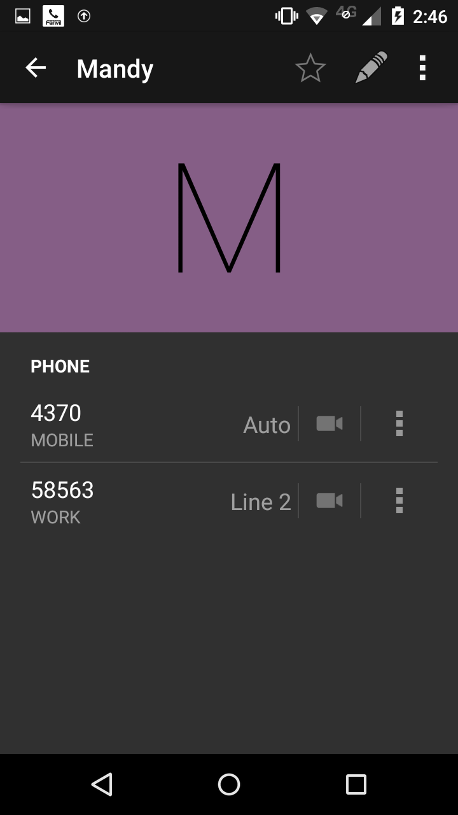
Delete key，including all the contact number of this people.

vDroid contacts can edit
including join to blacklist and join to white list.

    - view contact
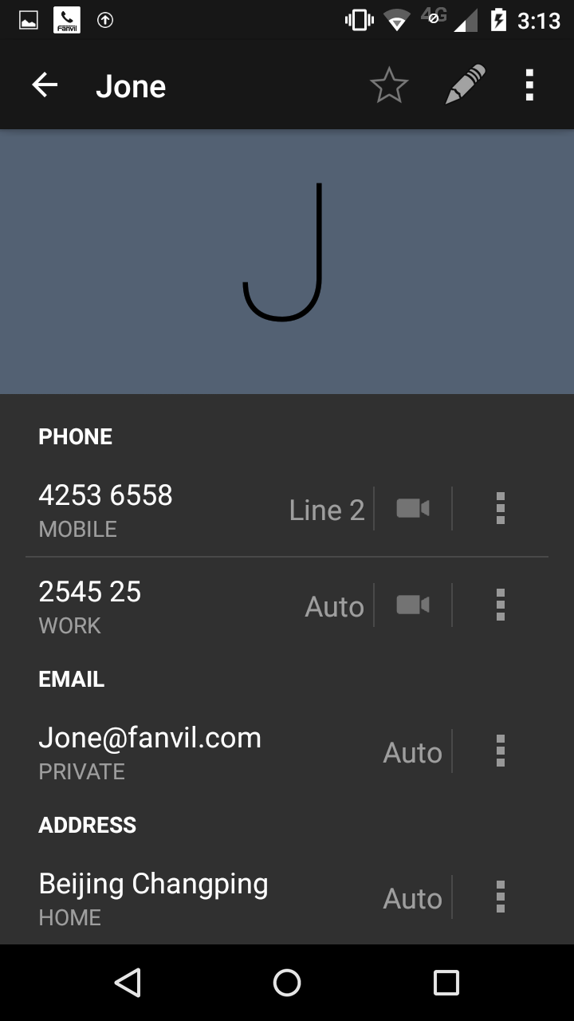
To view the contact information through contact list and to find the contacts

Click on the phone number will outgoing call
Or Video call
The top right corner:collect ,edit,delete
and For the corresponding operation
The more button of each contact contain black and white list
Click Head portrait can operate the Head portrait

    - Search contacts

search scope:phone contacts ,vDroid contacts and LDAP,click the contacts can outgoing the call
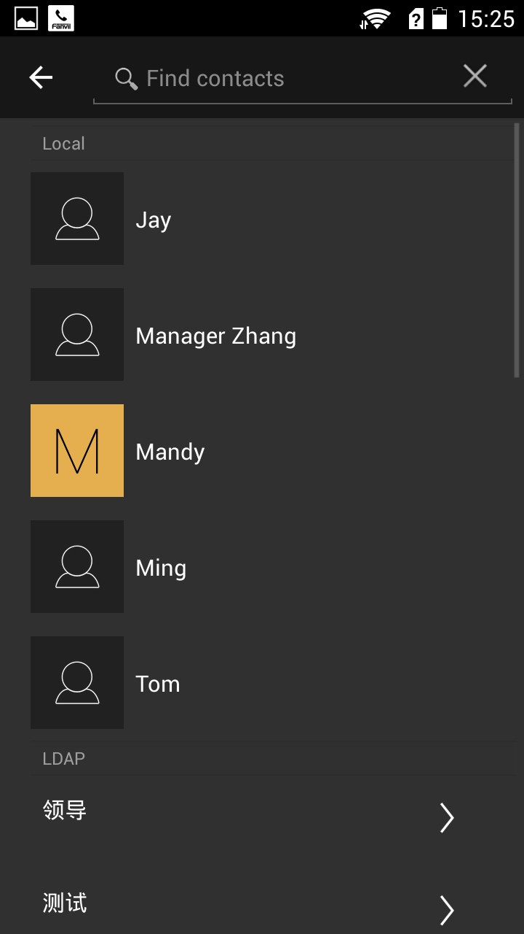
delete index

Before you do not enter an index term,show all local contacts, including ANDROID, VDROID and LDAP all contacts

LDAP all contacts.

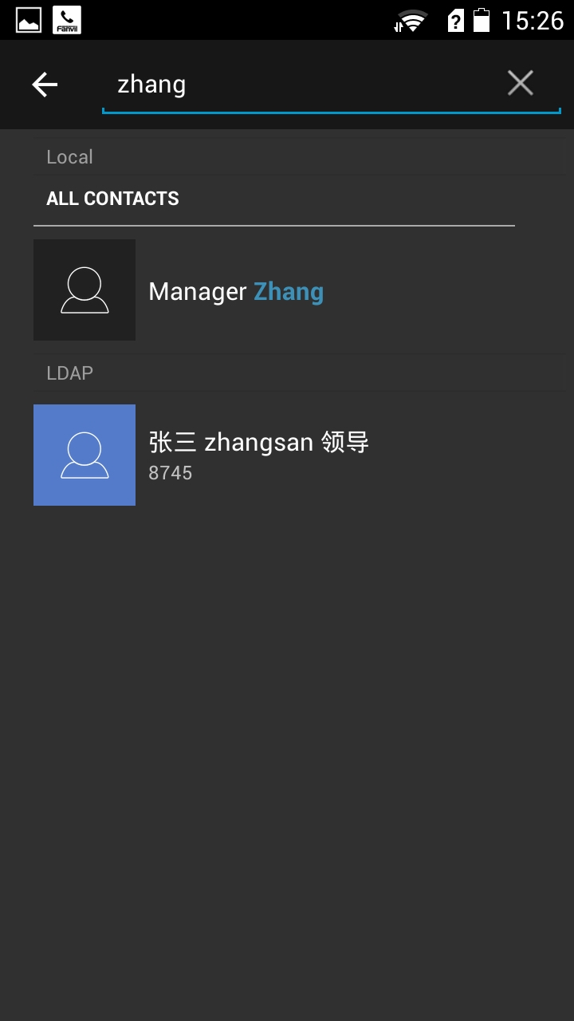

Local contacts qualified contacts.

LDAP qualified contacts.

2.1.4 add contacts
Return, follow the prompts to choose whether to
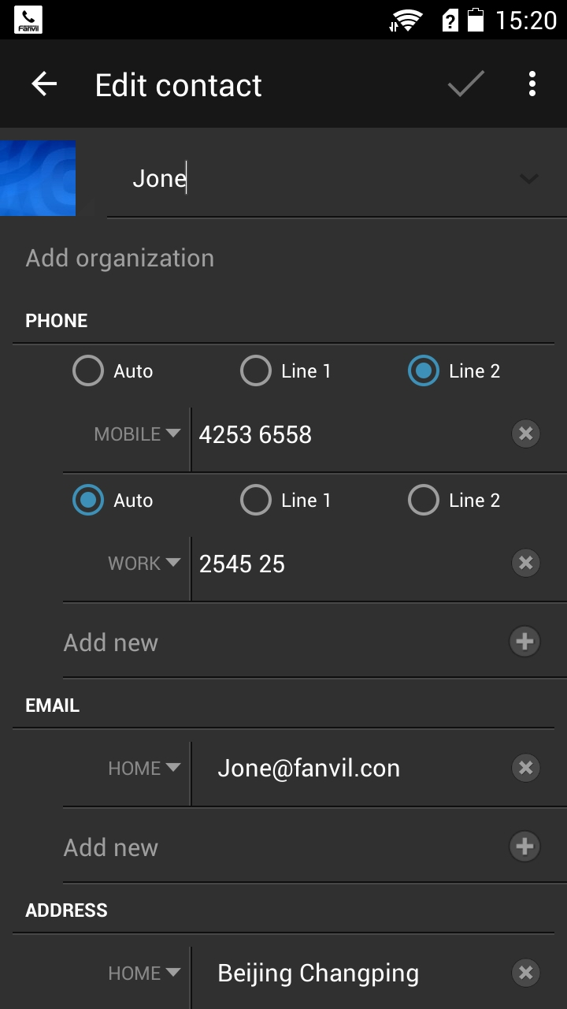
save
Add Head
add
Contact name

delete

Number bound line.

Cross delete

Add number

add contact mailbox, remove the mailbox cross

add mailbox

Add contact address ,cross delete address

Step 1: Click the top right corner of the page plus a contact number for a contact to add.

Step 2: Follow the diagram describes the fields to add information they need, click OK to save.

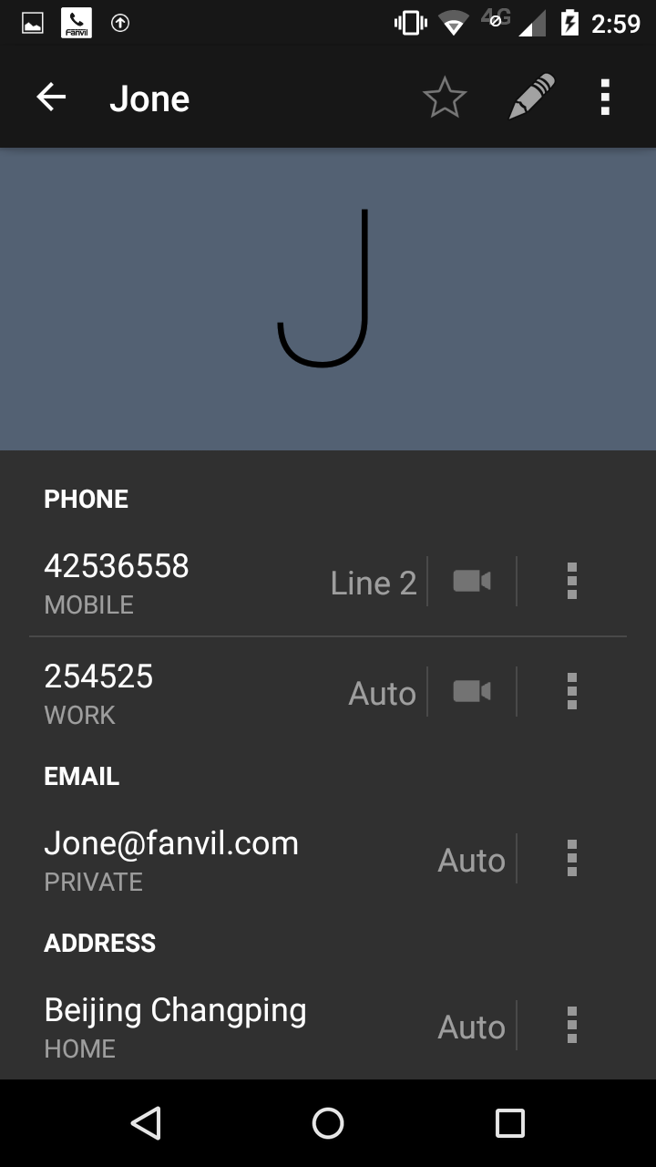
Step 3: detail page can call, favorites, edit, delete, add black and white lists and other operations.

favorites、edit、more（include delete）
Click to make a voice call using the Line 2

Click to make a audio call using the Line 2

    - delete contacts
You can delete The vDroid contacts :one by one or Delete by Query

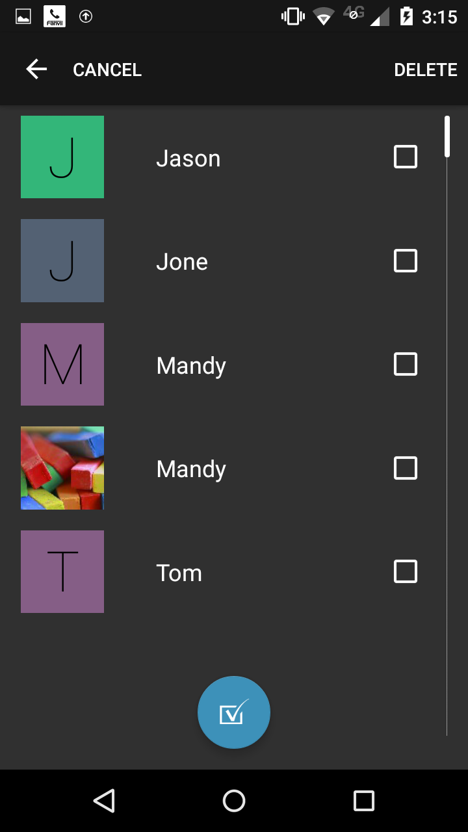

Delete button
Confirm Delete button

Delete from the contact
Click to select the Contacts

Select All button

Step 2: Click to select a contact, or use the Select All button to select all, the Delete button to delete.

Step 1：The contact interface, and click delete to the delete page.

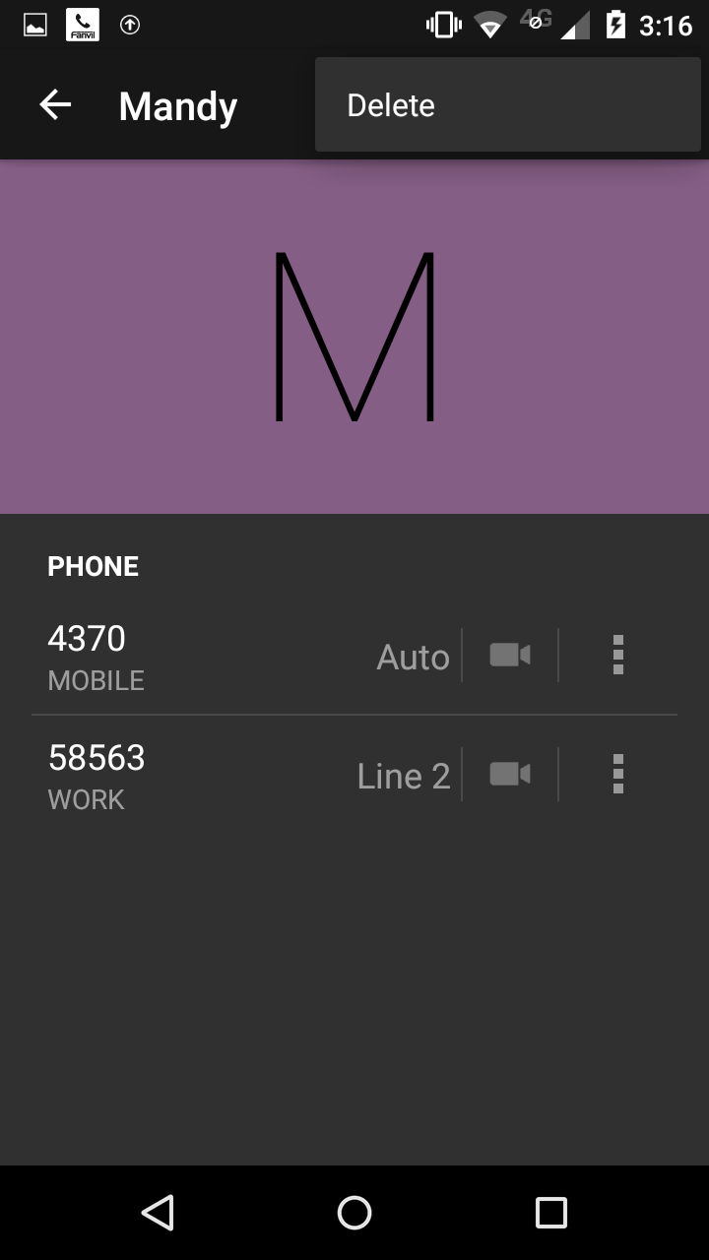
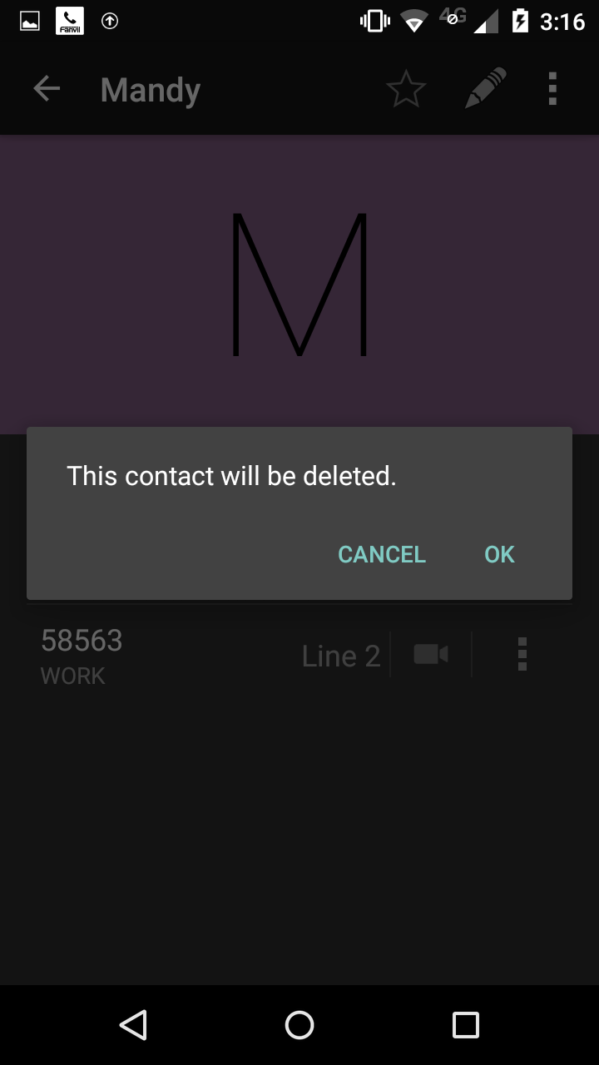

More button to expand the menu to delete

Remove from contact
detail interface

sure to Delete

Step 1: Details on the contact interface, click the More button to expand the menu to delete, click Delete.

Step 2: Click OK to delete, Cancel to return.

  - Group
    - add group
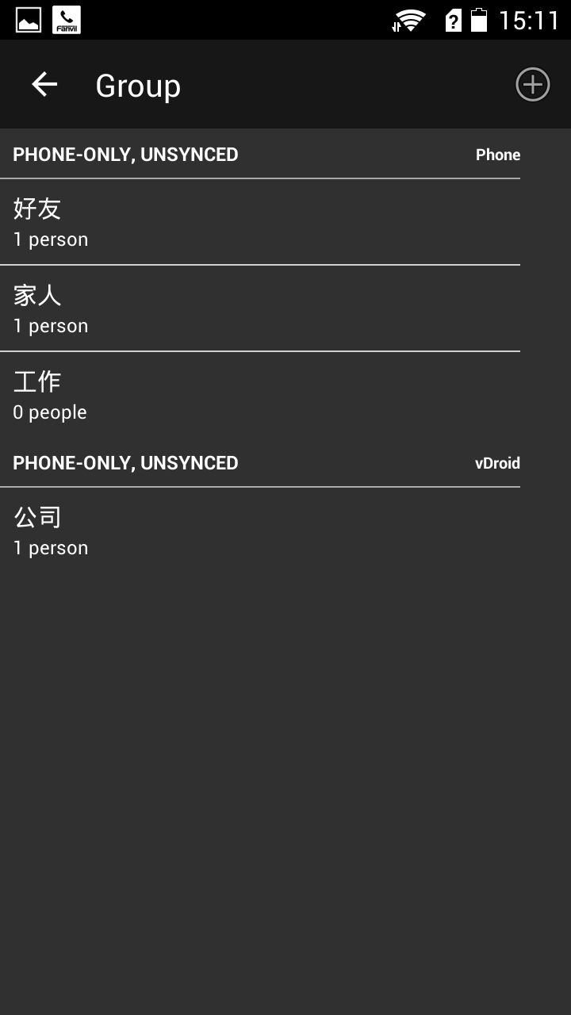
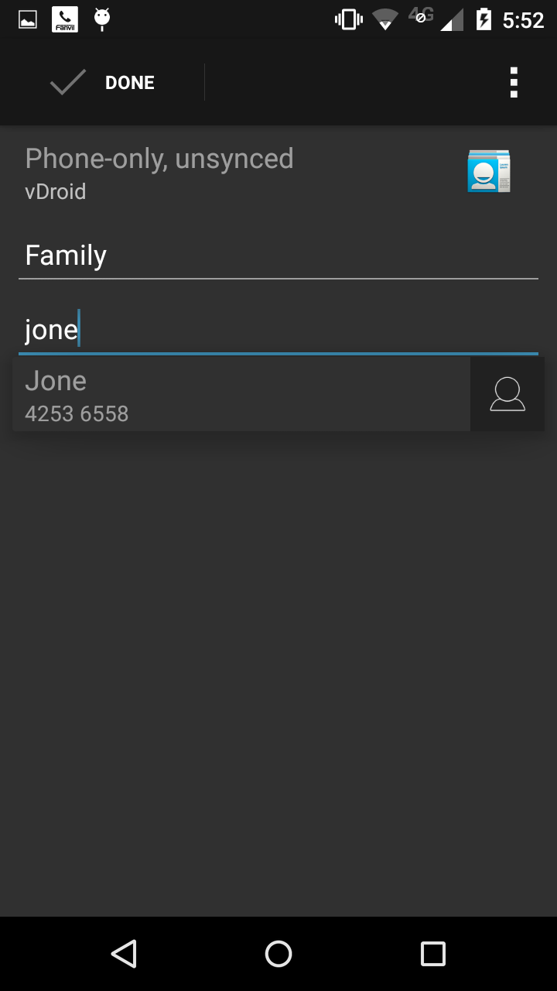

Step 1: Click the plus sign to add the top right groups.
Phone group list is part of a group of Android devices, vDroid is vdroidphone groups

Step 2：Enter the group name, enter the contact's name in the local name of the input can be added to this contact group.
Click the link behind the hot cross to delete.
Click the top left corner to complete the save.

    - delete and edit group

After entering the group, click on the upper right corner of
the more button
Expand the menu, including editing and deleting.
Select Delete, will delete the group, within the group
Contacts are not deleted.
Edit to enter the editing interface, you can group
editing.

  - network contacts

vDroidphone has 3 xml remote phonebookand 3 LDAP phonebook
    - add xml remote phonebook

edit
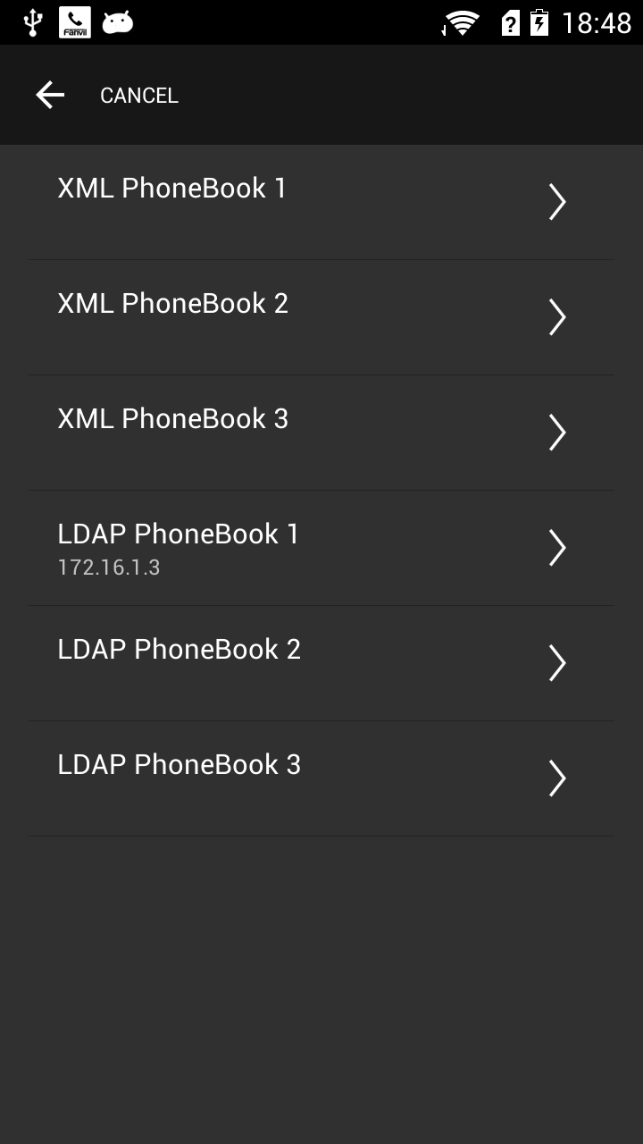
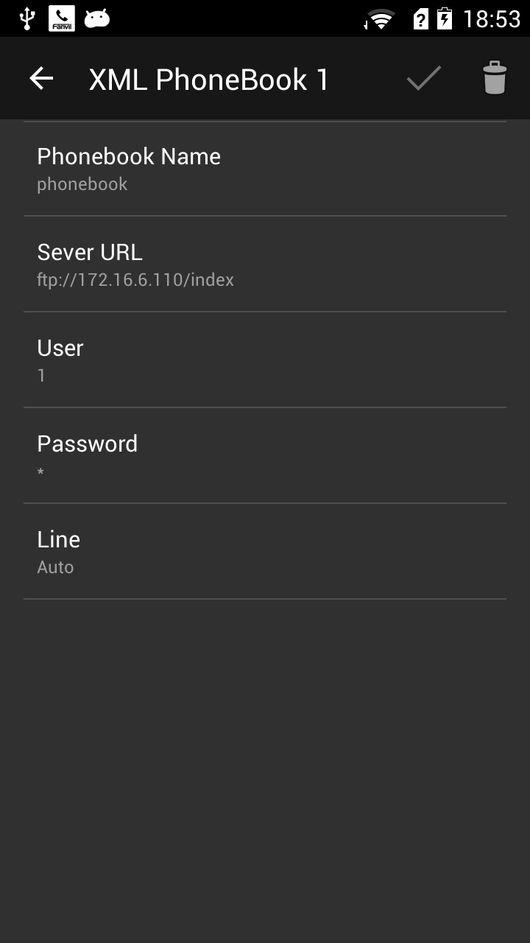
Internet telephony has been added for this you can click Go to view.

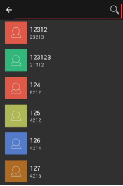
Search box
Step1: access to the network phone book list, click on the Edit button to add or edit a network phone book.
Internet telephony has been added for this you can click Go to view.

step 3： enter EDIT of a contact group, fill every blank then click on SAVE botton. you can delete everything by clicking on DELETE botton

Step 2:Show 3 xml phone book and three ldap phone book. It has been added to update the phone book name for the custom name.

step 4: you can search any contact after entering XLM contacts

Phonebook name | user-defined
Server URL | XMl remotephonebook’URL,for examble ftp://172.16.6.110/index.xml
username | server name
password | server password
line | Which line outgoing call
    - add LDAP phonebook

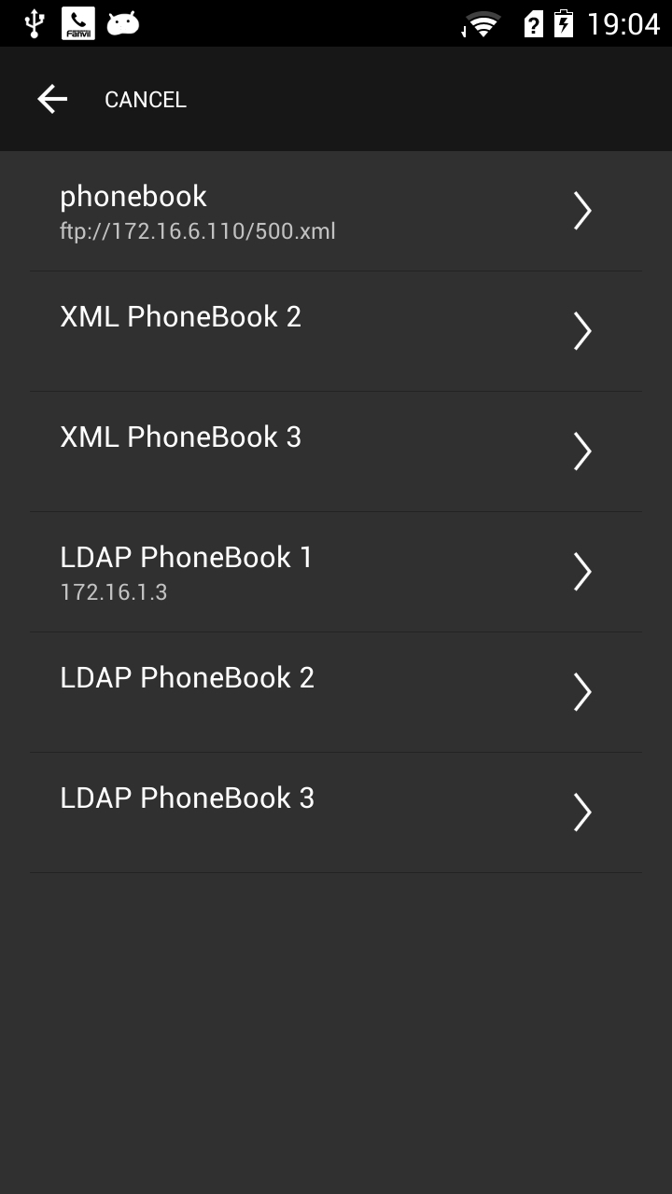
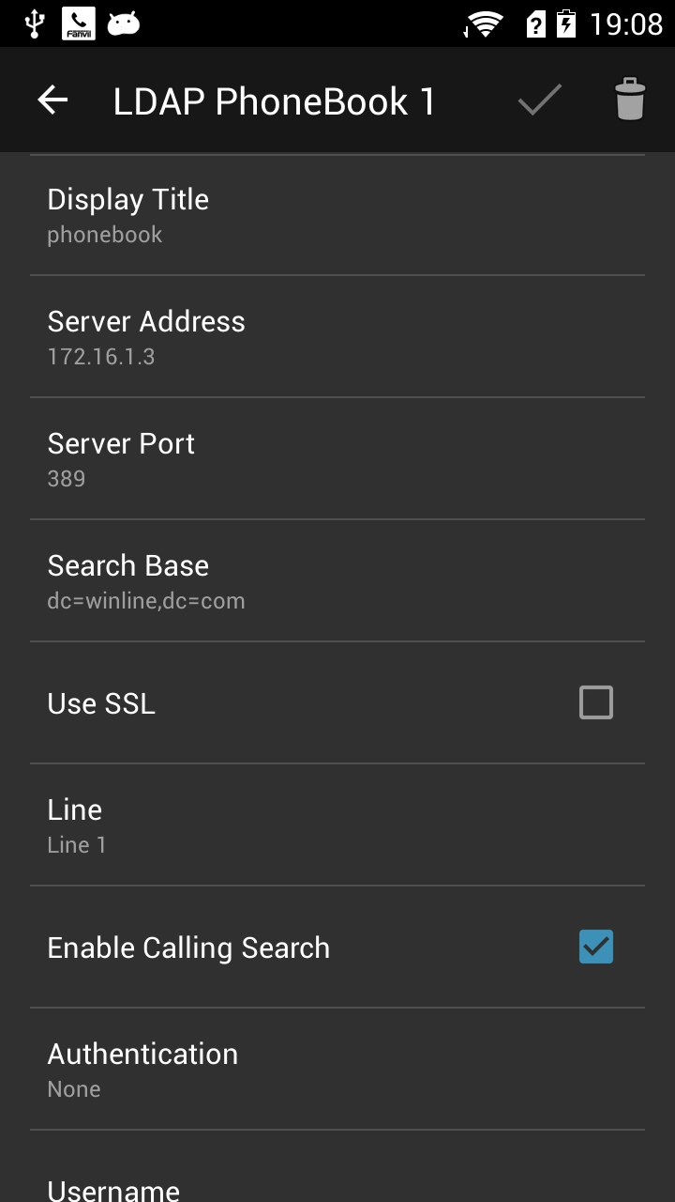

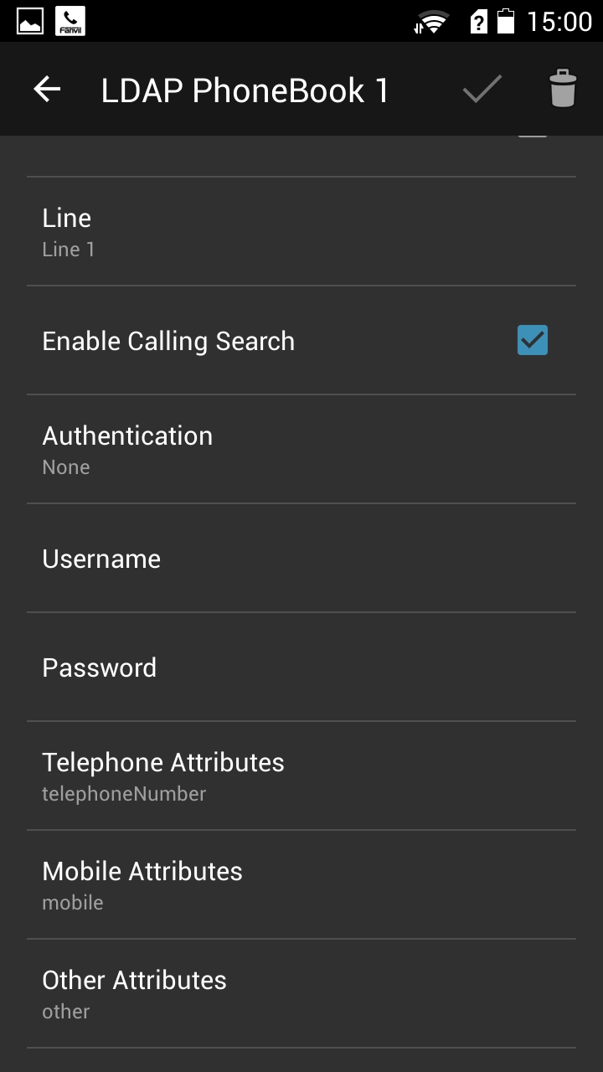
Search box
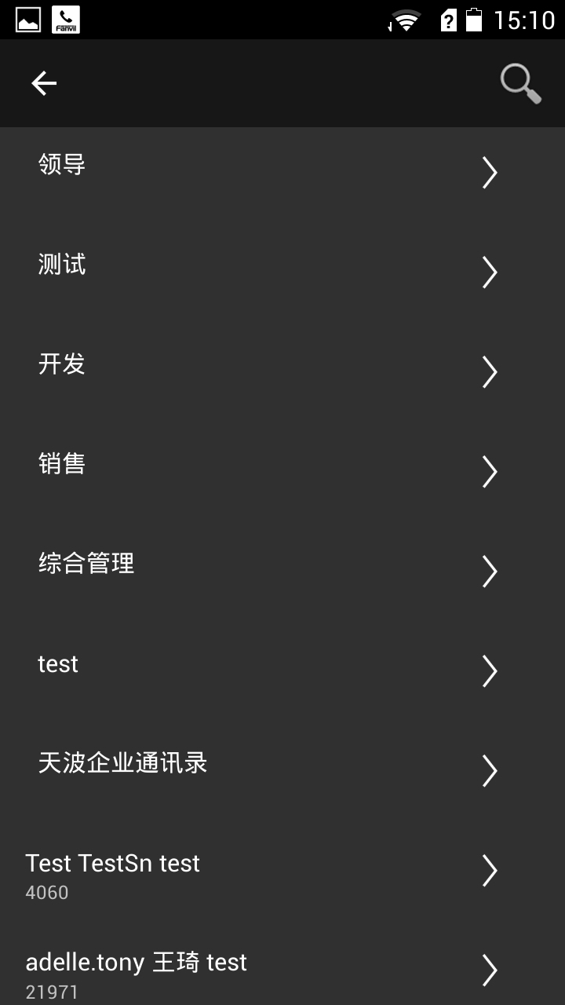
Step 1：Enter the network phone book editting page, show three xml phonebook and three ladp books. The phonebook updates to the new name that custom defined after added
Step 2：Enter the LDAP phone book editting page, and fill each item. Ok button to save, delete button to delete item info.
Step 3：Ok button to save and delete button to delete item info in the editting page.
Step 4：You can see the contacts after save and also can search contacts.

Note : Please refer to the use of specific LDAP method
http://www.fanvil.com.cn/images/user/2014050805.pdf

  - Entrance guard
VDroid can realize the entrance guard control, a key to open the door

Note:Need used with Fanvil brand entrance guard
    - edit Entrance guard
From the contact form below door into the editing interface

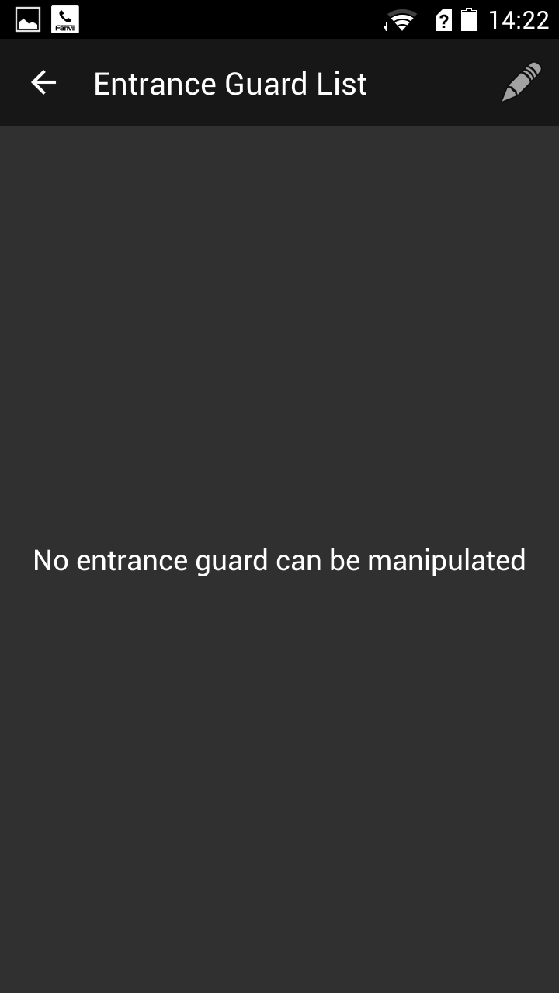
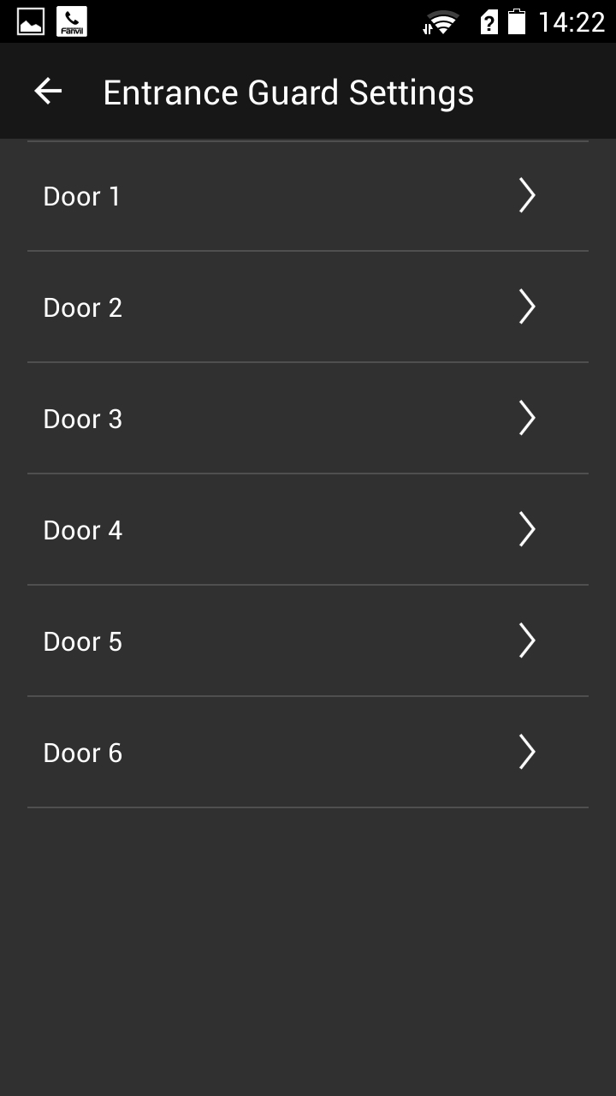
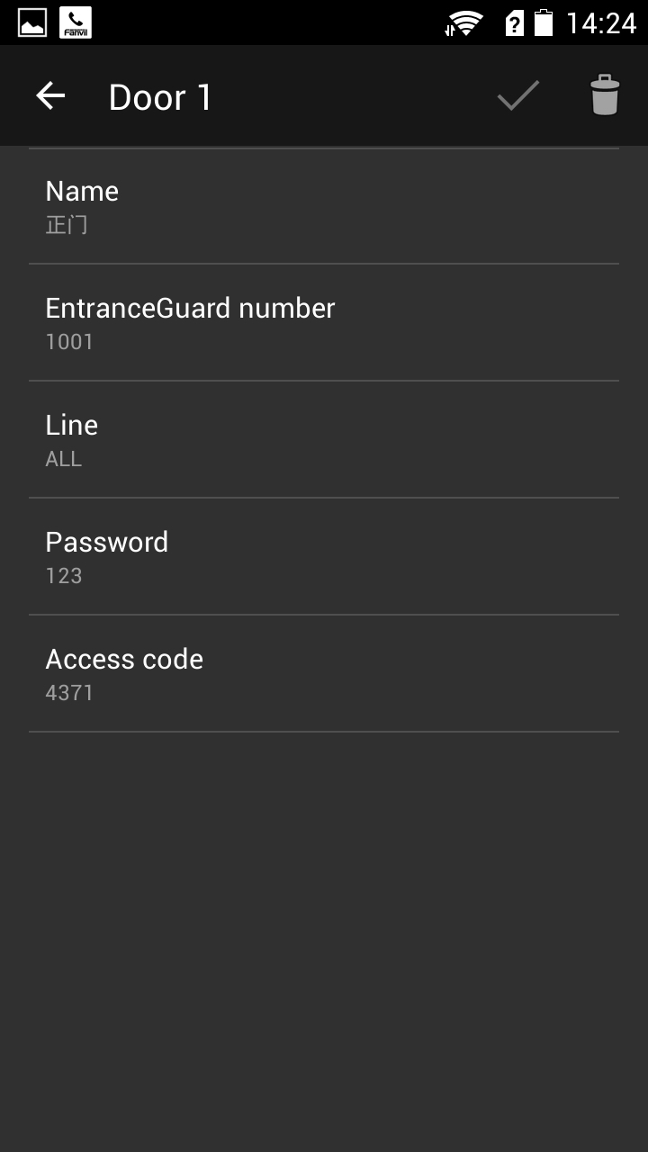

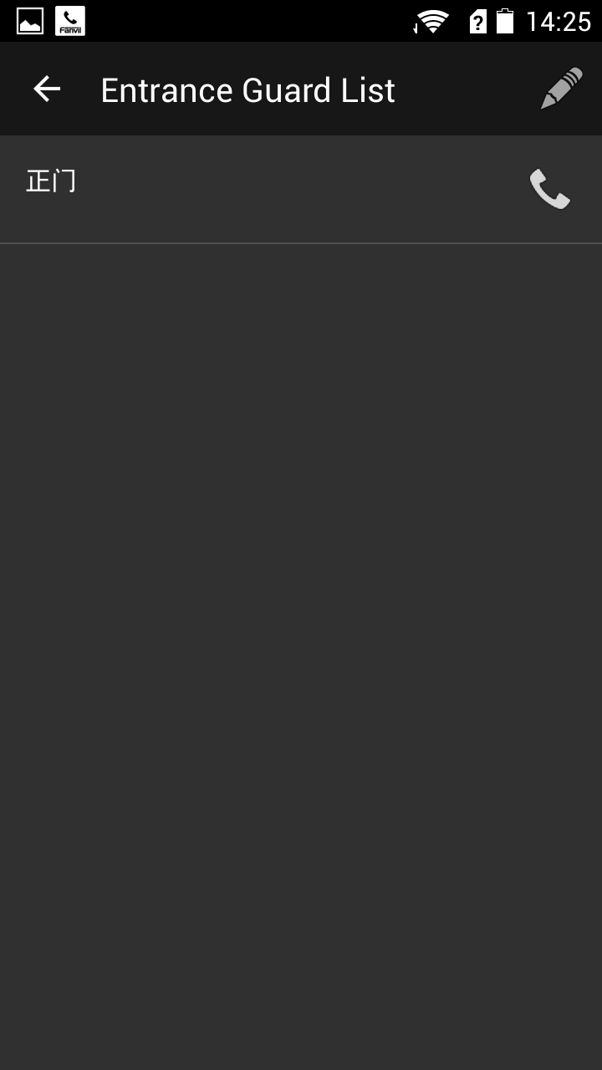
Step 1：Entrance guard list,click on the top right corner and add access control device.
Step 2：We support to six entrance guard and you can choose one to edit.
Step 3：According to the items input the entrance guard info. Ok button to save, delete button to delete item info.
click to call entrance guard.

Step 4：Save and see the entrance guard list,click to call entrance guard.

Each configuration items:
Access number | Entrance guard number
line | the line talk with Entrance guard and apear a key to open button
Access password | Need from the Entrance guard.when Entrance guard call vdroidphone,vdroidphone send Access password
Access code | Need from the Entrance guard.when vdroidphone call Entrance guard,vdroidphone send Access code
    - A key to open the door
Add a good door, in a talk on the phone. Press the button to open the door, the vDroid will open the door password sent to entrance guard, implement to open the door.
Step 1 :add Entrance guard devices on the vDroid ,the method refer to 2.4.1
Step 2 : a open button appear when vDroid and Entrance guard are talking
Step 3 : Entrance guard open after press the open button
Note : DTMF mode :SIP-INFO or RFC2388

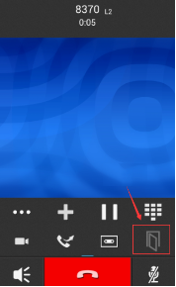

open button

Step 1:Add access relevant information
Step 2 :press open button ,open Entrance guard

Call Log
  - Call Log List
Call Log Classified：ALL、INOMING、OUTGOING、MISSED.
Left and right sliding screen switching type,
delete
Also can distinguish the type of color of the arrows.

Each record marked the callers, the line, the call mode, time, number of calls.

Click a call log, using the latest recording lines and call(audio or video)-only call.
Left and right sliding screen to switch the type of call log

Click the clock icon behind the call log, Enter Call details.

  - Call details
lick the clock icon behind the call log, Enter Call details, You can make an outgoing, view history, view a contact, add black and white lists and other operations.
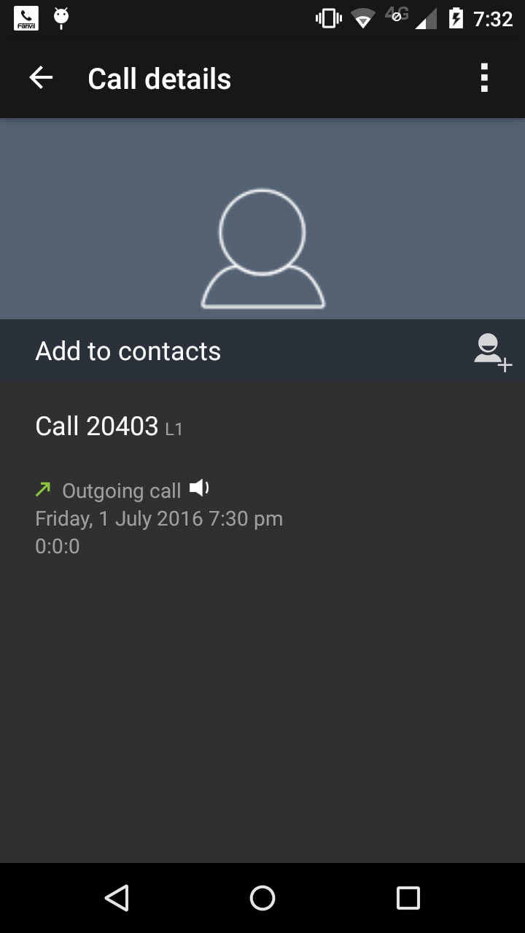
The Call Log of contacts：Click the icon(Like a person's pattern) to view the contacts. Click "Call 8370" to make a call

The Call Log of non-contacts：You can be added to a contact. Click "Call 8381" to make a call

More menu: More options button, you can choose more operation here including delete the record .

View the contact
Click it to call out

Add to contacts

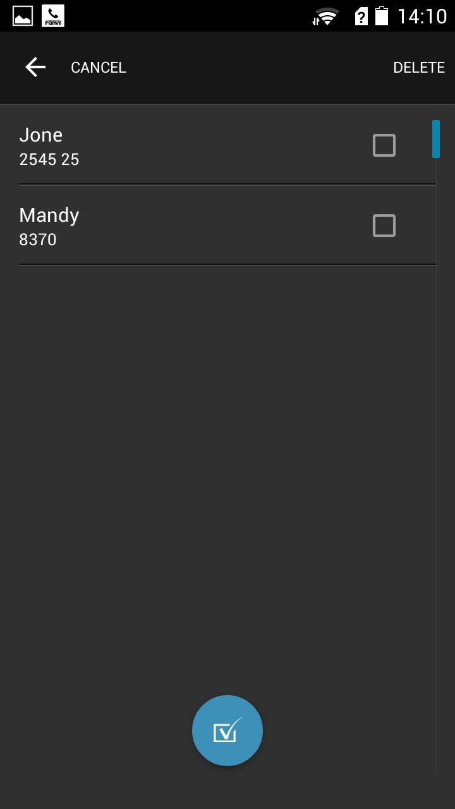

3.3 Delete Call Log

Click on and select it

Enter the call log interface, Click the Delete button.

Click Select one or use the Select All button, and click
the Delete Key to delete.
Select all

Favorite
  - FAVORITE
The main function of favorite: Centralized management of important numbers, Easy call, Subscribe state collection numbers(BLF function requires server support).
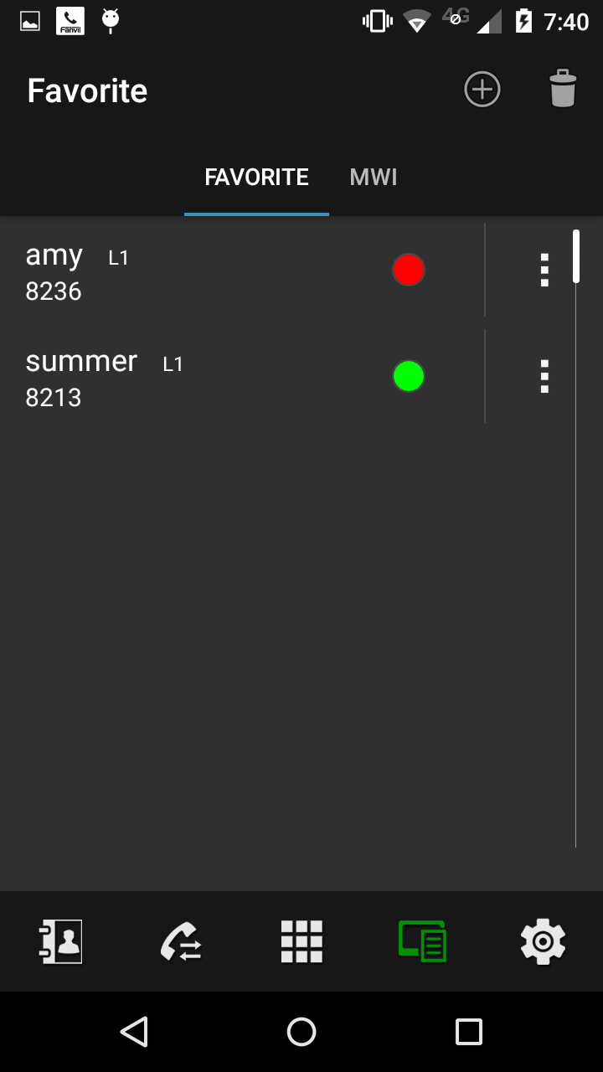

Status lights display the status of being a subscriber：
Green: Idle; Red: busy; flashing red: Ringing.

Click the subscription number to call.

    - Add and edit Favorites
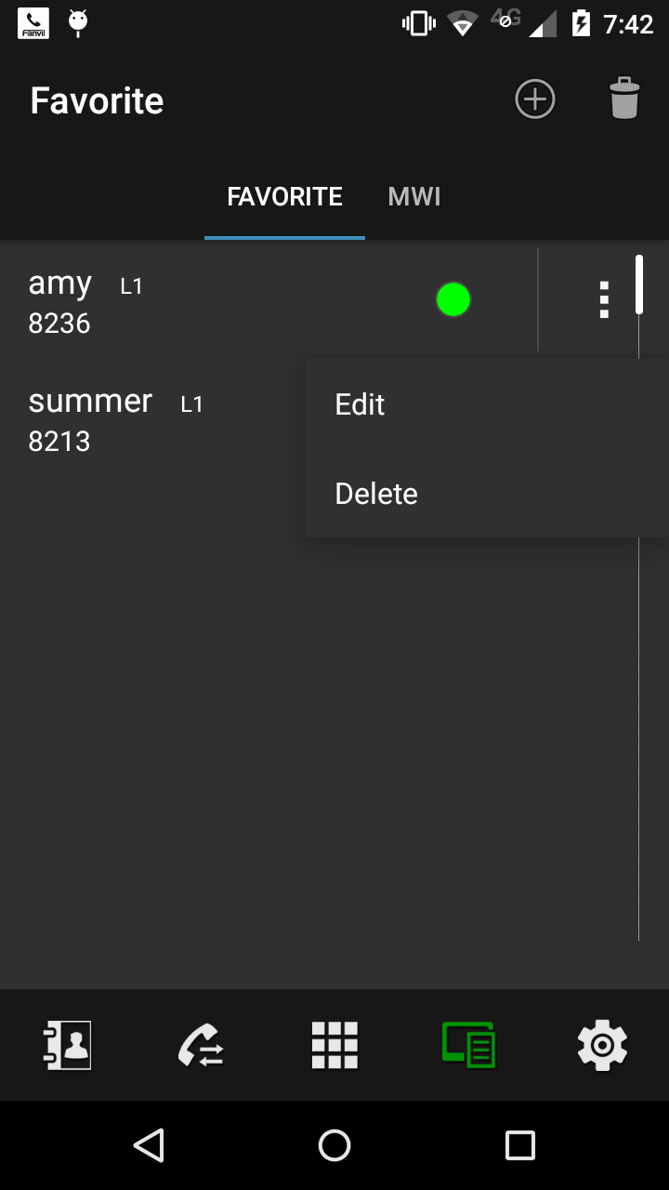
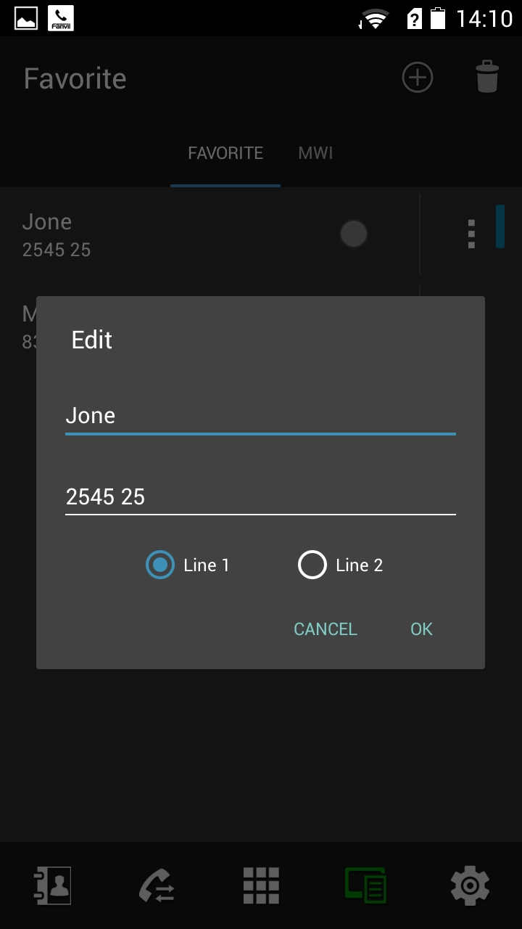
add

Step 1: Click the plus sign in the upper right corner, add favorites.

Step 2: Click favorited number behind menu button, select Edit.

Step 3: Fill in the name and number, choose the binding line.

    - Delete favorites
Delete favorites and delete call Log the same,
Divided into two categories: Remove single/ batch deletion.

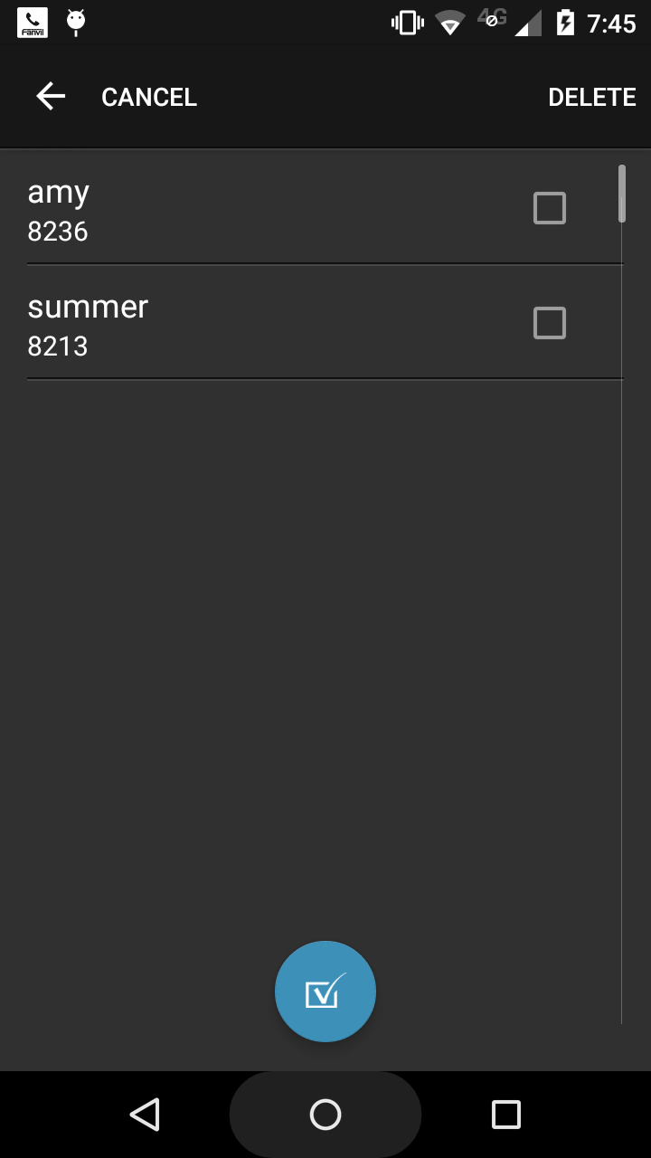
check all

Remove single：Click on the menu button and choose Delete.

batch deletion：Click the Delete button in the Favorites page, enter the batch deletion

  - MWI
The corresponding line opened MWI subscription feature(MWI need server support), you can view voicemail in this page.
    - Listen to voicemail
If the mwi number is set in sip-Advanced Settings, MWI behind the phone is green，Click on the phone icon directly call voicemail.
If you do not set the mwi number, the phone icon is gray, you need to manually dial the mwi number to listen to the message.

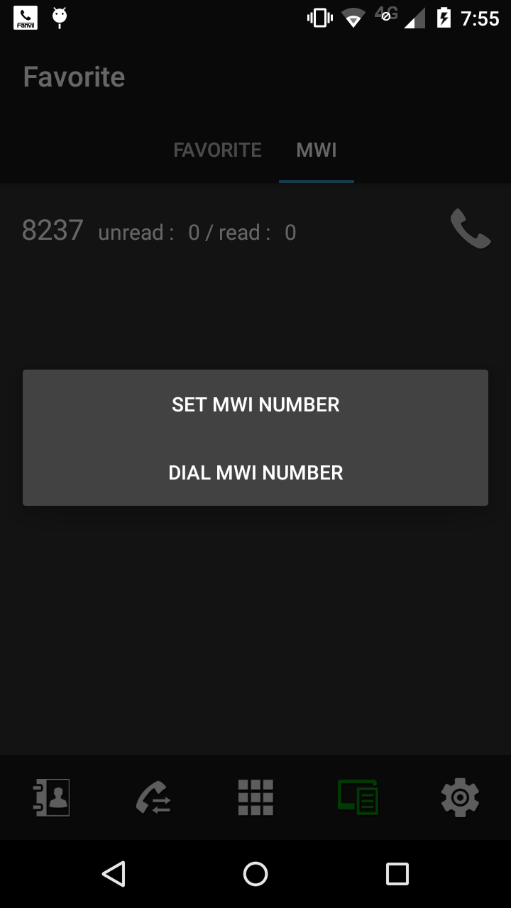
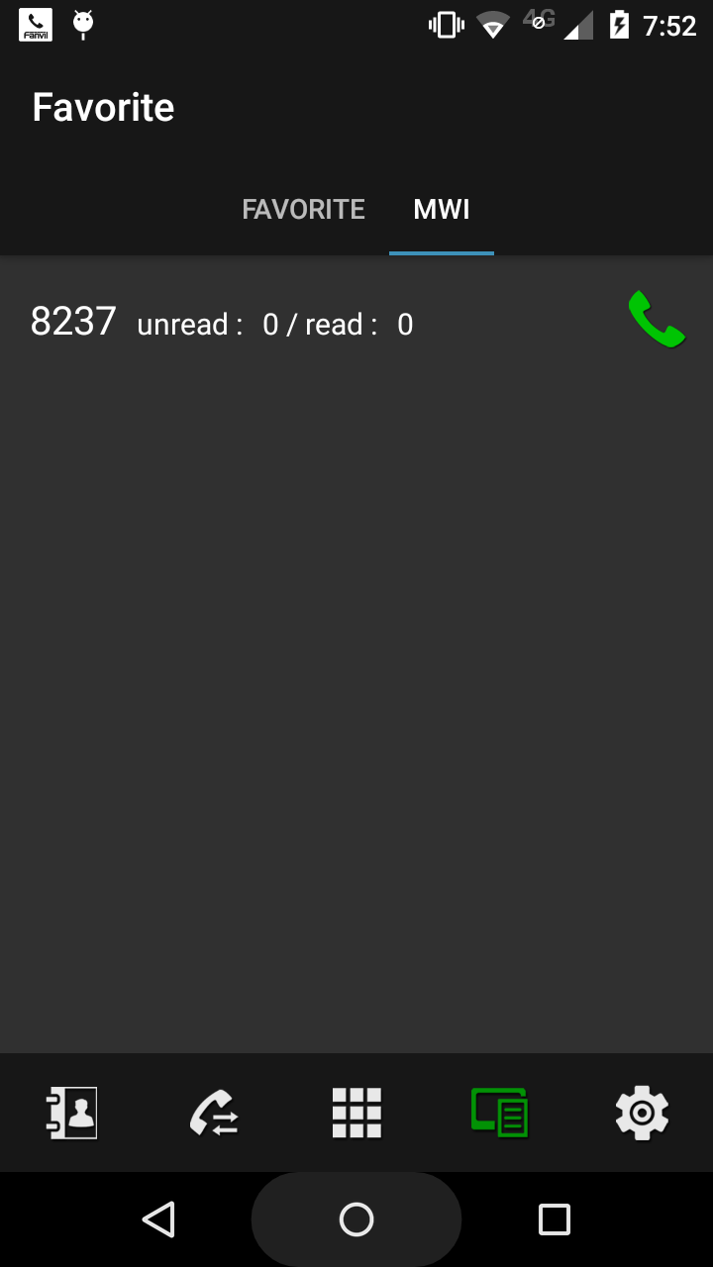
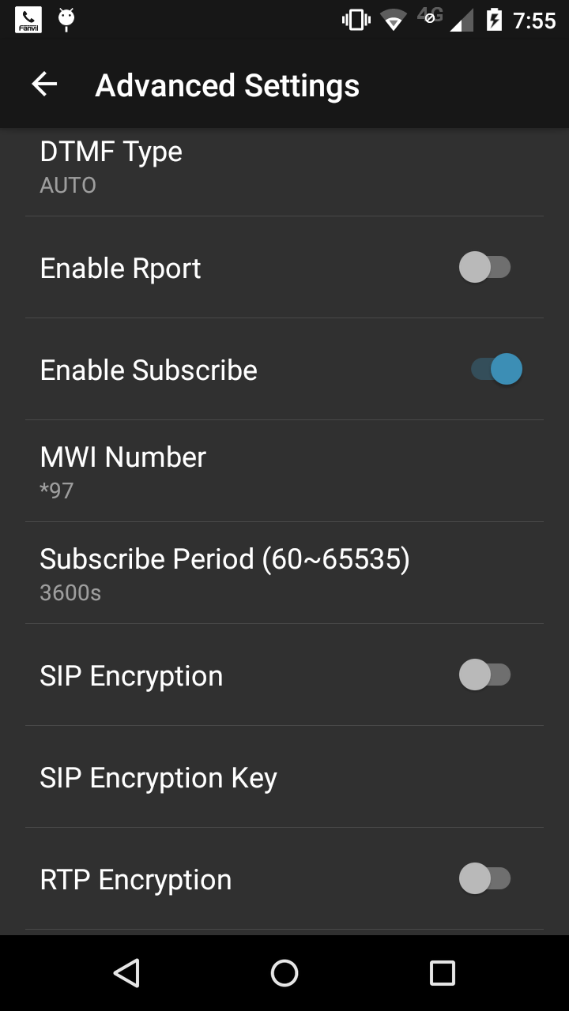
MWI Nnmber：set MWI number
The number of message

phone icon is green represent setting up voicemail number, you can directly click to call.

Not set voicemail number
mwi number is set: phone icon is green, you can directly click to call.

Voicemail number is not set: phone icon is gray. Call mwi number will enter the dial pad, you need to dial manually. Set mwi number in the sip advanced settings.

Settings
  - Hotspots
This function needs to match up Fanvil phone V2.5 version. VDroid only have hot-spot client function, Fanvil is supports of client and server function.

When vDroid and Tel (Fanvil tel) in the same LAN, it can be registered to Tel server , as telephone extension, it can syncing accepts calls. Extension and hotspots can dial each other using cornet.

When VDroid connected to the hot spots ,it will register automatically. VDroid has three methods to connect with hot spots: QR code scanning,manually add and hot spots filtration.
    - QR code scanning
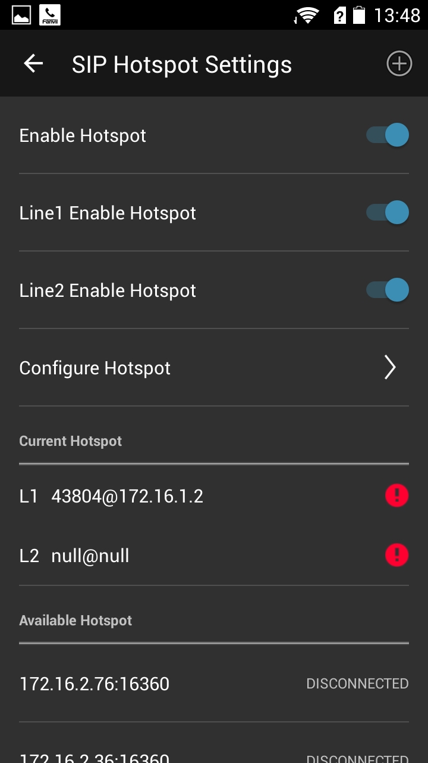
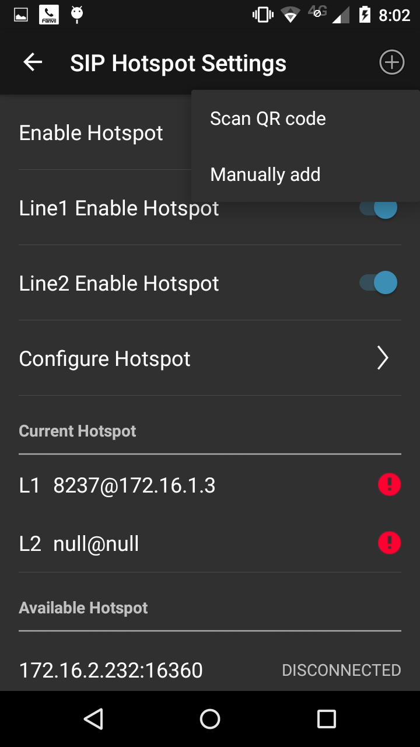
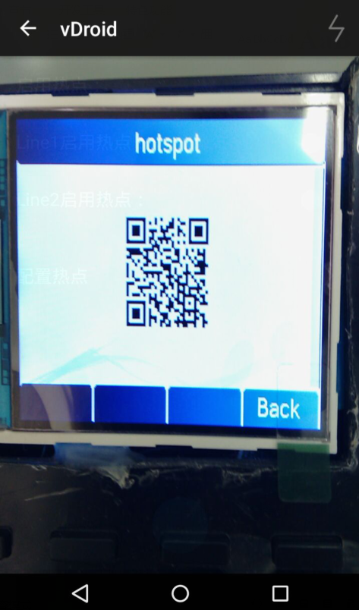
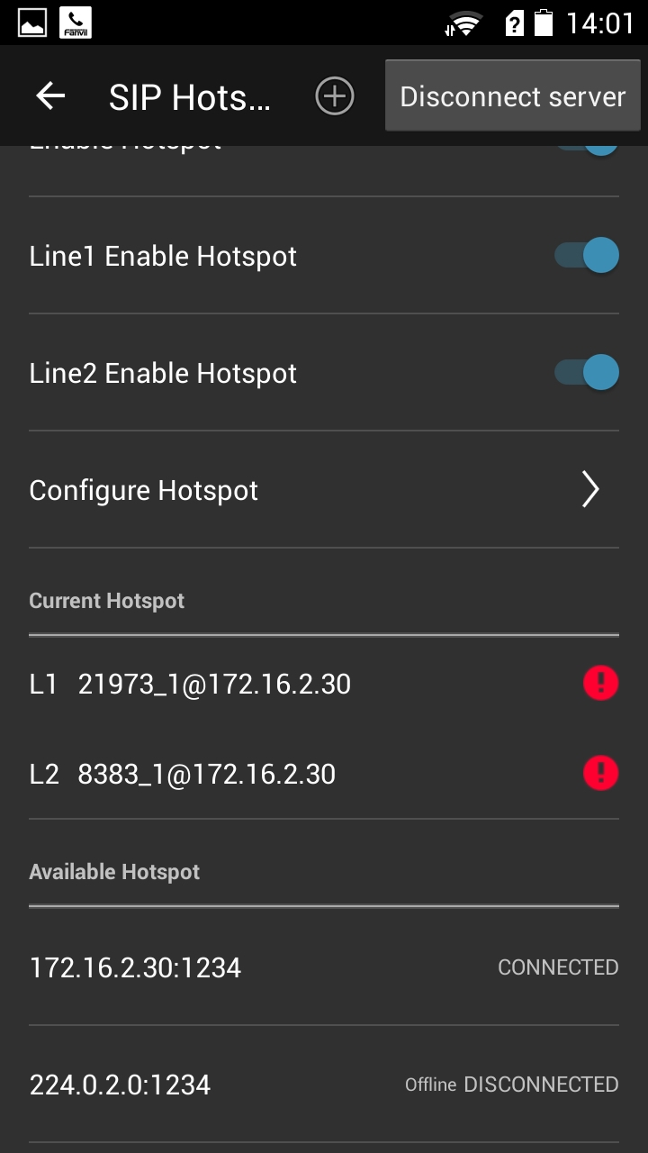
Ps: Fanvil F3/F4 tel support to generate hot QR code, then sets it to hot spots server, entering status—hotspot can see hot spots QR code.
Whole hot spot switch
The hot spot switch of line one
The hot spot switch of line two
The button that add to hot spot.
it is already registered to server, the vdroid extension number is 1.
Step 1: Open hot spots and hot line.
Step 2: Click on the plus button, select scan QR code,enter the scan interface .
Step 3: scaning QR code.
Step 4: it is already registered to server, the IP of server is 172.16.2.46, and vdroid extension number is 1.

    - Manually add
Step 1: Open hot spots and hot line.
Step 2: Clicking on the plus button, selecting the scan QR code,entering the scan interface .
Step 3: Enter the server’s IP and port, then click on add button.
Step 4: see about the details info about hot line.
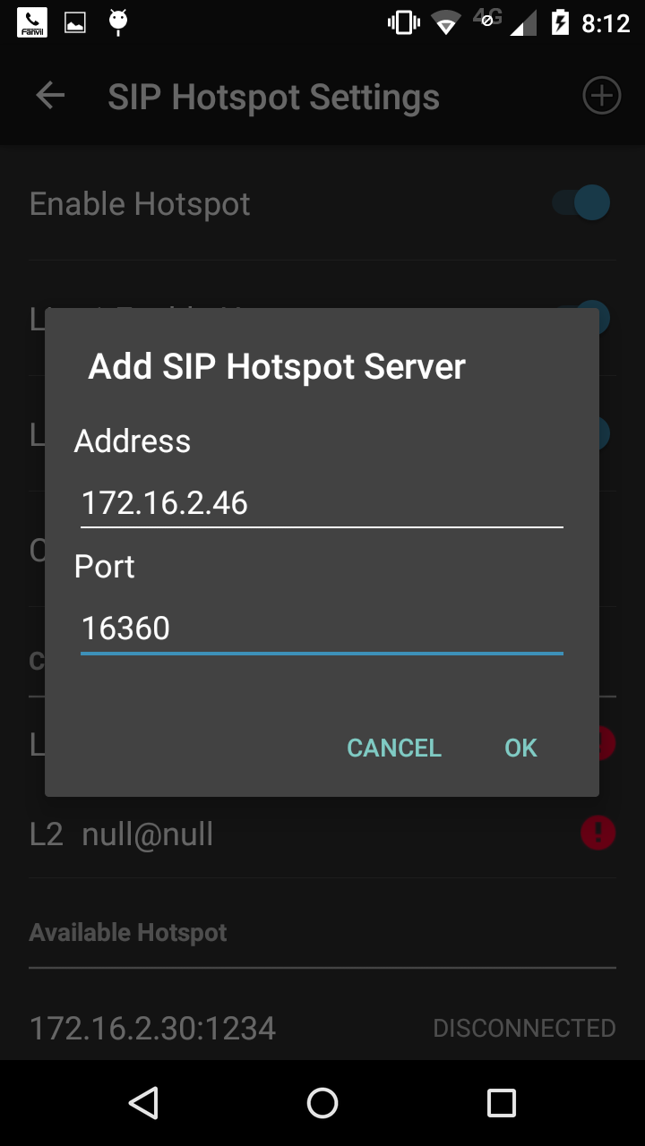
Step 1: Open hot spots and hot line.

Step 2: Clicking on the plus button, selecting the scan QR code,entering the scan interface .

Step 3: Enter the server’s IP and port, then click on add button.

Step 4: see about the details info about hot line.

Enter the server’s IP and port, then click on ok button.
    - Hot spots filter
Setting the filter rules,showing the hot spots server that is matching filter rules in LAN in the list of available, then connect it.
Step 1: Open hot spots and hot line.
Step 2: Setting the filter rules,and each field value and server value should be same .
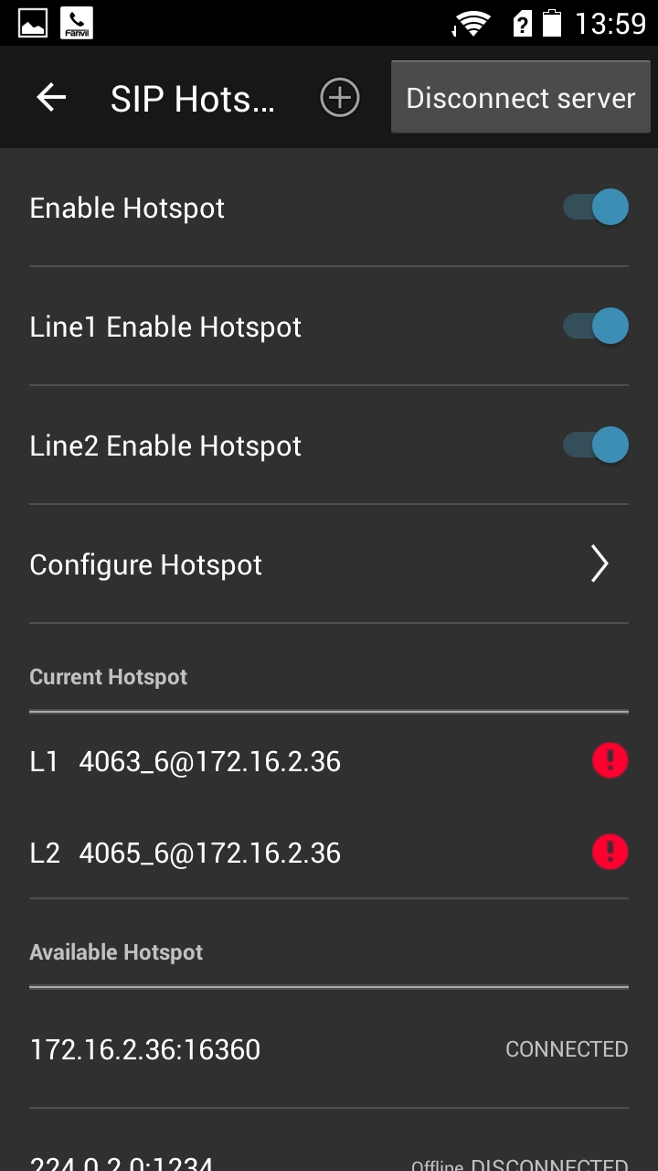
Step 3: Select the eligible hot spots in the available list, then connect it.
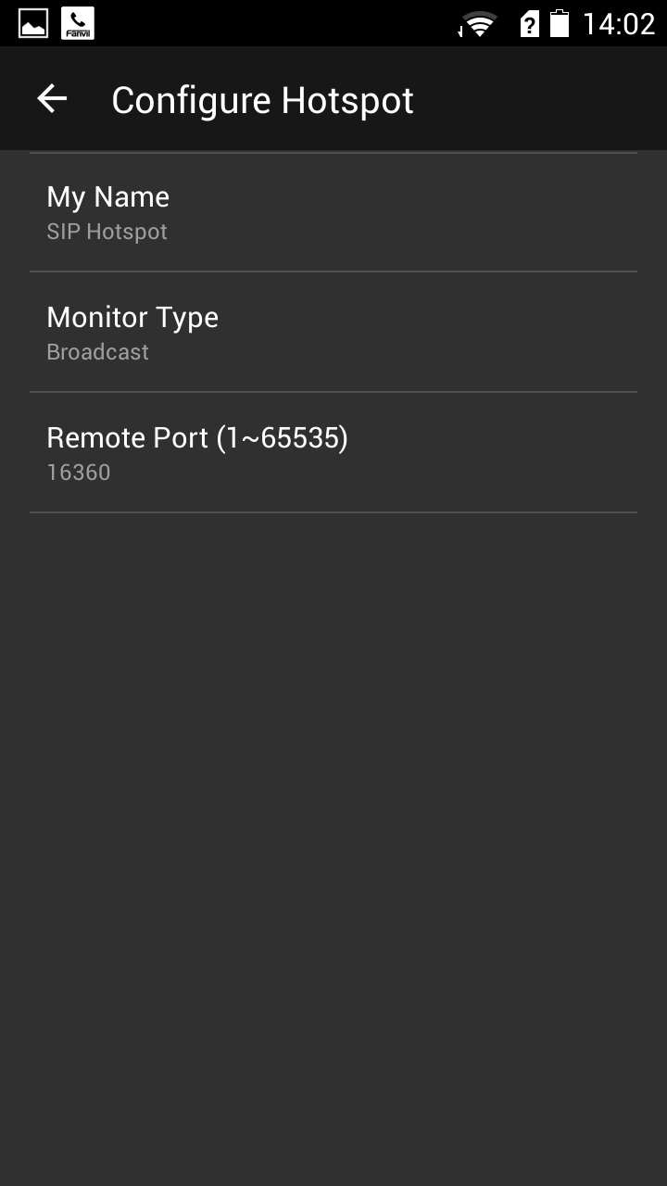
Step 1: Open hot spots and hot line.

Step 2: Setting the filter rules,and each field value and server value should be same .

Step 3: Select the eligible hot spots in the available list, then connect it.

    - Disconnect

Step 1: see about currently hot spots status.
Step 2: click on disconnection button. The account will be unregister after disconnection, and the currently hot spot info will be empty.
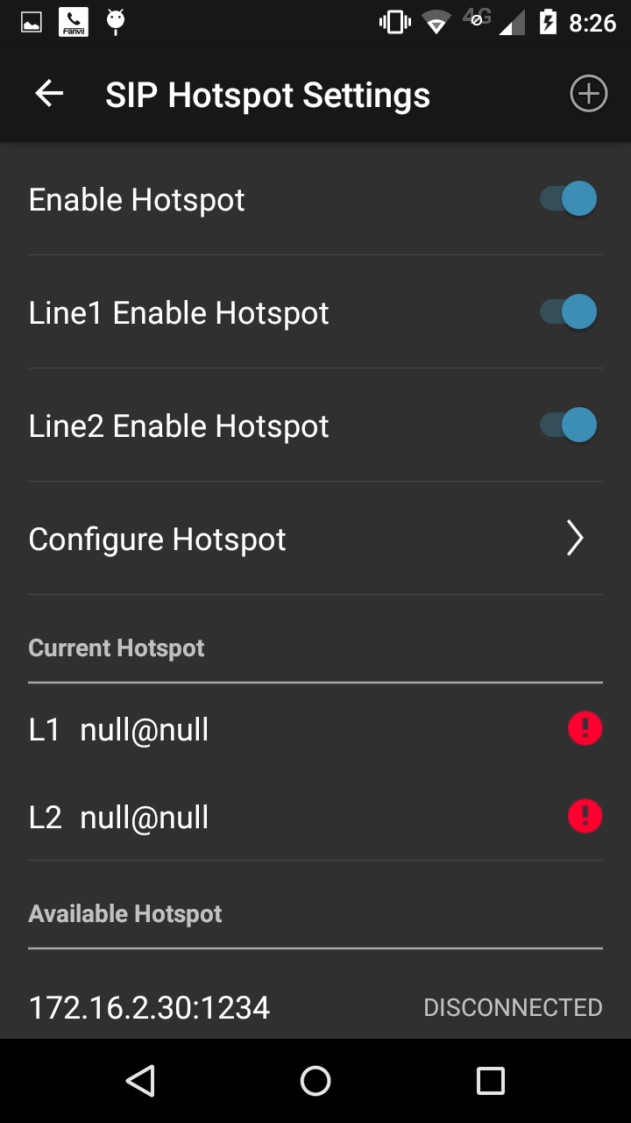
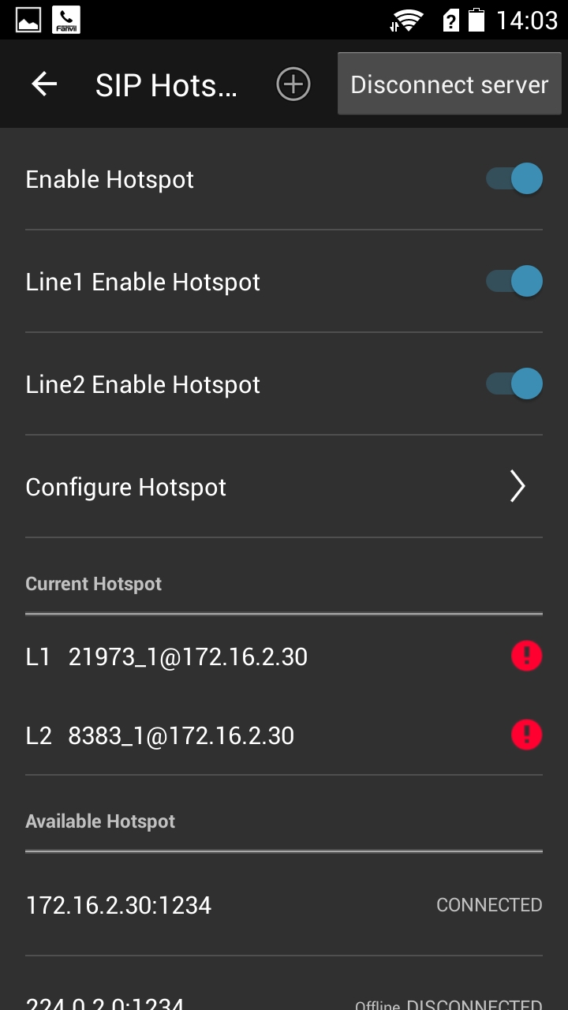
Step 2: click on disconnection button. The account will be unregister after disconnection, and the currently hot spot info will be empty.

Step 1: see about currently hot spots status.

  - Account Settings
VDroidphone is support to two accounts.
Accounts include basic Settings and advanced Settings. Basic settings include the basic info of account registration, advanced Settings are include with transferring, protocol ,encryption and so on.
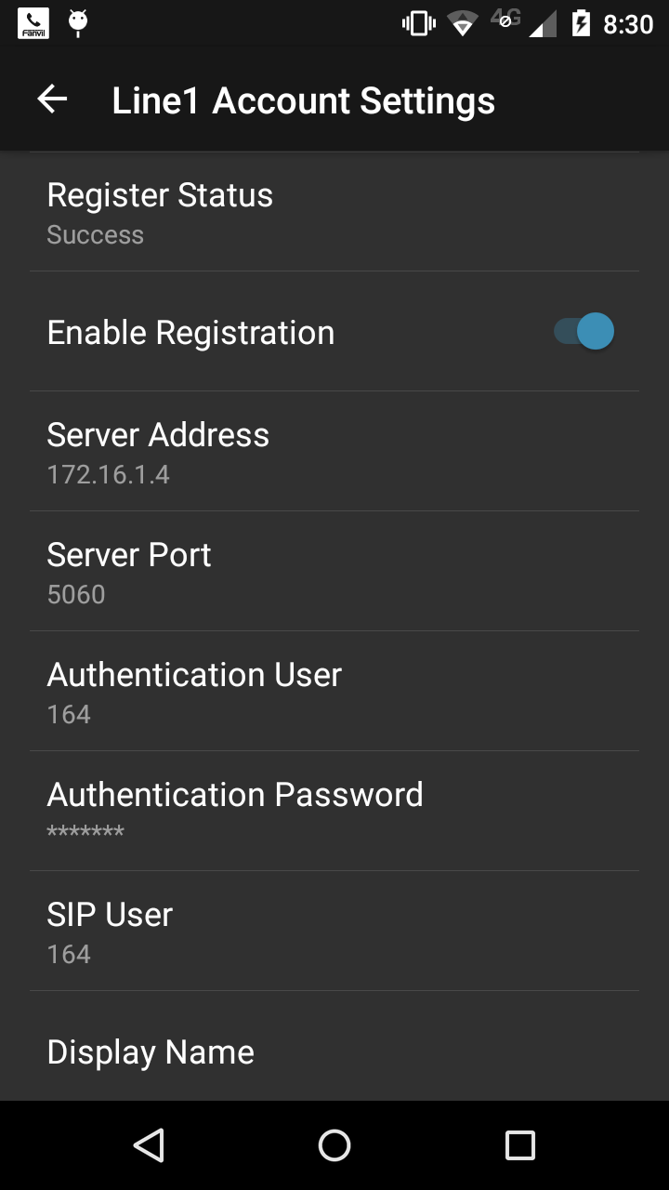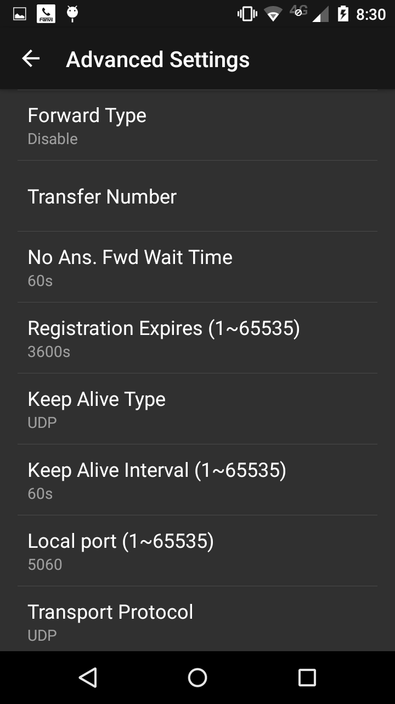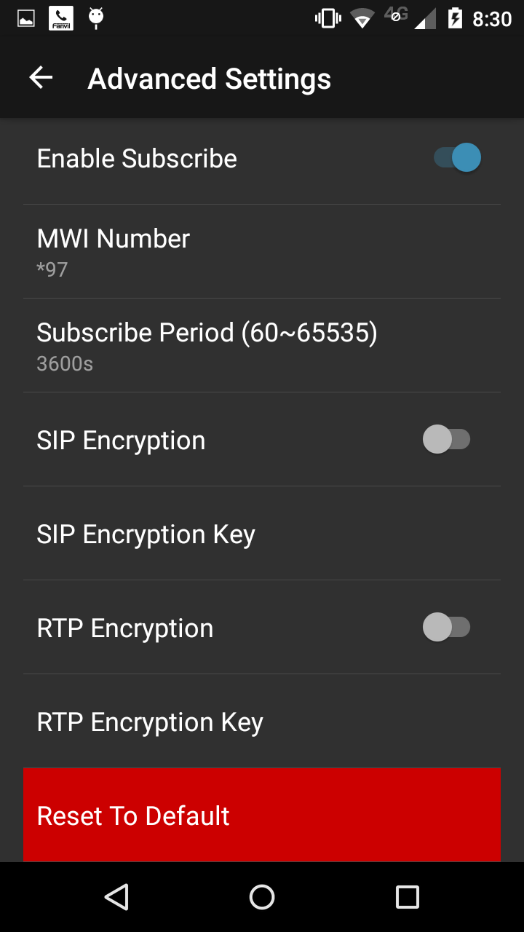

Account Settings
Field Name | Explanation
Basic Settings
Register Status |  | Shows registration status. Will show “Registered” if registered or “Unregister” if not registered.
Enable Registration |  | Enable/Disable register
Server Address |  | SIP server IP address or URI.
Server Port |  | SIP server port.Support in the form of domain address
Authentication User |  | SIP account name (Login ID)
Authentication Password |  | SIP registration password.
SIP User |  | Phone number assigned by VoIP service provider. Phone will not register if there is no phone number configured.
Display Name |  | Set the display name.Can be displayed on the called party,allows input English letters
Domain Realm |  | Configuring SIP local domain name. If the server does not require a local domain name for the specified SIP terminal domain, local domain name server can be configured to the same address or domain name. To simplify user input system, users do not have to enter the local domain name, the system will automatically fill in the address fetch register domain realm content
Advanced SIP Settings
Forward Type |  | Select Forward Type. Call Forward (off by default)  Disabled：No call forwarding – Default mode  BusyForward：If the phone is busy, incoming calls will be forwarded.  No answerForward：If there is no answer, incoming calls will be forwarded after a specified time.  Always Forward：All incoming calls will be forwarded.  When call forward, the machine will prompt a call
Forward Number |  | Number to which calls are to be forwarded
No Ans. Fwd Wait Time |  | Used in conjunction with Call Forward No Answer. Wait time in seconds before call is forwarded.
Registration Expires |  | SIP re-registration time. Default is 3600 seconds. If the server requests a different time, the phone will change to that value.
Keep Alive Type |  | Specifies the NAT keep alive type. If OPTION is selected, the phone will send OPTION sip messages to the server every NAT Keep Alive Period. The server will then respond with 200 OK.  If UDP is selected, the phone will send a UDP message to the server every NAT Keep Alive Period.
Keep Alive Interval |  | Set the NAT Keep Alive Interval. Default is 60 seconds. If the phone open SIP detection server function, the phone every time configured to detect whether a server response
Local port |  | Each line separate ports
Transport Protocol |  | Set transport protocol TCP, UDP .
DTMF Type |  | DTMF Type has three mode:  - DTMF_RFC2833  - DTMF_SIP_INFO  - DTMF_AUTO  different server provide different mode
Enable Rport |  | Configuration is supported RFC3581，rport is used in internet,needSIP server provided，support the connection of NAT between internet and the network
Enable Subcribe |  | subscribe the state of other number and voice mail.etc
MWI number |  | Notice and hear the voice mail  the MWI light flashing when have voice mail ,otherwise the light out,dial MWI call voice mail number to hear the mail
Subscribe Period |  | About Subscribe Period time
SIP Encryption |  | Whether to support SIP encryption
SIP Encryption Key |  | Input SIP Encryption Key
RTP Encryption |  | Whether to support RTP encryption
RTP Encryption |  | Input RTP Encryption Key
Reset To Defult |  | Clear all configuration ,reply to Factory settings

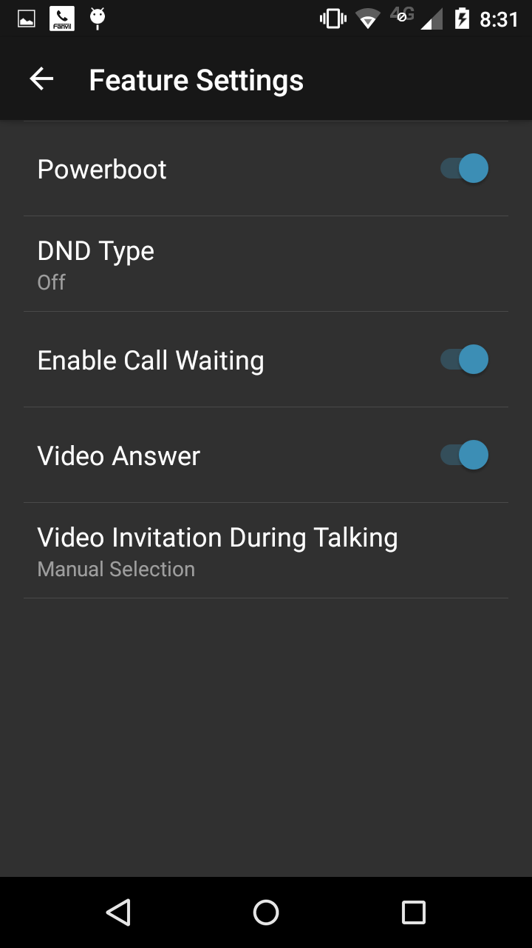
  - Feature Set
FieldName | Introduction
Power boot | Sets whether vdroid startup
DND type | DND type:  - Turn off：don't open DND.  - Phone： The software will not open DND mode, including two lines and IP call will be rejected.  - line：after select line,the below will appear line options,you can choose the DND line according to your need.
Call waiting | Turn on：new call will not be rejected when the line is busy, there will be a warning tone to noti you.  turn off: new call will be rejected when the line is busy.
Open the video call | When have a video call, its decide to whether we allow video call or not.
Call video invitation | The other sides sent invitation during voice calls and our actions.  Manually choose: manually choose to accept or reject.  Automatic answer: automatically accept video invitation.  Automatically rejected: automatically refused video invitation.

  - The media Settings

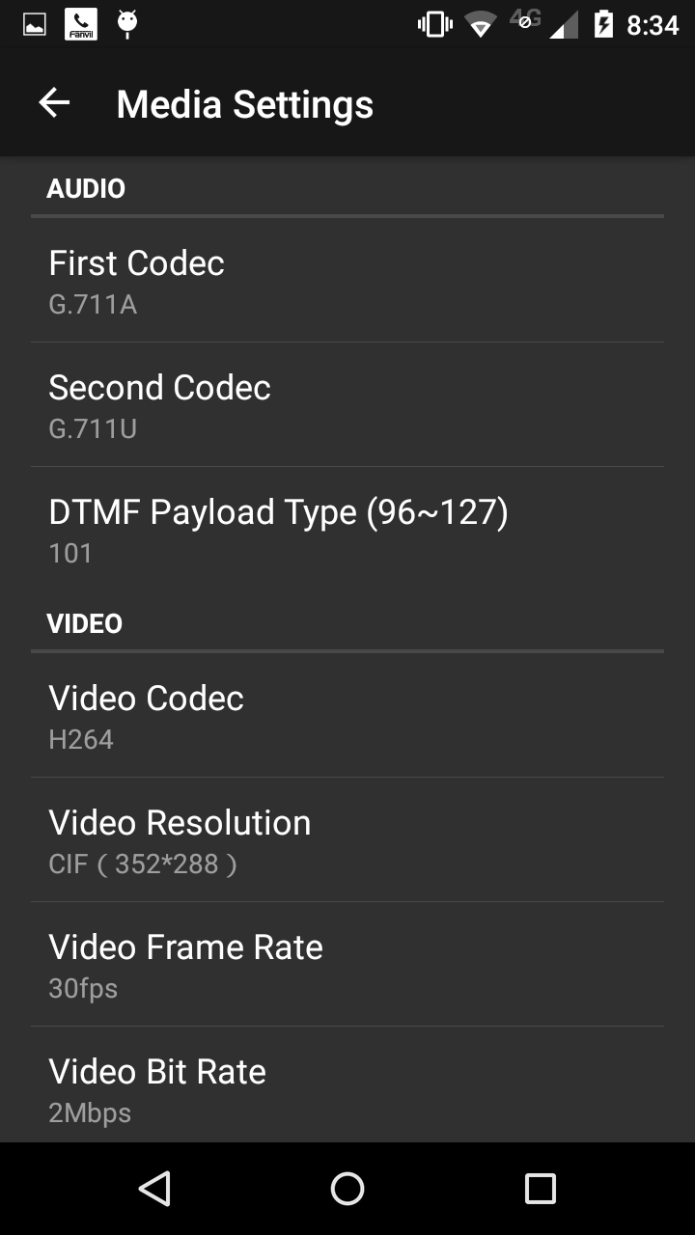
fieldname | Introduction
voice
First Codec | Choose DSP first priority Codec algorithm：G.711A and G.711u
Second Codec | Choose DSP Second priority Codec algorithm：G.711A and G.711u
vedio
- Video Codec

Video Resolution | Setting the Video Resolution in vedio call . we provide three types for choice: "QCIF (176*144)", " CIF (352*288)" ,"VGA(640*480)".
Video Framerate
Call broadband

  - limit Settings

The limit settings includes blacklist setting and white list Setting.
The number in the blacklist will be rejected when call up. When the DND mode,the number in the white list can call in.
The add and remove way of Backlist and white list are same. So, The following explanate blacklist operation only.


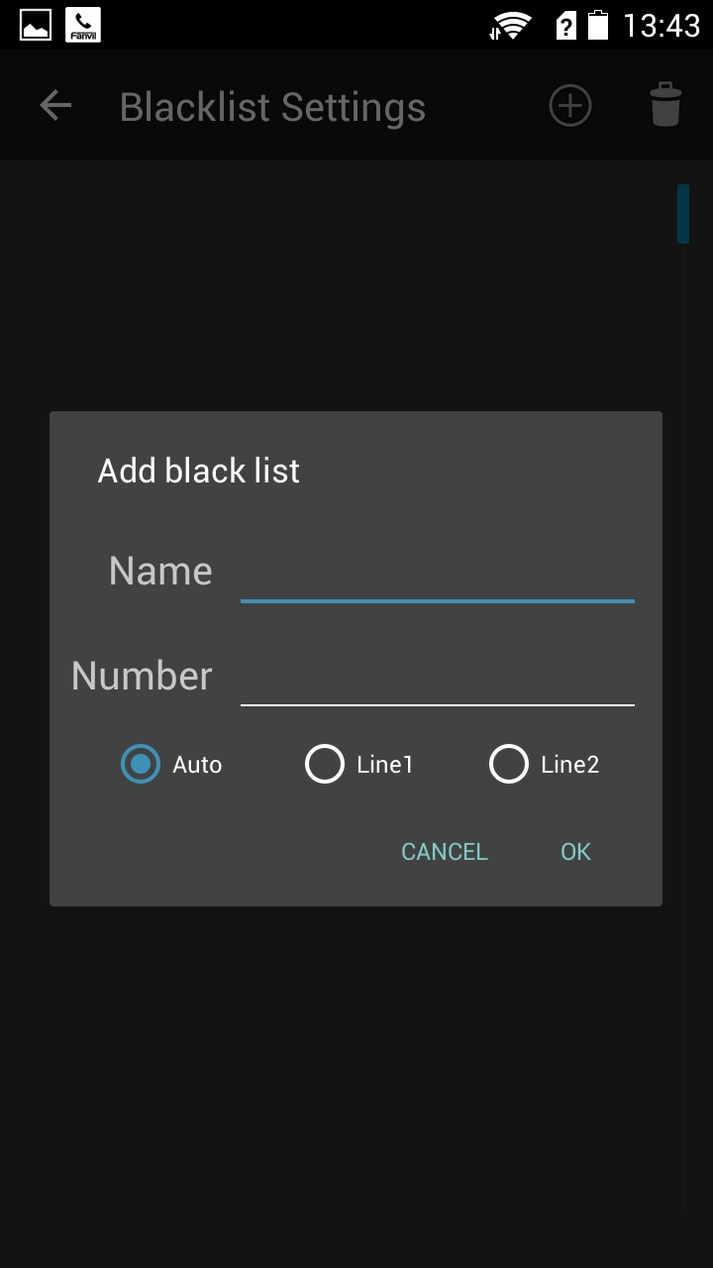
add
delete

1.Add the interface.
2.Click on the add button or remove button to operation.

  - Advanced
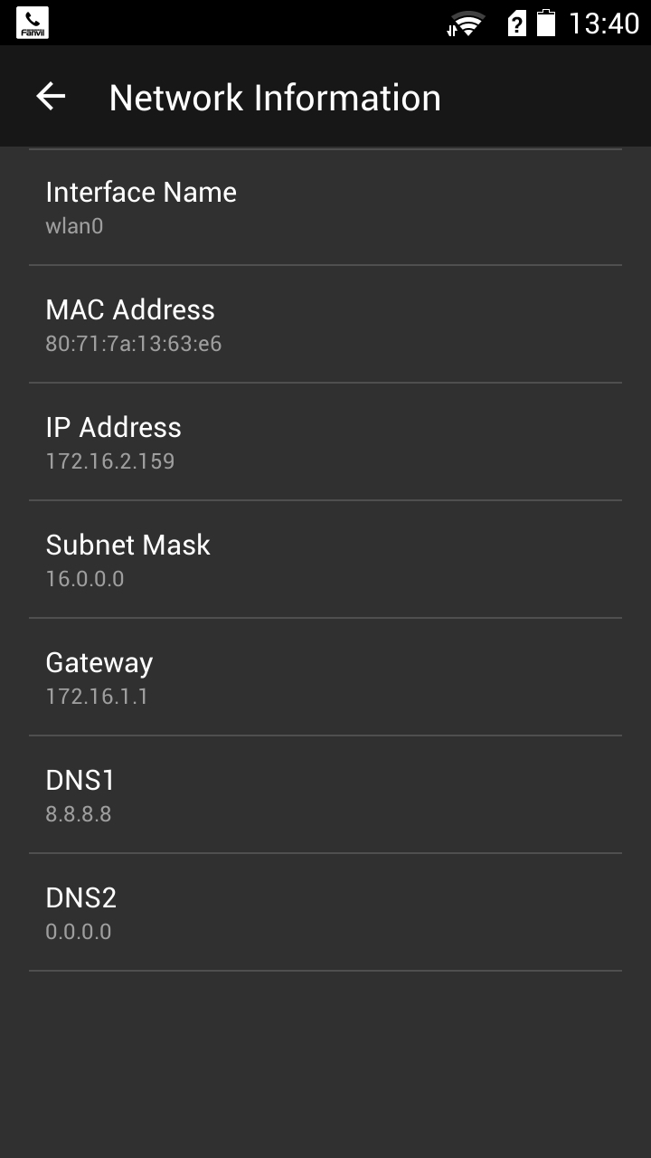
    - Network

Network Information
Check your phone's web information,
You can use IP for IP dial.

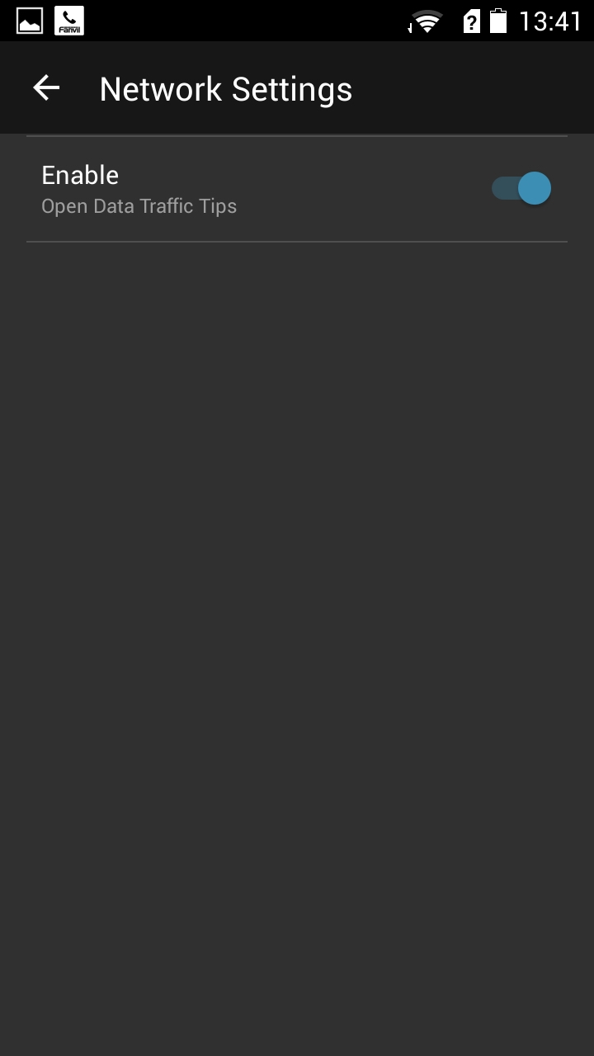
Network Settings

Whether to enable “Open Data Traffic Tips”,
If enabled, when you use data traffic, the user will be prompted.

STUN
Field Name | Explanation
Server Address | Setting SIP STUN server address
Server Port | Setting SIP STUN server port
Local SIP Port | Setting Local SIP Port ， The default is 5060(This port with immediate effect, modified, SIP call will use the modified port for communication )
Line1 | Line 1 whether STUN enabled
Line2 | Line 2 whether STUN enabled
Note:SIP STUN is used to realize SIP penetration to NAT, Implementation is a service, When the phone is set STUN server IP and port (default is 3478), and check the Use Stun later, you can use an ordinary SIP Server to realize penetration to NAT
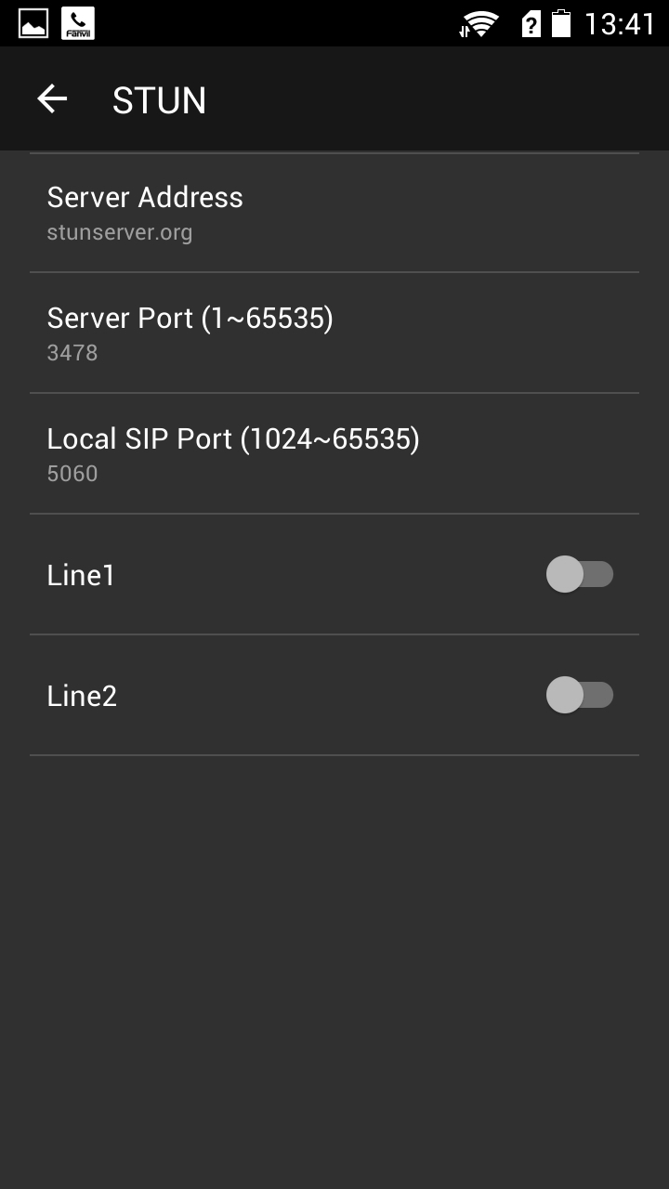
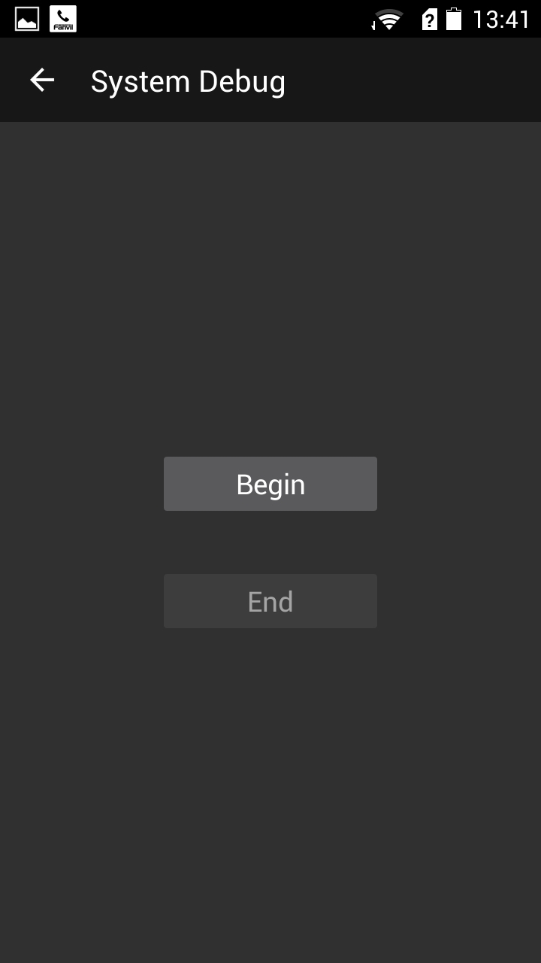
    - System Debug

When a system problem occurs, debug information can
be obtained through the system debug, Convenient
positioning of R & D personnel.

    - Back-Up

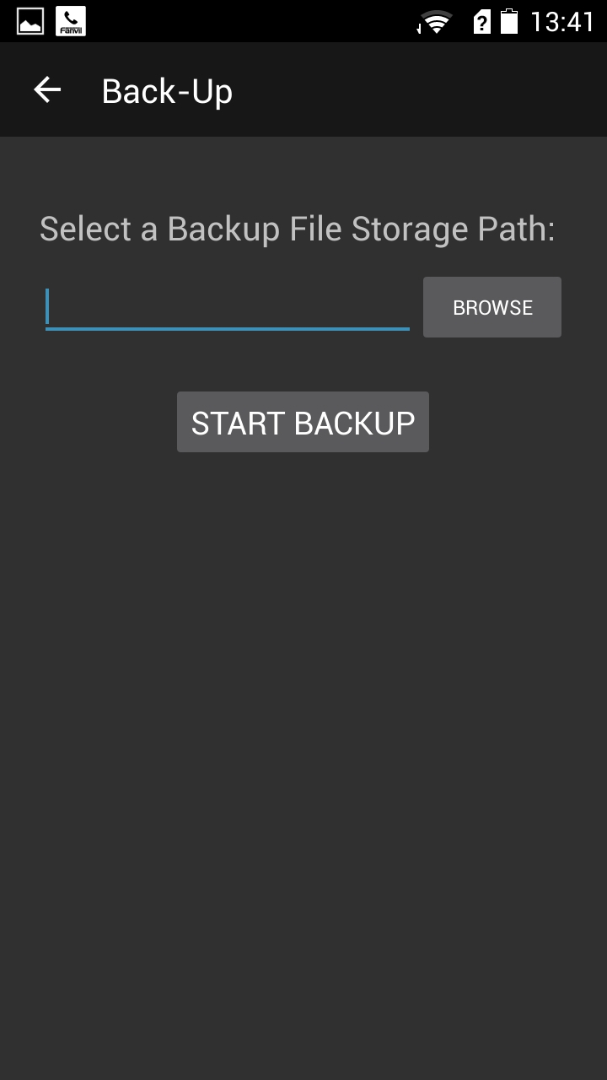
Support for information
systems Backup and restore Backup

    - Configuration Guide

When you install the software first star, To enter the Configuration Guide, Users can choose to enter the Configuration Guide or use their own(Exit the configuration Guide, directly into the software)

Configuration Guide will lead the user through the basic account configuration, Including manual registration account and connect to the hotspot.
Refer to chapter 5.1 Manual registration account, Refer to chapter 5.2 to connect to the hotspot.

    - Restore Config

Empty the entire software configuration, the software will automatically restart after emptying, without affecting Android devices.

About
  - Company profile

The introductions of Fanvil company's specific situation.

  - Help

Basic usage information.

  - Check the updates.

Check the new version and user decides to whether updates it or not.

Quit
After exit can not accepted any call and account unregister.

