- Put the server(your computer) and phone in the same hub(or at same lan network ),or contact the computer with lan port of phone.
- Make the Phone enter post mode: power off long press “#”power on ,Release # button until phone UI shows post mode.
- Set the ip of computer to 192.168.10.99
- Open ftp server, add a user, the username and password is: username/userpasswd
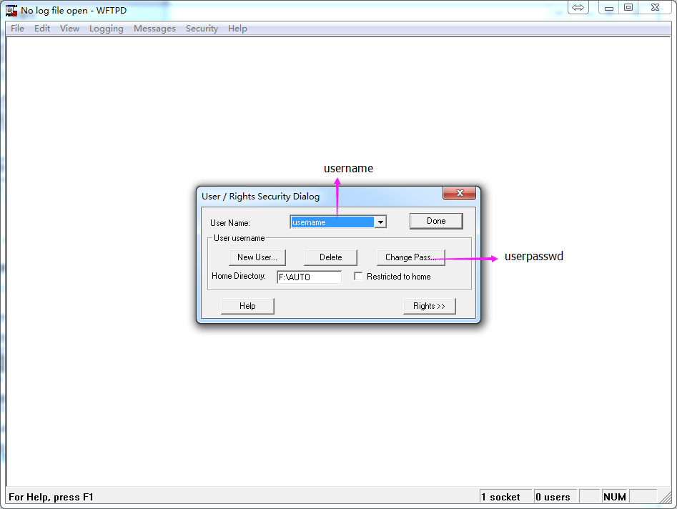
- Open the computer's Command Prompt window,
- telnet 192.168.10.1
- Enter u
- Enter voipwl
- The flashfile.bin will upload to ftp download directory
