Release Note

Software Version：R2.3.2.4600
Models： X3S、X4、S4、S2、X2、F3
Date： 2017.12.12

1 Adding New Features
1.Online Firmware Upgrading
2.Icon to indicate voice quality during the call
3.Recording function on 3CX server
4.Support 3CX hotdesking function
5.Support call transfer\hold\conference through DTMF
6. Support receiving SIP server address via DHCP “Option 120”
7.Support receiving VLAN ID via DHCP “Option 132”
8.Support MAC header in SIP messages but not carried by default

2 Optimization
- Optimized sip timer processing
- Optimized sip display name processing
- Optimized DSS page turning function
- Optimized the format of date display
- Optimized firmware upgrading visual indication, added progress bar
- Optimized SIP TCP/TLS STUN
- Optimized phone book, support turning pages by long pressing up/down button
- Enable phone to be effective immediately after upgrading configuration files, no need to re-start.
- Enable both firmware upgrading and downgrading

3 Bug Fixes
- Fixed the feature of related compatibility problems of TR069
- Fixed the feature of contact query related issues
- Fixed the feature of 3cx server auto parts in some cases
- Fixed the feature of the seting of speed dial keys in DSS, and if the number has multiple "*" problems that cannot be correctly dialed
- Fixed the feature of X3S cannot update the contact problem on 3CX PBX
- Fixed the feature of after the name of the SIP server was long, the problem of system abnormality was obtained after obtaining the DHCP IP
- Fixed the feature of when intercom calls are fixed, in some cases it will be switched to the handle channel problem
- Fixed the feature of name problem was not displayed according to the set priority during the call
- Fixed the feature of background image of 3cx shows the problem of white dots
- Fixed the feature of after failure of the TLS/TCP network exception registration, the registration issue will not be reinitiated
- Fixed the feature of in some cases, a wrong number will be called out in BLF/Atransfer

4 New Features Descriptions
1.Add firmware online upgrade function
Description： The automatic upgrade of firmware can be achieved through the configuration of the web page.
1.Web - system - upgrade page, fill in available upgrade server address, and if there is a new version on the server, the page will display version information and upgrade button will become available; Click upgrade to see whether the updated version is updated.
On the website, the Lcd - software version will also have the upgrade button, and the version will be updated.
2.Enable automatic escalation, fill in update cycle, and the chance to periodically update the update.
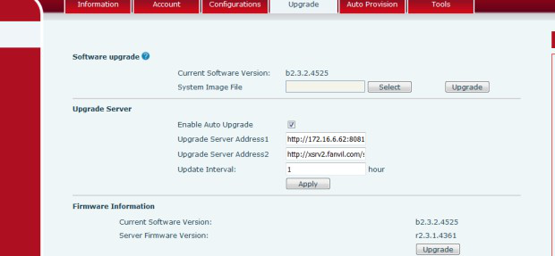
Web page configuration:

LCD display is as follows:
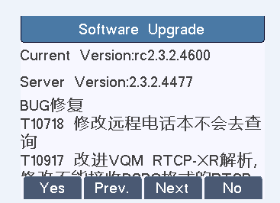
Click on the web page upgrade button or the LCD yes to upgrade the new version.
2. Add the voice quality icon in the call
Description： The voice signal quality of the two sides of the phone, the interface LCD has the corresponding icon prompt, which will be displayed according to the strength of the signal, as shown in the figure:
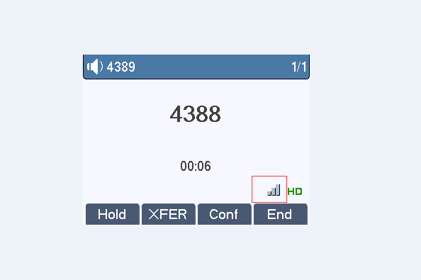
3. Add 3cx server recording function
Description： Support 3cx server recording function on call
Add new configuration items under the <RECORD CONFIG MODULE> MODULE
Type： 0:sip info
The webpage is as follows:
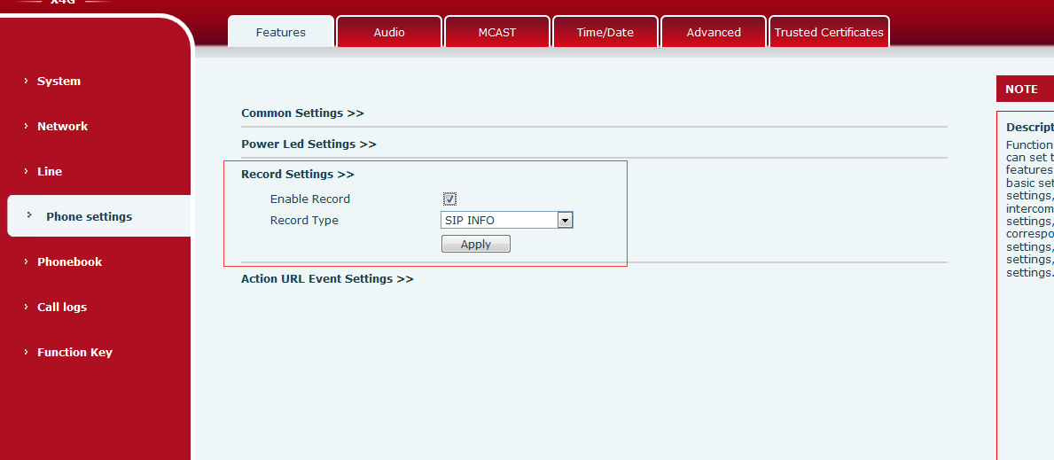
Usage:
The phone is registered with the 3CX server account, while the phone page is checked for Enable Record, and the type selects sip info
Then, the function key is set to the record key, the test phone call, press the recording key, the phone starts recording, press the recording button again, and the machine stops recording.
The recording module of the 3CX server will see the corresponding recording file
4. Support to achieve transfer\hold\conference function through DTMF
Description：By web export phone configuration file, the xfer, hold, the conf specified configurable DTMF content, call according to hold/transfer/conf, corresponding model of DTMF content directly to send a call interface remains the same, the DTMF content of hidden function keys.
Page shortcuts page, add BLF subtypes: BLF/DTMF, press this function button, and change to send DTMF on the call. When standby, SIP call BLF corresponding number.
The website configuration is as follows:
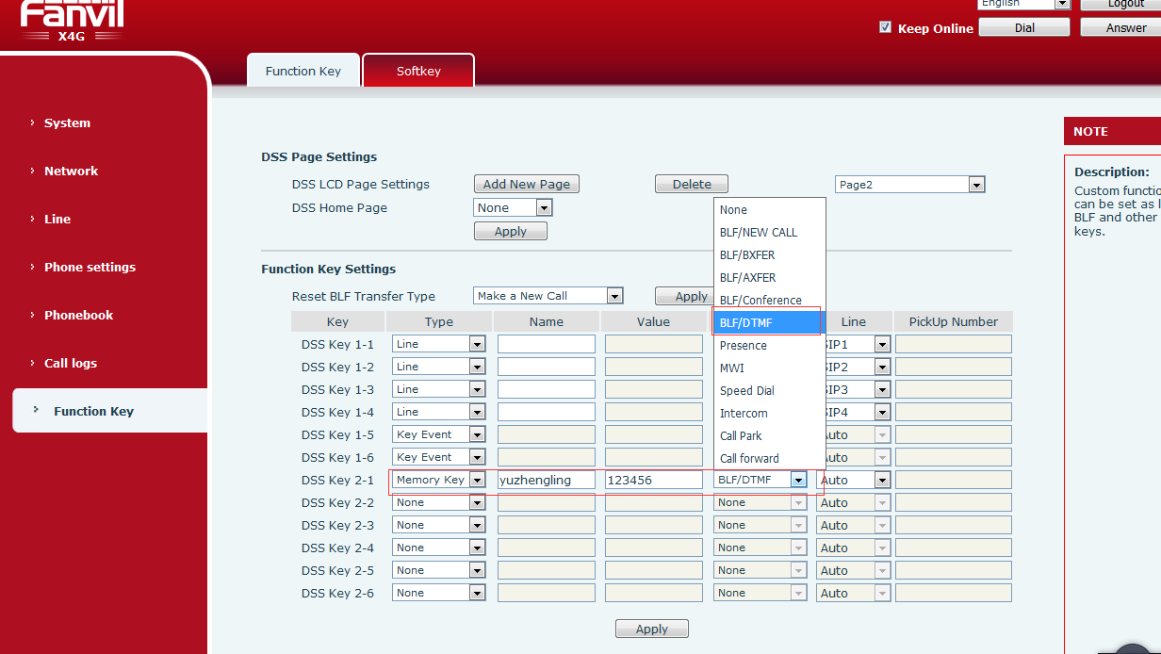
5. Support SIP account via DHCP Option 120
Description：The registered server address of the SIP account via DHCP Option 120
The web page adds configuration items as shown in the figure below:
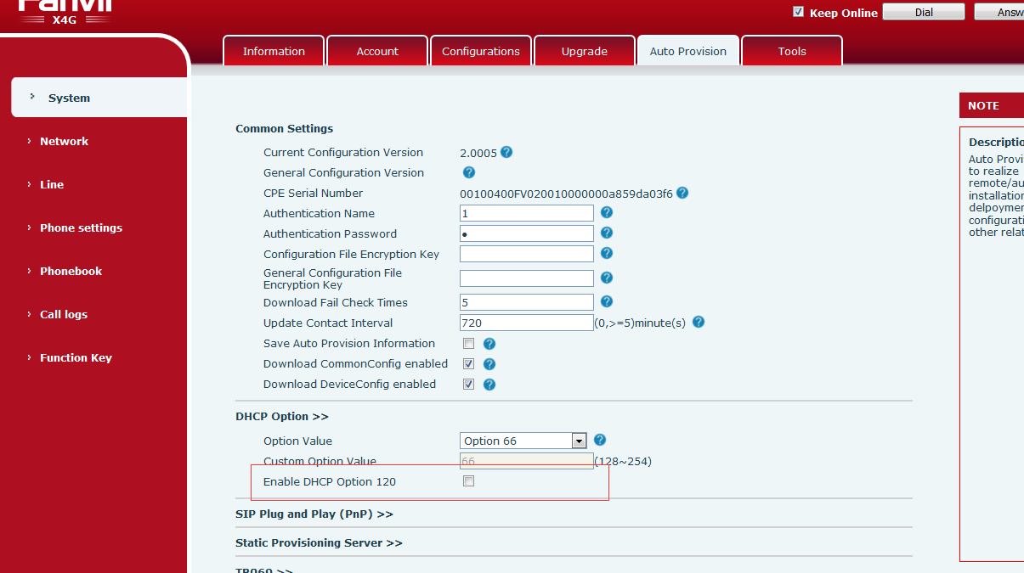
The Dhcp server configuration is shown in the figure:
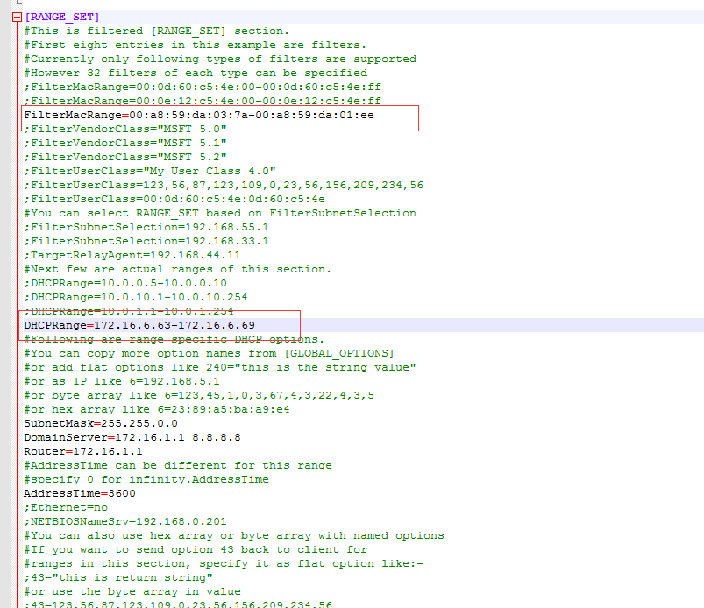
So in the MAC segment above, we're going to make sure that we're in the MAC
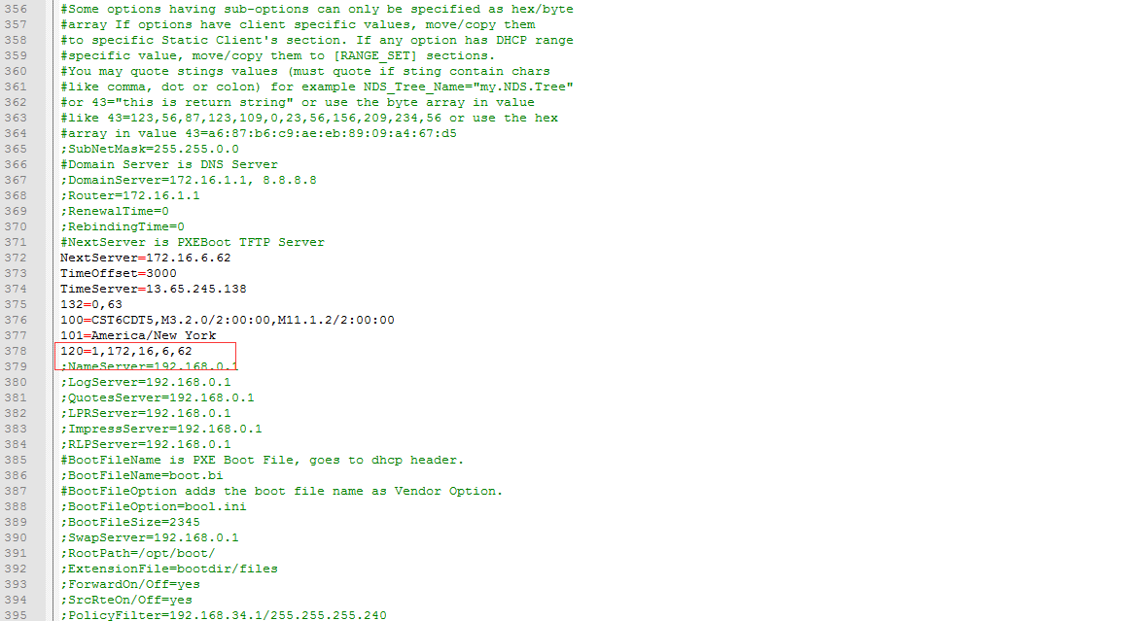
Option 120 configuration is shown in figure, where 172.16.6.62 is the server address of our server to sip server.
After configuration is done, the server can restart the machine to restart the phone. After the restart, the server address is the address of the next address.
6. Support DHCP Option 132 for vlan ID function
Description：By means of DHCP Option 132, a vlan ID function is obtained by the phone. After the phone is switched on, the vlan ID is not taken to obtain the DHCP, and the DHCP is retrieved after obtaining the vlan ID.
DHCP option supports custom (128-254), which is vlanID, 2 bytes, and cannot be duplicated with autoprovision.
Add option 132 at the DHCP server, as shown in the figure:
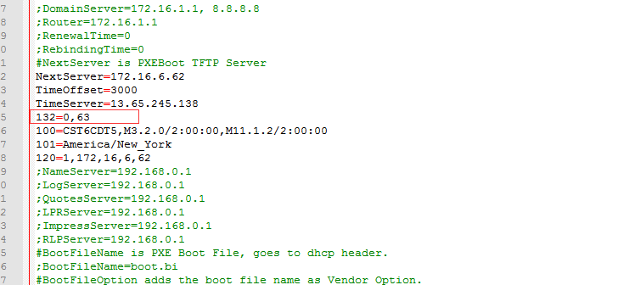
And 63 of them is vlan ID.
Web page setup:
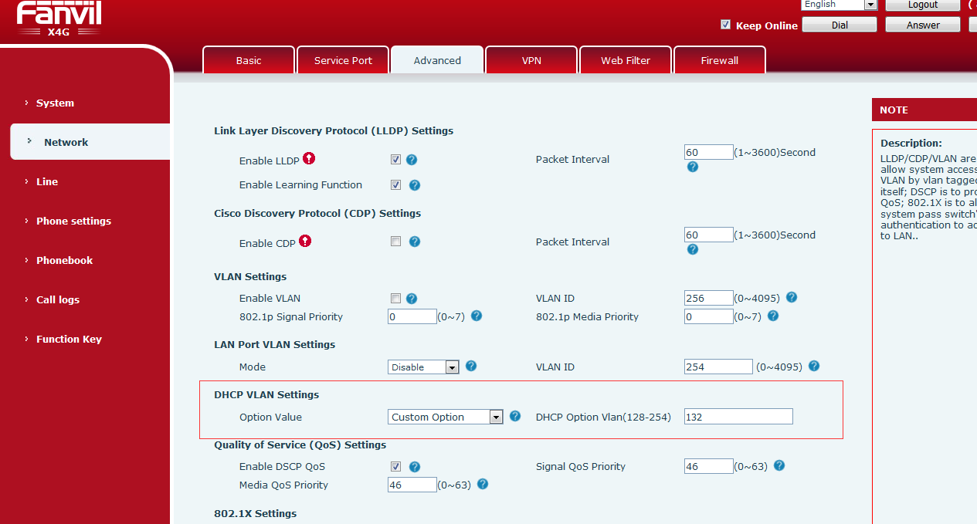
7. Add support version control and not upgrade to low version
Description：Configure file Autoprovision module to add "Enable FW Ver Check:" configuration item, you can control the version not to upgrade to the current version of the lower version, by default.
Enable FW Ver Check:1 cannot be degraded;Enable FW Ver Check: 0 can be demoted
8. Optimized the feature of not restarting real-time validation when upgrading configuration files
Description：The configuration file <GLOBAL CONFIG MODULE> adds "CFG Update Realtime:" configuration item, which is closed by default and does not need to be rebooted when the phone is updated.
Note: This function is only for some modules, and some modules still need to be rebooted to take effect.

