Release Note

Version：R2.2.0.3685
Model：X3S/X3G/X4/X4G
Date： 2017-07-15

1 New Features
- Added the feature of web help documentation
- Added the feature of search incoming call and outgoing call in Broadsoft directory
- Added the feature of web page can show about Cloud phonebook
- Added the feature of dsskey access to cloud phonebook
- Added the Code Plan feature
- Added the feature about continue to send RTCP Recv Report at hold states
- Added the feature of cdp
- Added the feature of custom music ringtone
- Added the feature of group listen
- Added the feature of hardware watchdog
- Added the feature blf list of voipswitch serve

2 Optimization
- Optimized the feature of LDAP search
- Optimized the feature of sip header shorthand
- Optimized the feature of payload negotiation mechanism, priority using remote parameter values.
- Optimized the feature of search expire method when sip Registration receive more than one contact field in 200 ok
- Optimized the feature of Call forward feature code, and support carrying number to report
- Optimized the feature of Switch Input Method
- Optimized the feature of flash read-only file compression
- Optimized the feature of screen protection and energy-saving feature
- Optimized the feature of xml pbook search feature.
- Optimized the feature of color on the LED lights in different condition
- Optimized the feature of sip group backup feature
- Optimized the feature of RTCP XR - JSON format
- Optimized the feature of backup function in double image
- Optimized the feature of Chinese and Japanese font
- Optimized the feature of Japanese on web pages

3 Bug fixes
- Fixed the gigabit version phone, which is slowly to get access the web via a LAN port
- Fixed the problems that the network phone could not display on some browsers
- Fix the problem that the uaCSTA could not connect after the network reconnect
- Fixed the import HTTPS and sips certificate files were not successful
- Fixed the problem of - 4:30 wrong time zone
- Fixed the problem of priority over call Waiting before blind
- Fixed the problem when the Web user guest access was logged in
- Fixed the problem of auto provisioning pages could not save configuration items
- Fixed the problem of 16MB phone could only store 315 call records
- Fixed the problem of hot-spot issues
- Fixed the problem of LDAP display issue
- Fixed the problem of local contact queries with the last line of rows in the number query result
- Fixed the problem of language problems of web pages and LCD synchronization

4 New Features Descriptions

1 Added the feature of custom music ringtone
Description: The phone is imported music bell, and then this is the ring tone for the incoming ring tone;
The System upgrade on the web supports wav files, LCD/web can select music as incoming ring tone, and the web configuration was as follows: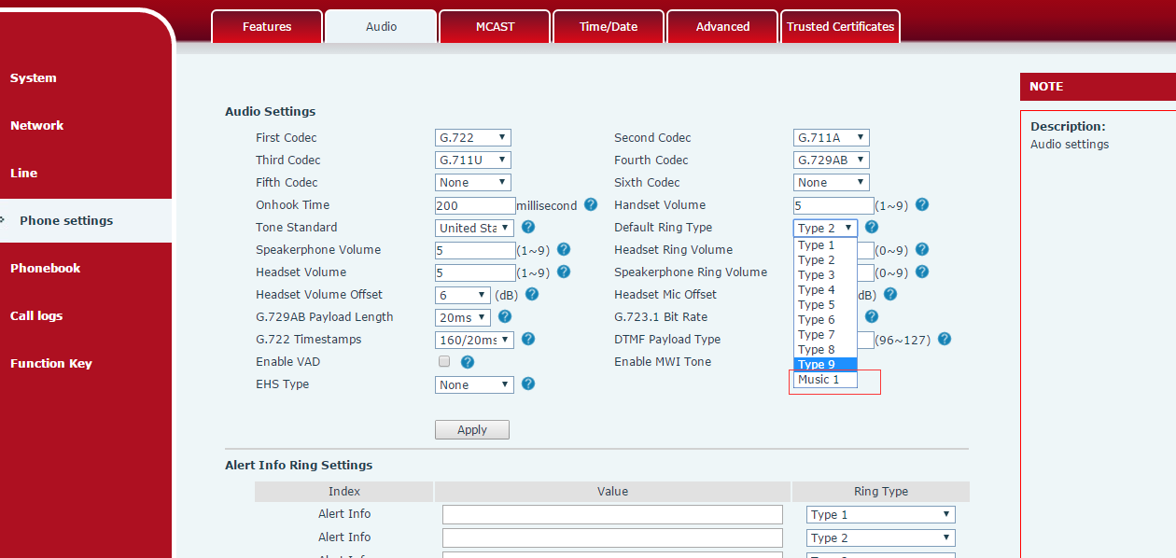

2 Added the feature of group listen
Description:The Group Listening function means to enable hands-free, with a handle or headset for simultaneous playback. Only the mic of the handle or headset can be picked up and the mic is closed.
The Web first sets up the function key to listen to the group, as shown:
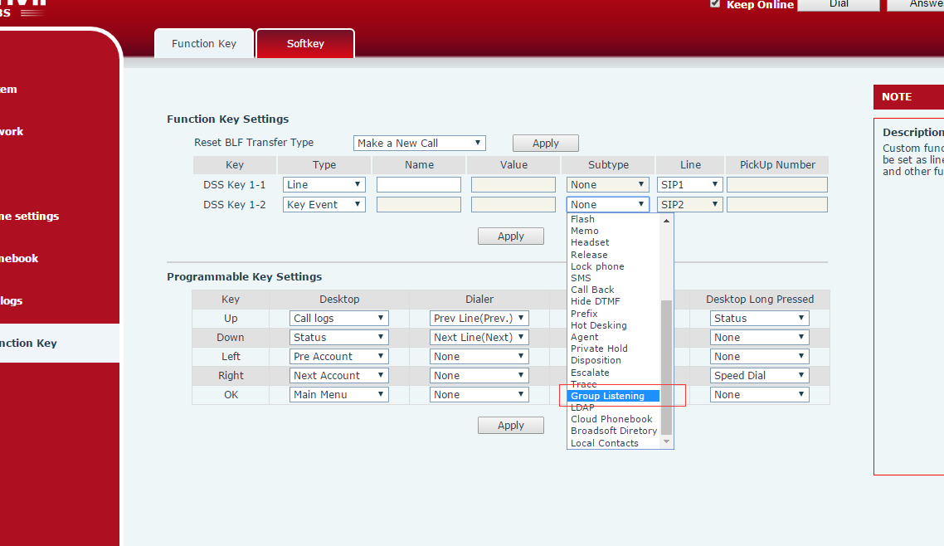
（1）The phone group : the test machine does the handle phone call, and the DSSkey key is used during the call. At this time, the handle and the speaker can hear the sound of the right side, but only the sound of the handle can be heard.
（2）Call group: firstly in the web configuration Ring From Headset as the group to listen to at the same time Auto Answer By Headset with good, test the unit insert the Headset, as shown in figure: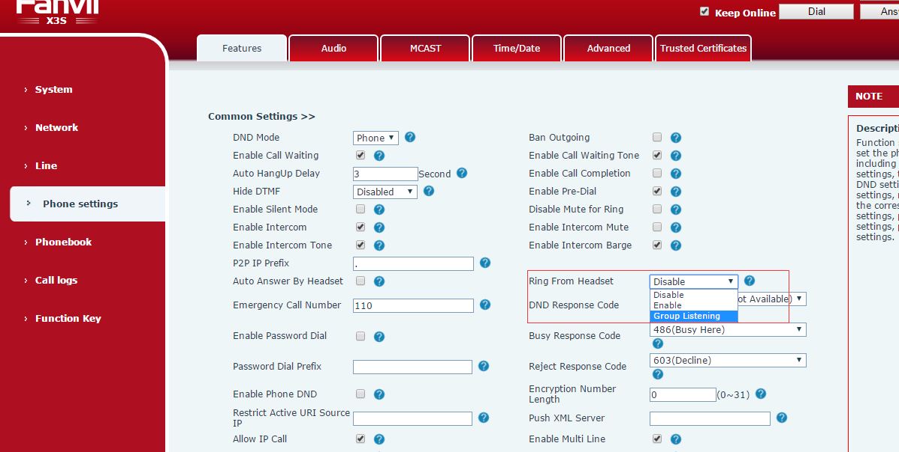
Then the auxiliary phone calls the test phone, and when the headset rings, the test phone is pressed to the DSSKEY,at this point, the phone Hands-free ringing and the headset rings.

3 Added the feature of hardware watchdog
Description: The hardware watchdog can automatically restart the recovery system if the device is abnormal

4 Added the feature of web page can show about Cloud phonebook
Description: The web phone web added the content of the cloud phonebook, mainly the user to view the cloud phonebook information and easy to used
These include two phone books: cloudphonebook and LDAP
(1) Cloudphonebook web configuration path: voip->phonebook->Cloudphonebook: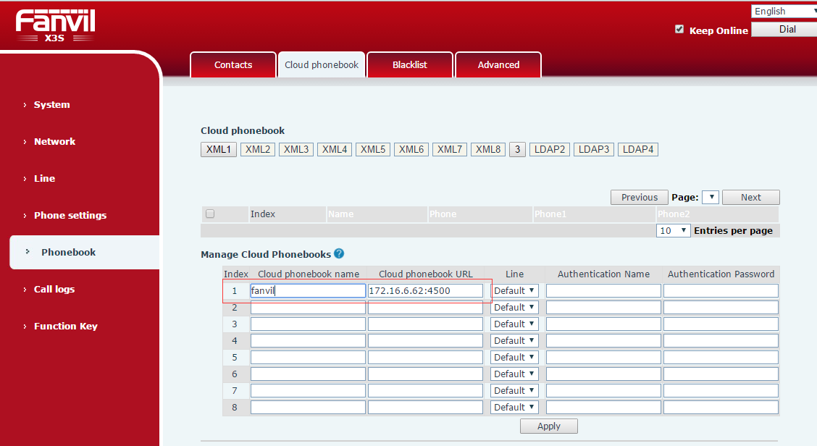
(2) LDAP configuration path: Web: voip-> phonebook-> cloudphonebook: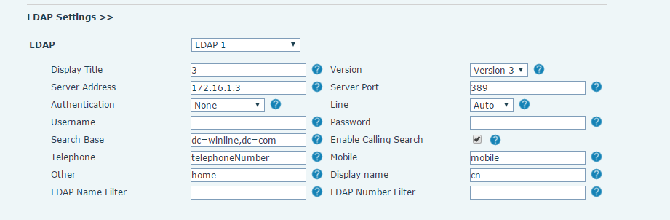
(3) WEB browsing: voip-> phonebook-> cloudphonebook: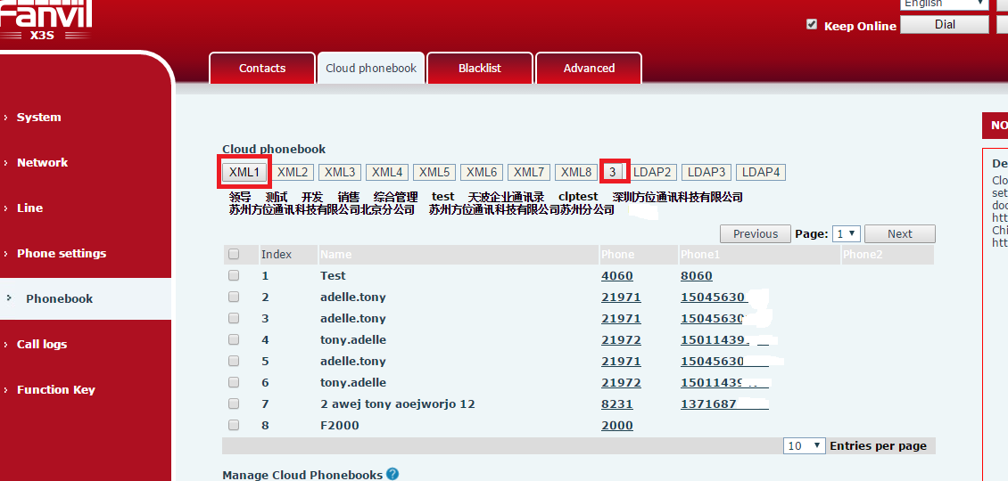

5 Added the feature of dsskey access to cloud phonebook
Description: Function keys - keyevent phonebook can be set to the local phone book and cloud phonebook, after, phone standby press the DSSKEY goes to the corresponding phone book and then can ues.
web configuration as shown in figure: