Release Note

Version:2.1.1.3263
Model:i20S/i30/i31S/PA2
Date :2017-10-31

1 New Features
- Add automatically upgrade for access list and dial peer(Door phone)
- Add system time display on Web GUI
- Support door control for Action URL list(Door phone)
- Enhance the Video configuration in the Web GUI
- Add manual reboot operation by keypads (Door phone)
- Add reboot management
- Support the vlan function for PA2(PA2)
- Disable AEC (echo cancellation) by sending DTMF for PA2(PA2)
- Add camera time synchronization

2 Optimization
- Enhance SIP egistration stability
- Enhance Post mode feature：
- Long-press key # and * go into post mode when the device is boot-up; for PA2, using button + and – go into post mode;
- Long-press # key to exit post mode for 5 seconds, while PA2 long press + button for 5 seconds to exit post.
- Enhance the web GUI display.
- Enhance SIP STUN processing
- Enhance TR069 processing
- Enhance audio quality (PA2)
- Enhance keyboard processing (Door phone)

3 Bug Fixes
- Fix the issue of memory leaks.(PA2)
- Fix the wrong of ua search rules
- Fix guest access causing device crash.
- Fix the problem that clearing door-access-log issue in the post mode.(Door phone)
- Fix the problem that dual-call processing.(Door phone)
- Fix the error of video codec flow limit.
- Fix the auto-reboot issue if the network disconnects more than 5 minutes.
- Fix the problem of the speed of the sowing key to hang up.
- Fix the problem of changing the camera connection mode do not work.(PA2)
- Fix the bug that sip enable TLS registration to cause the device crash.

New Features Descriptions
  - Add automatically upgrade for access list and dial peer(Door phone)
Description：You can use upgrade access list and dial peer via auto-provision method. The cfg items is listed in the below table:
Upgrade URL：
Auto AList Url :
Auto AList User :
Auto AList Password:
Auto DPeer Url :
Auto DPeer User :
Auto DPeer Password:
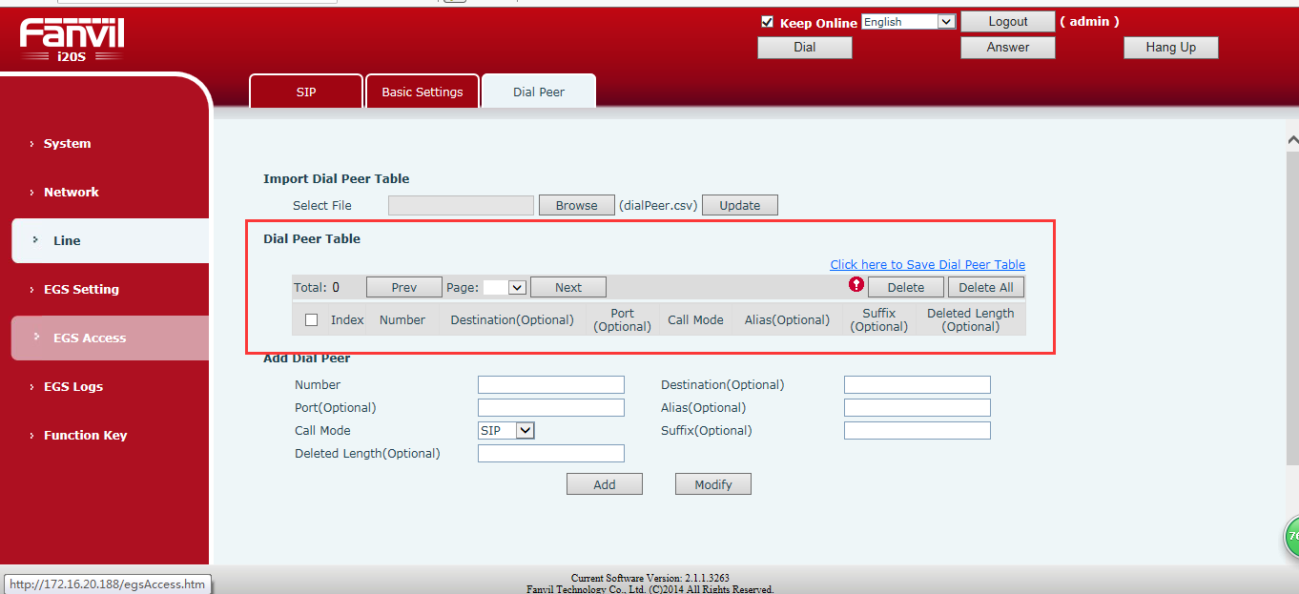
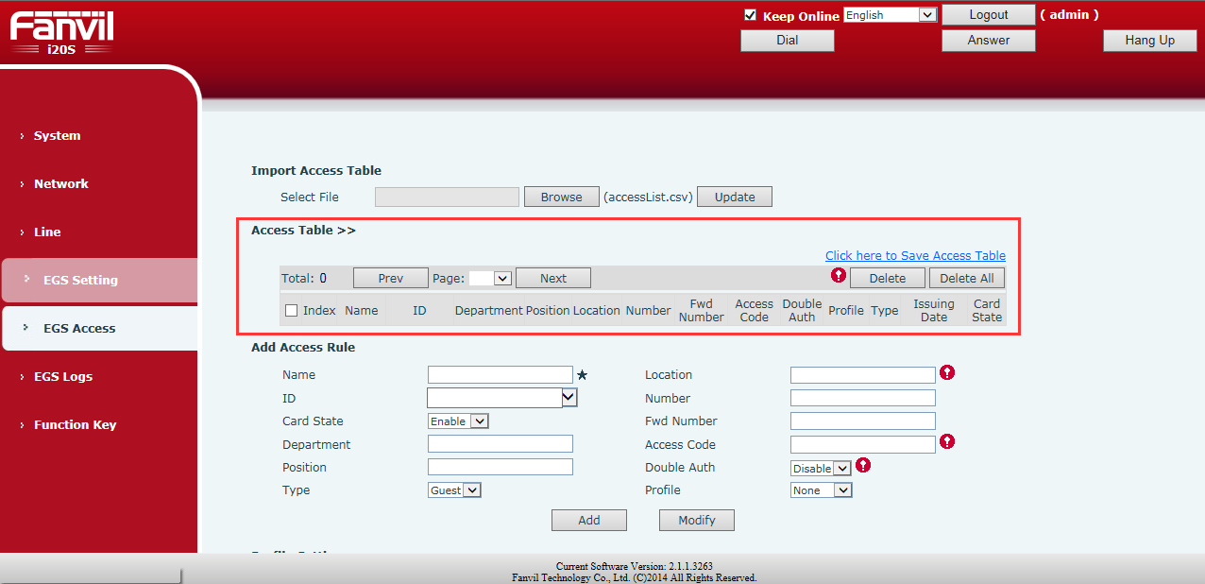
2. Add system time display on the web page
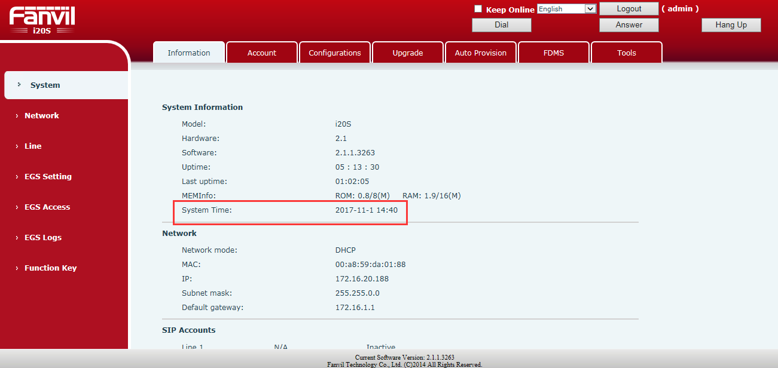
3. Action url list of door control (Door phone)
Web Configure paths：EGS Setting –Action URL
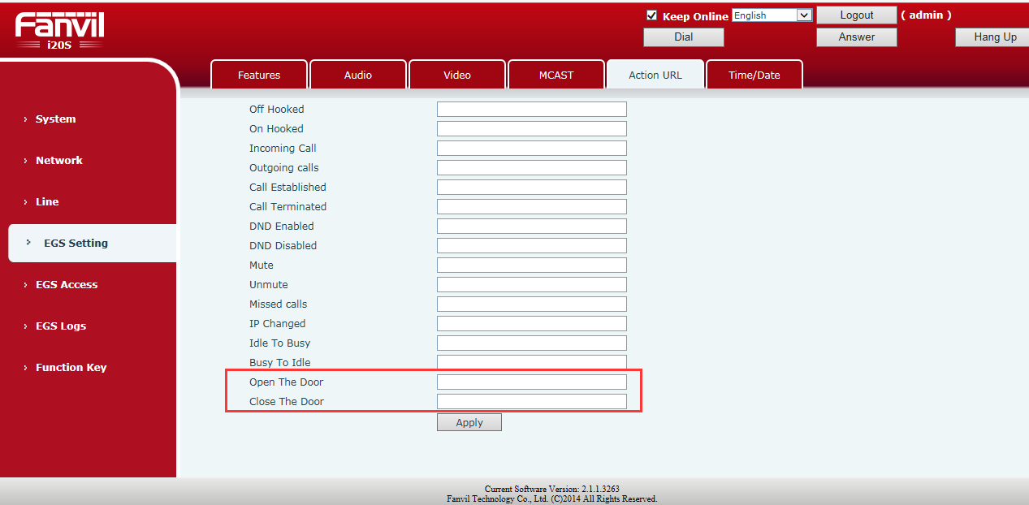
Description：input http://PC’s IP/DOOROPEN.xml? after the URL Setting of Action Enter; input http://PC’s IP/DOORCLOSE.xml? after the door close of Action Enter；It is not reported when the power is up, but only when the state changes.
4. Add a digital wide dynamic configuration for video
Web Configure paths：EGS Setting –Video
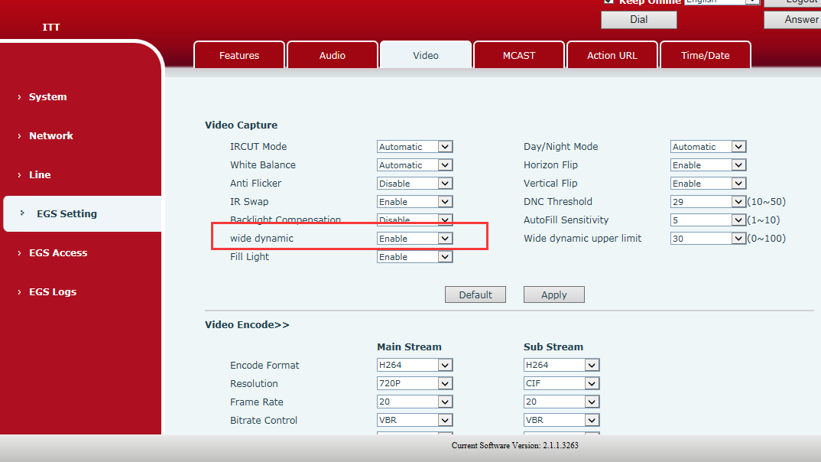
Description：Set wide dynamic enable，then set up video calling, digital wide dynamic associated with the optimization of backlit scenarios, is a time when people were in backlight conditions may be because the background is too bright, is a black man, after open will help to optimize
5.Add video direction configuration
Web Configure paths：EGS Setting –Video
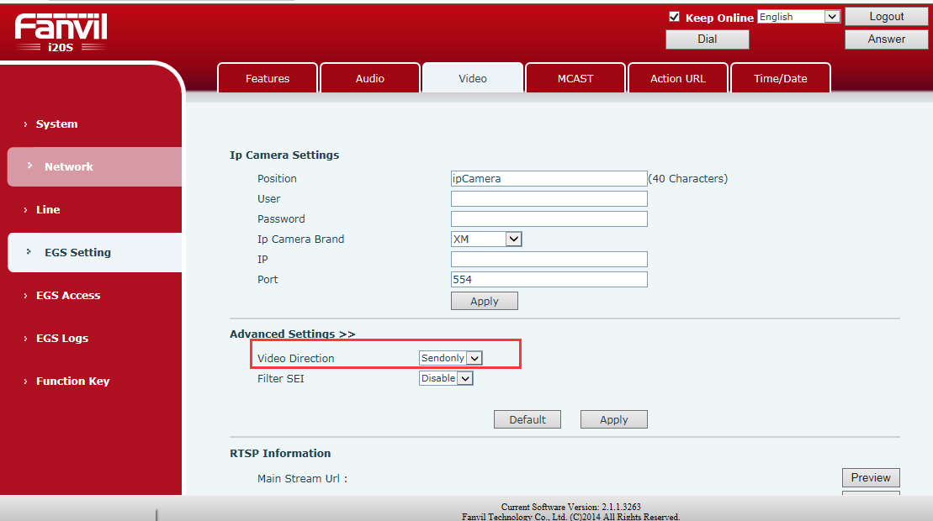
Description：Set Video Direction as sendonly，then Set up video call, and the SDP package in the invite package is sendonly；Set Video Direction as sendrecv，then Set up video call, and the SDP package in the invite package is sendrecv。
6. Enhance the Video configuration in the Web GUI
Web Configure paths：EGS Setting –Video
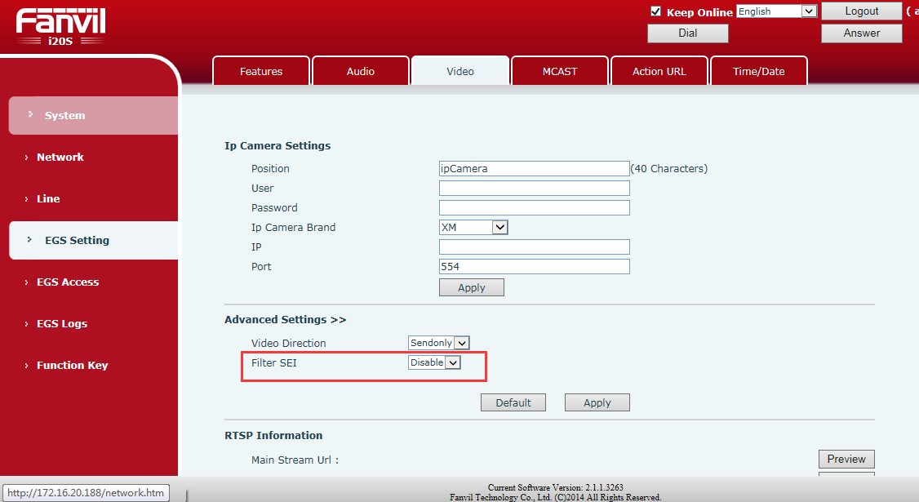
Description：Add the configuration Filter SEI on the web video page, which defaults to disable。
Set the Filter SEI to enable, then the terminal establishes video call, filtering h264, and the SEI can be seen in the package.
Set the Filter SEI to disable, then the terminal establishes video call, filtering h264, and the SEI can not be seen in the package.
7. Add the Video profile configuration
Web Configure paths：EGS Setting –Video
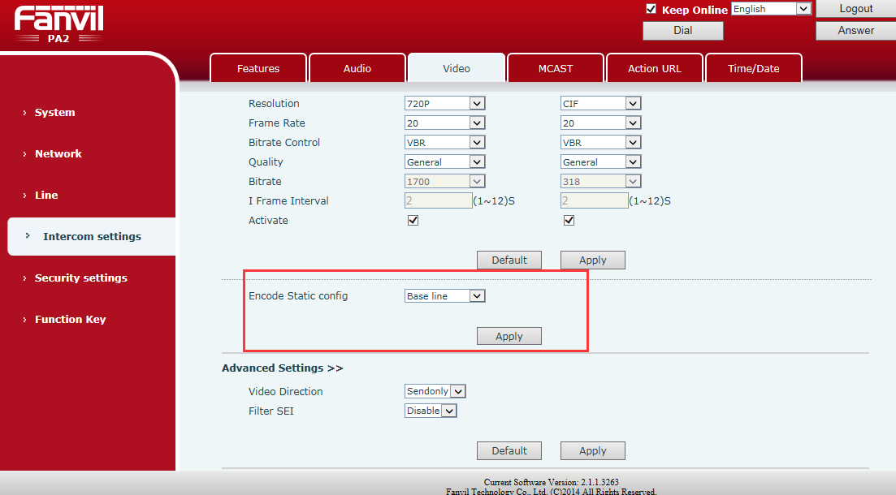
Description：Grab the packet filter h264, and you can see that the Encode Static config Settings are consistent with the capture package.
8. Add keyboard restart commands (Door phone)
Description：Press “#****##”，then the access control will restart.
9. Add reboot management
Web Configure paths：System –Tools
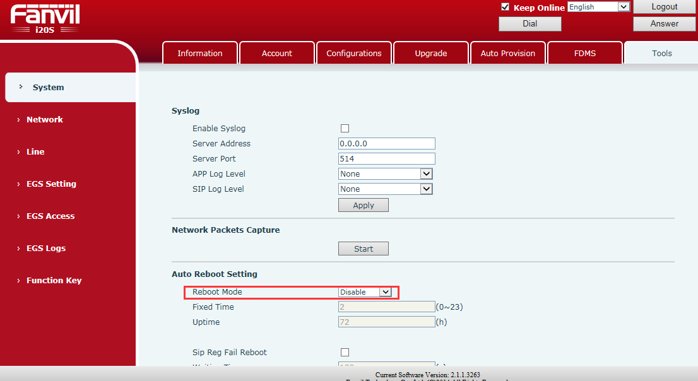
Off by default
Description：1. Custom restart：①Set point time：Set a fixed point in time to restart, and the configurable range is 0-23.②Fixed running time：Set how long to run after the restart, and the unit is hours.
2. Abnormal restart：①network anomaly： Deploy how long after the configuration failed to restart the network connection。②Sip registration is abnormal：Deploy how long after the configuration sip registration failed to restart automatically.
10. Add the VLAN function for PA2(PA2)
Description：
The condition for using Vlan is that lan port mode needs to be switched to bridge mode
1.If you change the connection mode of ipCamera to External mode, the system will automatically switch the lan port to bridge mode. At this time, you will see the Advanced page, the configuration page of Vlan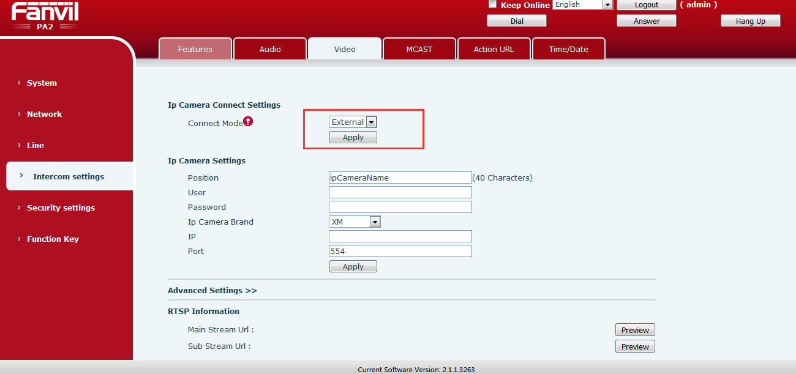
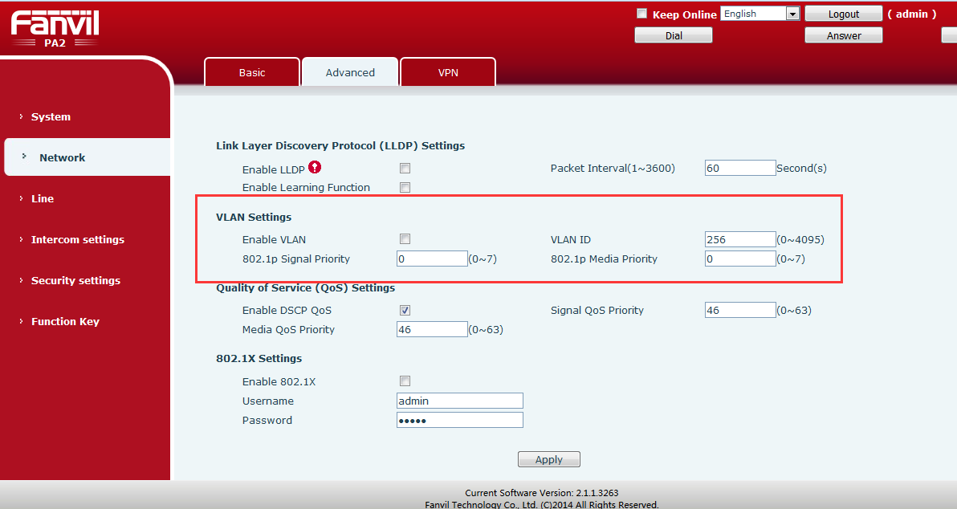
2.If you change the connection mode of IpCamera to Local mode, the system will automatically switch the lan port to the routing mode. If Vlan is enabled, the system will shut down synchronously. In this case, there will be no Advanced page under the network tab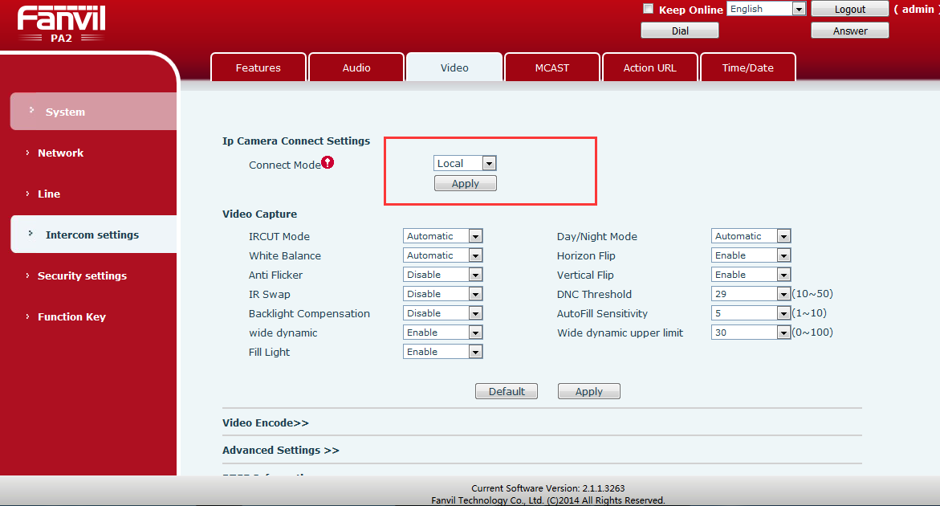
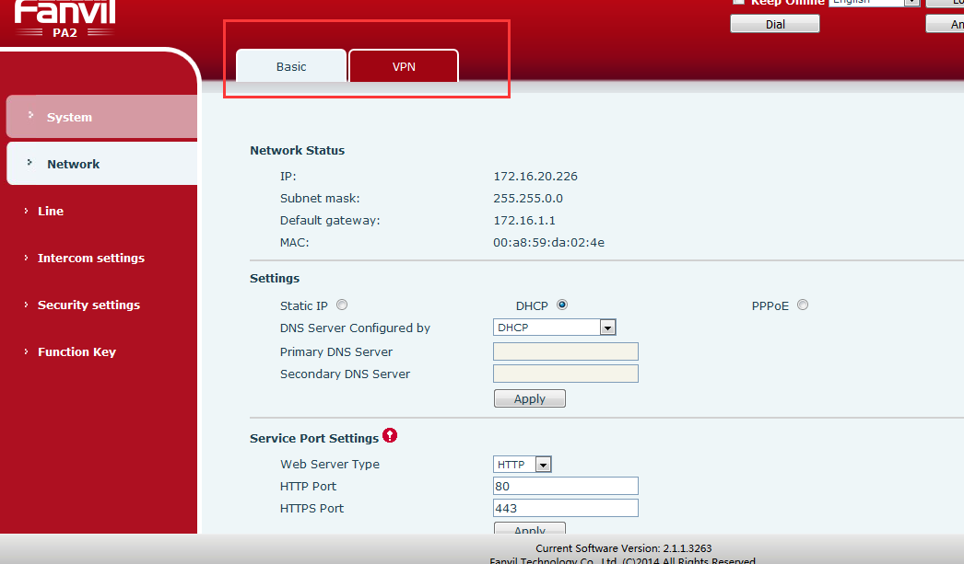
11. Disable AEC (echo cancellation) by sending DTMF for PA2(PA2)
Description：PA2 add the function that to turn off AEC via remote DTMF, it is convenient to remote verification speaker and microphone working status is normal.
1. Establish a call, and the call is normal, auxiliary phone side with no echo.
2. Auxiliary phone input DTMF code #5*5#，then the test terminal will turn off echo cancellation.At this time, the assistant phone can hear the echo when speaking。
3. Hang up the call, the test terminal should be back to normal. Make a call again, and the auxiliary phone speak without echo.
12. Add camera time synchronization
Description：
Configure paths：EGS Setting –Video，then click preview
