Release Note

版本号：2.1.1.2924
适用型号：PA2
日期：2017-8-7

New Features
- Added the feature that PA2 can sync local camera time.
- Added the feature that you can choose to play sound through built-in speakers or external speakers.

Optimization
- Added the local system time.
- Modified the WAN IP default to 192.168.1.128.
- Adjusted the volume of playing IP address.
- Adjusted the volume of the intercom.

3 Bug Fixes
- Fixed the issue that reboot does not take effect after changing camera connection mode.
- Fixed some bugs of sip module, improved the stability.
- Fixed the issue of the built-in Topsee camera connection failed.

New Features Descriptions
1． Added the feature that PA2 can sync local camera time.

Description：After PA2 time changed, the local camera time would be synchronized.

- Select the type of device that plays the sound.
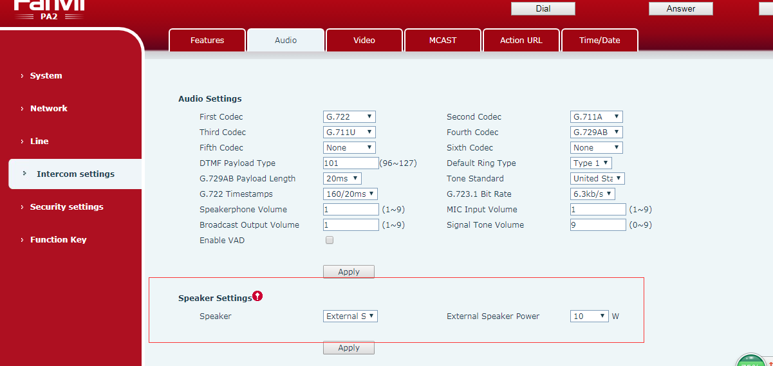
Description：You can choose to play the sound through a built-in speaker or an external speaker, and you can also select the power of the speakers.

